MEDIEVAL ROME
History 303
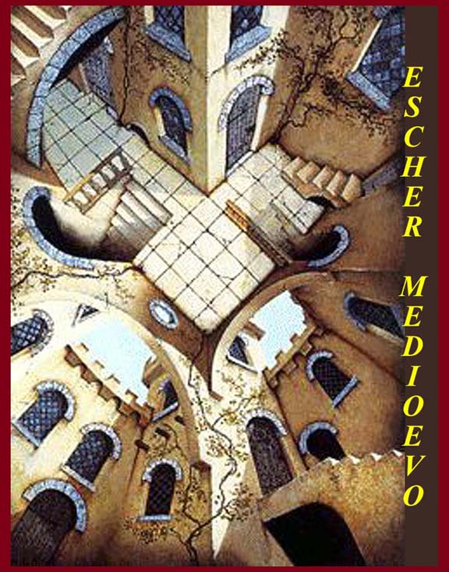
Fall Semester 2010
Tom Wukitsch – Instructor

Table of Contents

Unit 1: Introduction and the  Constantinian Legacy | Page 3
Unit 2: Barbarians | Page 29
Unit 3: Gregory and Other Christians | Page 35
Unit 4: Exarchs and the East | Page 56
Unit 5: Monastics | Page 68
Unit 6: Franks and Holy Romans | Page 83
Unit 7: Economics | Page 101
Unit 8: Late Architecture | Page 109
Unit 9: Late Artists and Writers | Page 118
Unit 10: Cola, Plagues, Other  Opportunities | Page 127

Unit 1--Medieval Rome
Introduction and the Constantinian legacy.
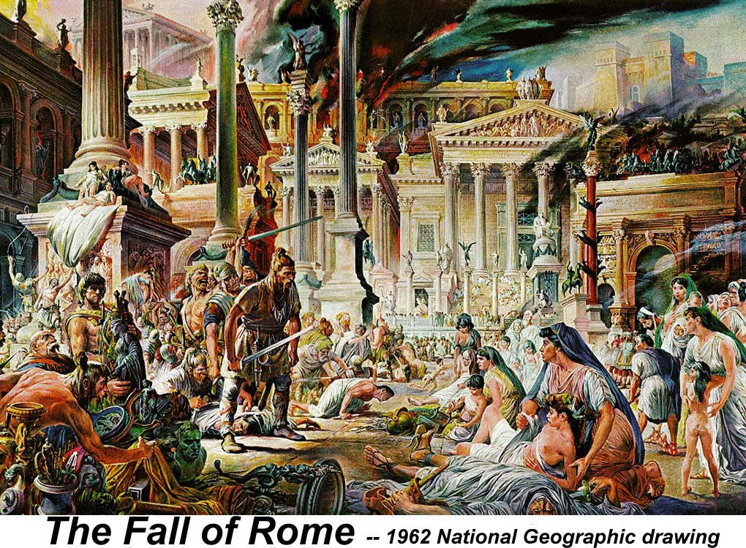

“The Dark Ages” is the pejorative name that Renaissance humanists gave to the period that started with the “fall” of Rome and ended with their own arrival.

A. Introduction
Dark Ages or Darkened ages
In general, "Darkness" was pejoratively applied by snooty Renaissance folks much like "pre-Raphaelites" -- not liking what came in between.
This was particularly true of Italians who thought that what came
In between was German and thus Barbarian.

"Medieval" really just means "middle period"
Early and late Medieval
Different dates in different place -- like all historical period labels.
In "Western Civ", "medieval" is usually applied only to Europe,
but historians of other areas also use the term.
Even in Europe, period names don't always mean the same thing.
Historians usually pick their own parameters

For our purposes, we will try to drop the term "dark ages" but no penalty for
forgetting. We will, however, use Medieval, early and late, for Rome.

We'll use Early Medieval to mean the time between Gregory the Great
(born about 540, Pope from 590 until 604) and ca. 1000.

Late Medieval will mean 1000 through the debatable beginning
of the Renaissance -- we'll decide later when that is.

Although the course is about Rome, we will talk about other places if needed.
Milan, Ravenna, Constantinople, Avignon, etc.

Before starting on the Medieval period, we'll go into some background:
Constantine's legacy -- for better or worse
Barbarians -- anyone non-Roman -- "your barbarian is my cousin"
Benedict and early monasticism
Gregory was a monk and maybe a Benedictine
He wrote a biography of Benedict
Byzantines and their Representatives.

Despite what it sounds like, this isn't a linear history course
There are timelines and an abbreviated history, but we will concentrate on
trends and controlling factors (some of which are people) rather than
on events
We won't always go in chronological order
Benedict, for example, is in the century before Gregory
but will come after him in the course.
And the founders of the other Medieval monastic orders,
Francis and Dominic, will be discussed with Benedict even though
they're late Medieval. Even Ignatius, who was counter-Reformation, will rate a mention.
Krautheimer's Medieval Rome
http://www.mmdtkw.org/VKrautheimerRome.html

B. Constantine's legacy

The "Donation of Constantine"
Constantine gives Rome and the Empire to Pope Sylvester 1 -- impious fraud
http://www.newadvent.org/cathen/05118a.htm

Extent of the Empire -- map exercise: from Augustus until 1500
Orphan maps? (Periodical Historical Atlas of Europe)
http://www.euratlas.com/time1.htm

Structures: Church basilicas and rounds

Tituli -- home churches to which someone held title

Ancient Roman Basilicas
Basilica of Maxentius/Constantine
Largest built, curile basilica

Tomb dinners -- an ancient Mediterranean tradition:
Dining/assembly area in front of tombs

Grand triclinia: banquet halls for large numbers of guests

Exposing tombs -- ambulatoria around tombs

Basilicas:
Old St. Peter's
http://www.mmdtkw.org/VOldStPeters.html
http://roma.katolsk.no/pietrovaticano.htm
Not oldest, but eventually assumed greatest importance.
Funerary chapel (martyrion) expanded into huge basilica
Good example of a semi-round ambulatory cut around a tomb
Perhaps built by Constantine (or Constantius)
Eventually demolished because it would have fallen --
but lasted more than 1000 yrs.
St. John Lateran
http://www.newadvent.org/cathen/09014b.htm
http://www.canticanova.com/articles/misc/art7f1.htm
http://members.tripod.com/romeartlover/Vasi46.html
"Mother of all churches"
Converted grand tricliniun
Not a tomb church
(Lateran Continued)
Medieval Baptistery still standing
"Constantine's bathtub" (Rienzo connection)
Medieval cloister
Scala Sancta
Leo 3's Triclinium Mosaic from Palace
Disastrous Palace fires
Renaissance/baroque redecoration of the church

Quattro Coronati
http://www.santiquattrocoronati.org/index_enn.htm
http://www2.siba.fi/~kkoskim/rooma/pages/SQUATTRO.HTM
4th Century Titulus Aemilianae built by Pope Miltiades (311-14)
Restored by Pope Honorius 625-638) and by Pope Hadrian 772-95
Basilica built by Pope Leo 4 (847-55).
Sacked by the Norman, Robert Guiscard, in 1048.
Rebuilt on a smaller scale by Pope Paschal 2 (1099-1118).
Monastery and cloister added in the 12th and 13th centuries,
held by Benedictines until the 16th.
Fortress guarding the Lateran (1246, Innocent 4)
and haven for Popes during conflict with the Hohehstaufen
Camaldolese monks got it in 1521 and 40 years later the Augustinians got it.
Now Augustinian nuns.
Fresco finds in late 1990's

St. Sabina
http://en.wikipedia.org/wiki/Santa_Sabina
http://www.sacred-destinations.com/italy/rome-santa-sabina
5th century (422-23), built on the site of Titulus Sabinae by Peter the Illyrian.

Became the Dominican HQ in 1218
(overtaken by S. Maria Sopra Minerva in 1370.)
Last home of Dominic, later was home of Thomas Aquinas.
Wooden doors are pre-450, perhaps the first doors of the church.
Windows are translucent selenite.
Restored in first half of 20th century
-- renaissance and baroque additions removed.
Medieval cloister is attached.
Additional courtyard with "Dominic's" orange tree.

Rare Round Churches
Round Roman Temple
Funerary rotundae without fronting basilicae?

S. Costanza
http://en.wikipedia.org/wiki/Santa_Costanza
http://www.sacred-destinations.com/italy/rome-santa-costanza
http://www.bluffton.edu/~sullivanm/italy/rome/costanza/costanza.html and linked pages
Originally a Mausoleum located outside the Aurelian walls on Via Nomentana
Not a church until 1254 -- Pope Alexander 4
Vault mosaic, with portrait of Costanza, is 4th century
Costanza's porphyry sarcophagus -- original in the Vatican

S. Maria ad Martyres -- Pantheon
http://www2.siba.fi/~kkoskim/rooma/pages/PANTHEON.HTM

http://www.romanconcrete.com/

Built by Hadrian as a massive rebuilding of
Marcus Agrippa's homage to the Julio-Claudian patron gods.
Temple closed in 5th century and given by Emperor Phocas to Pope Boniface 4.
Boniface consecrated it as S. Maria ad Martyres before 609
(in that year he proclaimed "All Saints Day" in the church.)
In 663, Eastern Emperor Constans 2 stole the bronze roof tiles.
Gregory 3 reclad the roof with lead in 735.

Used as a fortress and later as a poultry market
during Avignon Captivity (1309-77)
Restored to use as a church after the Captivity -- in use since then.
Renaisance redecorations.

S. Stefano Rotondo al Celio
http://en.wikipedia.org/wiki/Santo_Stefano_Rotondo
http://www2.siba.fi/~kkoskim/rooma/pages/SSTEFROT.HTM
http://www.sacred-destinations.com/italy/rome-santo-stefano-rotondo
A purpose built round church -- probably modeled directly
after the Byzantine church of the Holy Sepulchre in Jerusalem.
Same size as Jerusalem rotunda
First church consecrated by Pope Simplicius (468-83), perhaps in 460.
Perhaps financed by the Verlarian family who had Jerusalem connections
-- not a titulus.
Built on the site of a Mithraeum within the Castra Peregrinorum
(a military barracks for foreign troops -- training for foreign officers).
Decorated by Pope John 1 (523-26) and Pope Felix 4 (526-30).
Colonnades altered and transverse arches added by Innocent 2 (1130-1143).
Renaissance restorations
Martyr frescoes
Other Roman Medieval Churches
S. Sebastiano -- 3rd century catacomb church, 4th basilica, 9th rededication
Ss. Giovanno e Paulo -- 2-3 century titulus, 4th century church,
restored mid-5th, restored early 12th after Norman sacking
S. Pudenza (Pudenziana) 390 -- original but badly restored apse mosaic is
Earliest of its type in Rome
S. Maria Maggiore
Basilica Liberiana 352-66, Damasus Basilica 366-84, Sixtus3432-40
S. Maria della Neve -- Aug 4-5 358
Ss. Cosmas and Damian in Foro 527
S. Marco in Piazza Venezia -- ca 800
S. Cecilia in Trastevere -- early titulus Ceacilia, 5th century church replaced in 9th
S. Prassede (Praxedes, sister of Pudenza) 5th century church replaced in 822
Zeno chapel 817
S. Maria in Trastevere -- Supposedly Peter's parish, 4th Century church rebuilt in
12th
S. Clemente 1100s (Earlier church destroyed by Guiscard)
S. Maria del Popolo 1227
S. Lorenzo fuori le Mure
Search for their names on the Internet
Dark Ages/Medieval Times -- In One Page

Constantine moved his capital to Constantinople in the third decade of the fourth century.

During the 400's AD, the western part of the Roman Empire collapsed into several smaller states. In Spain and Portugal there were the Visigoths, in North Africa the Vandals, in Italy the Ostrogoths, in the Balkans the Avars, and in France the Merovingians. In England, this is the time of (legendary) King Arthur.

About 550, Justinian, the emperor of the surviving eastern part of the Roman Empire, tried to recapture the West, and succeeded in retaking Italy, North Africa, and part of Spain. But these successes were only temporary.

In the 600's AD, Arab armies fired by their new religion, Islam, swept from Arabia Felix (modern Saudi Arabia) into the Roman Empire and the Parthian Empire, and succeeded in taking over major parts of both. They establishing a huge empire running from Pakistan in the east to Spain in the West, including North Africa (with Egypt).

By the late 700's, Europe also was united under the emperor Charlemagne, although more weakly than the Arab Empire.

When Charlemagne died in the 800's, his European empire was split among his sons, and soon fell apart, roughly into the modern states of France and Germany. Italy was ruled by the Lombards, and eastern Europe by the Slavs.

Throughout this period Europe was plagued by invasions of Vikings from Scandinavia. Some of these settled in northern France about 1000 AD, and from there invaded England in 1066 and Sicily a little later.

In the southern Mediterranean and West Asia, the Arab empire also collapsed into smaller kingdoms ruled by different dynasties. The Turks took over Baghdad, the old capital, and the Fatimid dynasty took over Egypt. There were small Islamic kingdoms in West Africa, and along the East African coast Indian and Arab traders brought the Islamic faith.

The First Crusade was launched in 1096, where the French, English, and Germans united to try to capture Jerusalem and the Mediterranean coast from the weaker Arabs. This first Crusade was a great success, and the Crusaders established a kingdom along the coast.

Further Crusades after the first were much less successful, because the Arabs had gotten themselves together to fight back. By 1200 AD the Europeans had lost most of their territory along the Mediterranean coast (this is the time of Robin Hood).

At the same time, the Europeans were busy fighting wars at home against each other. England and France fought throughout the 1100's, 1200's and 1300's over which would control western France. The city-states in Italy fought with each other and with Germany. During the 1300's, several waves of bubonic plague swept through Europe, carrying off 30 to 50 percent of regional populations.

By the 1400's, however, Europe was recovering from the wars and from the plague. There was a civil war in England, but elsewhere the Renaissance was beginning. ----------------

From http://www.factmonster.com/ce6/world/A0860804.html

The history of Rome in the Middle Ages, bewildering in its detail, is essentially that of two institutions, the papacy and the commune of Rome. In the 5th century the Goths ruled Italy from Ravenna, their capital. Odoacer and Theodoric the Great kept the old administration of Rome under Roman law, with Roman officials. The city, whose population was to remain less than 50,000 throughout the Middle Ages, suffered severely from the wars between the Goths and Byzantines. In 552, Narses conquered Rome for Byzantium and became the first of the exarchs (viceroys) who ruled Italy from Ravenna. Under Byzantine rule commerce declined, and the senate and consuls disappeared.

Pope Gregory I (590–604), one of the greatest Roman leaders of all time, began to emancipate Rome from the exarchs. Sustained by the people, the popes soon exercised greater power in Rome than did the imperial governors, and many secular buildings were converted into churches. The papal elections were, for the next 12 centuries, the main events in Roman history. Two other far-reaching developments (7th–8th century) were the division of the people into four classes (clergy, nobility, soldiers, and the lowest class) and the emergence of the Papal States.

The coronation (800) at Rome of Charlemagne as emperor of the West ended all question of Byzantine suzerainty over Rome, but it also inaugurated an era characterized by the ambiguous relationship between the emperors and the popes. That era was punctuated by visits to the city by the German kings, to be crowned emperor or to secure the election of a pope to their liking or to impose their will on the pope. In 846, Rome was sacked by the Arabs; the Leonine walls were built to protect the city, but they did not prevent the frequent occupations and plunderings of the city by Christian powers.

By the 10th century, Rome and the papacy had reached their lowest point. Papal elections, originally exercised by the citizens of Rome, had come under the control of the great noble families, among whom the Frangipani and Pierleone families and later the Orsini and the Colonna were the most powerful. Each of these would rather have torn Rome apart than allowed the other families to gain undue influence. They built fortresses in the city (often improvised transformations of the ancient palaces and theaters) and ruled Rome from them.

From 932 to 954, Alberic, a very able man, governed Rome firmly and restored its self-respect, but after his death and after the proceedings that accompanied the coronation of Otto I as emperor, Rome relapsed into chaos. The papal dignity once more became the pawn of the emperors and of local feudatories. Contending factions often elected several popes at once. Gregory VII reformed these abuses and strongly claimed the supremacy of the church over the municipality, but he himself ended as an exile, Emperor Henry IV having taken Rome in 1084. The Normans under Robert Guiscard came to rescue Gregory and thoroughly sacked the city on the same occasion (1084).

Papal authority was challenged in the 12th century by the communal movement. A commune was set up (1144–55), led by Arnold of Brescia, but it was subdued by the intervention of Emperor Frederick I. Finally, a republic under papal patronage was established, headed by an elected senator. However, civil strife continued between popular and aristocratic factions and between Guelphs and Ghibellines. The commune made war to subdue neighboring cities, for it pretended to rule over the Papal States, particularly the duchy of Rome, which included Latium and parts of Tuscany. Innocent III controlled the government of the city, but it regained its autonomy after the accession of Emperor Frederick II. Later in the 13th century, foreign senators began to be chosen; among them were Brancaleone degli Andalò (1252–58) and Charles I of Naples.

During the “Babylonian captivity” of the popes at Avignon (1309–78) Rome was desolate, economically ruined, and in constant turmoil. Cola di Rienzi became the champion of the people and tried to revive the ancient Roman institutions, as envisaged also by Petrarch and Dante; in 1347 he was made tribune, but his dreams were doomed. Cardinal Albornoz temporarily restored the papal authority over Rome, but the Great Schism (1378–1417) intervened. Once more a republic was set up. In 1420, Martin V returned to Rome, and with him began the true and effective dominion of the popes in Rome.
From The Columbia Electronic Encyclopedia

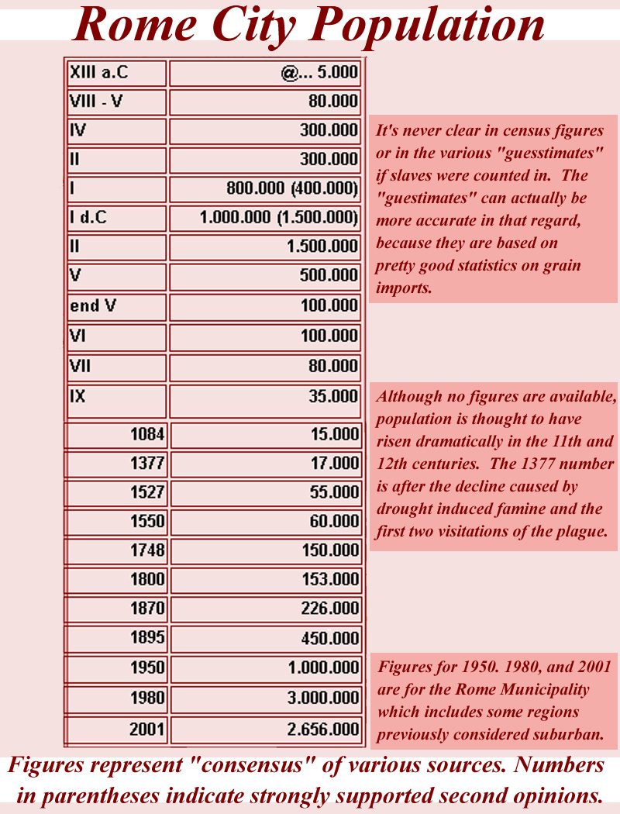

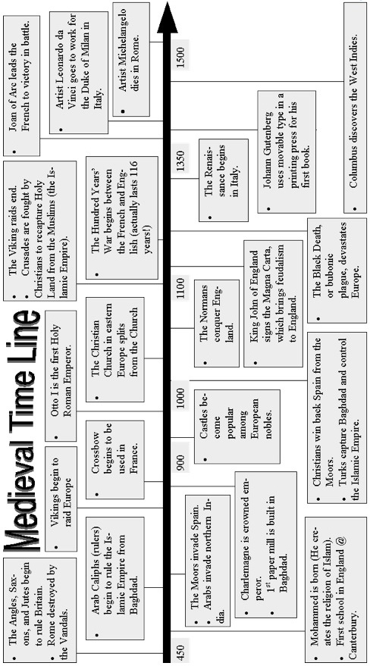
Rome Chron , derived from http://roma.katolsk.no/chronology.htm
Octavian through the medieval period -- 31 BC to 1500 AD

31 BC
Octavian (from 27 BC known as Augustus) defeated Marc Anthony at Actium, and gained control of the Roman empire.
AD 61
Sts. Peter and Paul worked in Rome.
AD 64
Nero ruling. Rome burnt. Christians were blamed, leading to persecutions.
AD 64 or 67
St Peter the Apostle martyred. Paul martyred about the same time.
AD 95
Member of the imperial family and Manius Acilius Glabrio, consul in AD 91, were tried and sentenced for the Christian faith. This is the first recorded example of converts among persons in prominent positions in Roman society.
AD 97-105
During the pontificate of St Evaristus, priests were assigned to the tituli, effectively making them the first parish churches of Rome.
c. AD 100
During the reign of Emperor Trajan (98-117). Rome had 1.000.000 inhabitants.
AD 253
Rome first divided in an Eastern and a Western empire.
AD 258
The first celebration of the feast of Sts. Peter and Paul on 29 June is recorded in this year.
AD 273
The Aurelian Wall built.
AD 293
Diocletian introduced tetrarchy, a system were four emperors ruled together. The division between the East and West was formalized.
AD 303
The Diocletian persecution of Christians started.
AD 305
The Baths of Diocletian completed. Many of the workers were Christian slaves. Parts of the baths are now the church of Santa Maria degli Angeli.
AD 308-309
Pope St Marcellus defined the liturgical functions of the tituli. They had already functioned as parish churches for two centuries (see 97-105); with St Marcellus' decision this status was formalized.
AD 312
Constantine won the Battle at the Milvian Bridge in Rome, and became sole ruler of the Roman Empire. He most likely converted to Christianity at this time, although due to a common baptismal practice in his time he held off baptism until he was on his deathbed.
AD 313
The Decree of Tolerance issued by Constantine and Licinius, granting Christians the right to practice their religion. Pagan rituals were not yet banned in the Empire.
AD 326
The first San Pietro in Vaticano consecrated.
AD 330
Emperor Constantine moved the capitol of the Roman empire to Constantinople. The division of the empire was now beyond repair. Building projects were carried out under Constantine, among them the first Christian basilicas. After the death of Constantine, a long time passed before major public buildings were erected in the city, and it gradually fell into decay.
AD 356
Santa Maria Maggiore founded according to legend. It may have been built somewhat later.
AD 361-363
The reign of Emperor Julian the Apostate. Julian was the last Roman emperor who instigated persecutions of Christians.
AD 391/2
Emperor Theodosius banned all pagan cults and closed the temples.
AD 402
The seat of the Western Emperor moved to Ravenna by Emperor Honorius.
AD 408
Visigoths led by Alaric reached the gates of Rome. Pope Innocent I acted as the city's representative in the negotiations.
Ravenna became the capital of the Western empire.
AD 419
The first imperial intervention in a papal election occurred when Emperor Honorius supported Pope St Boniface against the Antipope Eulalius.
AD 451
Attila the Hun reached Rome. Pope Leo I struck a deal with him and saved the city.
AD 455
Rome attacked by Vandals under Geiseric.
AD 472
Ricimer of the Suevi captured Rome.
AD 476
The fall of the Western Empire. The last emperor in Rome, Romulus Augustulus, was forced to abdicate and was exiled. Odoacer became the first Barbarian king of Italy.

AD 483
To prevent disputed arising from papal elections, Pope Simplicius was aided by Odoacer, the Herulian King of Italy, in establishing a law regulating the elections.
AD 493
Acting on orders from the Byzantine Emperor Zeno, Theodoric overthrew Odoacer and ruled as King of Italy and from 493 as King of the Romans.
AD 499
A synod was held in Rome. Among the preserved documents is a list of churches.
AD 536
The Byzantine General Belisarius, sent by Emperor Justinian, saved Rome from the Goths.
AD 537
Vitigis the Goth cut the aqueducts during a siege of Rome. They reached the Castel St'Angelo, but was repelled by the Romans under Belisarius' leadership.
AD 540
Emperor Justinian initiated the last building program before the Middle Ages.
AD 547
Totila the Goth took Rome while Belisarius was in Constantinople. Belisarius was sent back to Rome, and recaptured the city.
The population of Rome had fallen to about 30.000.
AD 550
Totila the Goth took Rome for the second time.
AD 552
The Byzantine General Narses re-captured Rome from Totila.
AD 589
Severe flooding of the Tiber destroyed houses, churches and granaries. The flood was followed by plague, which killed Pope Pelagius II in 590.
AD 590
St Gregory the Great elected as Pope. By 593, he had established peace with the Lombards and appointed his own governors in several Italian provincial cities. This was the basis of the temporal power of the Popes in the Middle Ages.
AD 607
The Byzantine Emperor Phocas recognized the Roman pontiff's primacy over all Churches.
AD 663
The Byzantine Emperor Constans II spent 12 days in Rome, during which he stripped a number of public buildings and churches of bronze and other metals which he shipped to Constantinople.
AD 725
Rome's first hostel for pilgrims founded by King Ine of Wessex.
Emperor Leo III instigated iconoclasm in the East. Refugees from the iconoclast persecutions in the East had already been coming to Rome for some time, and now their number increased. Many of them settled in the area around Santa Maria in Cosmedin, also known as Santa Maria in Schola Graeca.
AD 729
Rome besieged by Lieutprand, who had entered a temporary alliance with the Exarch of Ravenna. The siege was broken by Pope Gregory II, and Lieutprand was forced to offer his arms and armour at the Tomb of the Apostle.
AD 754
King Pippin the Short defeated the Lombards and bequeathed territories in Ravenna and Rome to the Church.
AD 800
Charlemagne crowned at San Pietro in Vaticano.
AD 846
The suburbs of Rome attacked by Saracen raiders. San Pietro in Vaticano was desecrated. To protect it from further attacks, Pope St Leo IV built walls around the Vatican, which came to be known as 'the Leonine City'.
AD 849
A papal fleet defeated the Saracens off Ostia.
AD 852
The Leonine Walls completed.
AD 975
Pope Benedict VII assigned SS Quattro Coronati as a titular church to Dietrich of Trier; this is the first time a non-Italian became a titular priest.
1054
Schism between the Eastern Churches and the Roman Church.
1073
Gregory VII elected Pope. Emperor Henry IV contested the election, and the Pope excommunicated the Emperor who was forced to humble himself at Canossa in January 1077. The Investiture Contest continued to cause problems for a while longer.
1083
Emperor Henry IV occupied Rome.
1084
Rome attacked by Normans. Emperor Henry IV was imprisoned at the Castel Sant'Angelo.
1140
A war between Rome and Tivoli ended in Roman victory. Pope Innocent II refused to let the Romans destroy the town, and rebellion broke out in Rome. The Senate was revived (1144) under the leadership of Arnoldo da Brescia, and Rome was declared independent of the Papacy.
1145
Pope Lucius II led an attack on the Capitol in an attempt to end the rebellion that had started in 1140. He died of the wounds he received in the charge.
1148
Pope Eugenius III excommunicated the rebel leader Arnold of Brescia, who was later executed by Emperor Frederick Barbarossa. The Senate now has 25 senators, which dropped to 15 in 1150-51.
c. 1150
The Cosmati family developed a new mosaic style, used in many of Rome's churches.
1163
For the first time, a cardinal was allowed to return to his diocese outside Rome when Pope Alexander III let Conrad of Wittelsbach, Archbishop of Mainz, return to his see.
1179
The 3rd Lateran Council held.
1187
The reconstructed Senate had 56 senators, 4 from each of the 14 districts of Rome.
1198
The Senate had only 1 senator. A few years later, a treaty declared that there were to be 56 senators. The system soon collapsed, and in 1205 there was only 1 senator left.
1200
Rome has a population of about 35.000.
1215
The 4th Lateran Council summoned by Pope Innocent III.
1300
The first Holy Year proclaimed by Pope Boniface VIII (1294-1303). Among the approximately 200.000 pilgrims who came to Rome were Dante, Cimabue, Giotto and Charles de Valois, brother of the King of France. Dante mentions the events in Canticle XXXI of Paradise in his Divine Comedy.
1302
Pope Boniface VIII (1294-1303) issued the bull Unam sanctam, proclaiming the supremacy of the papacy over secular authority.
1303
The University of Rome, Università della Sapienza, established by Pope Boniface VIII (1294-1303).
1309
Pope Clement V transferred the papacy to Avignon, France. This was done mainly because of the civic unrest and national crisis in Rome at the time. It remained there until 1377.
c. 1320
A list from about this year says that there were 414 churches in Rome. They were all in various states of disrepair, and 43 had no clergy permanently attached to them. 261 parish churches needed 1 or 2 priests for their support.
1341
One of the most damaging floods of the Tiber came this year.
1347
Cola di Rienzo proclaimed himself Liberator of the Holy Roman Republic and Tribune of the People.
1348
The Black Death struck Rome. An earthquake caused severe damage; the façade of San Giovanni in Laterano collapsed and San Pietro in Vaticano was damaged.
1350
Celebration of Holy Year. A visit to San Giovanni in Laterano is recommended in addition to visits to San Pietro in Vaticano and San Paolo fuori le mura .
1354
Cola di Rienzo returned to Rome after two years in exile. In October, he was killed by a mob.
1377
Gregory XI returned the papacy from Avignon to Rome.
1378
The Great Schism begins, with one pope in Rome and one in Avignon.
1383
An extra ordinary Holy Year is proclaimed by Pope Urban VI.
From 1383 to 1388 a plague decimated the population of Rome.
1390
Celebration of Holy Year. Privileges were extended to cathedrals outside Rome, and Santa Maria Maggiore was added to the list of churches in Rome where indulgences could be obtained.
The plague returned with the pilgrims.
1400
Rome had a population of about 17.000, only half of what it had in 1200.
A Holy Year was celebrated. About 120.000 pilgrims came to Rome. The plague also returned, and claimed up to 800 victims each day.
1417
Under Pope Martin V, the Great Schism that began in 1378 ended.
1420
Pope Martin V reestablished Papal authority in Rome.
1422
New outbreak of the plague, and great flooding of the Tiber.
1423
Celebration of Holy Year.
1450
Celebration of Holy Year.
1452
The demolition of the old Basilica of St Peter began.
1453
Constantinople was lost to the Turks. This marks the end of the Byzantine Empire.
1462
Pope Pius II (1458-1464) issued the bull Cim almam nostram urbem, promoting the protection of ancient buildings.
1470
Pope Paul II changed the frequency of Holy Years to every 25 years, and set the opening date to Christmas Eve.
1475
The Vatican Library inaugurated by Pope Sixtus IV.
1500
Celebration of Holy Year. This was the first time all the four Holy Doors were opened and closed at the same time.

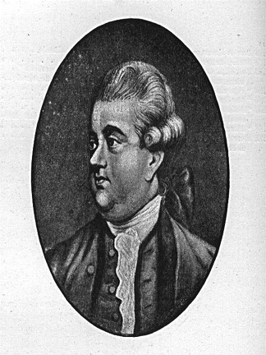Edward Gibbon: General Observations on the Fall of the Roman Empire in the West
from The Decline and Fall of the Roman Empire, Chapter 38

The Greeks, after their country had been reduced into a province, imputed the triumphs of Rome, not to the merit, but to the FORTUNE, of the republic. The inconstant goddess, who so blindly distributes and resumes her favours, had now consented (such was the language of envious flattery) to resign her wings, to descend from her globe, and to fix her firm and immutable throne on the banks of the Tiber.[1] A wiser Greek, who has composed, with a philosophic spirit, the memorable history of his own times, deprived his countrymen of this vain and delusive comfort by opening to their view the deep foundations of the greatness of Rome.[2] The fidelity of the citizens to each other, and to the state, was confirmed by the habits of education and the prejudices of religion. Honour, as well as virtue, was the principle of the republic; the ambitious citizens laboured to deserve the solemn glories of a triumph; and the ardour of the Roman youth was kindled into active emulation, as often as they beheld the domestic images of their ancestors.[3] The temperate struggles of the patricians and plebeians had finally established the firm and equal balance of the constitution; which united the freedom of popular assemblies with the authority and wisdom of a senate-and the executive powers of a regal magistrate. When the consul displayed the standard of the republic, each citizen bound himself, by the obligation of an oath, to draw his sword in the cause of his country, till he had discharged the sacred duty by a military service of ten years. This wise institution continually poured into the field the rising generations of freemen and soldiers; and their numbers were reinforced by the warlike and populous states of Italy, who, after a brave resistance, had yielded to the valour, and embraced the alliance, of the Romans. The sage historian, who excited the virtue of the younger Scipio and beheld the ruin of Carthage,[4] has accurately described their military system; their levies, arms, exercises, subordination, marches, encampments; and the invincible legion, superior in active strength to the Macedonian phalanx of Philip and Alexander. From these institutions of peace and war, Polybius has deduced the spirit and success of a people incapable of fear and impatient of repose. The ambitious design of conquest, which might have been defeated by the seasonable conspiracy of mankind, was attempted and achieved; and the perpetual violation of justice was maintained by the political virtues of prudence and courage. The arms of the republic, sometimes vanquished in battle, always victorious in war, advanced with rapid steps to the Euphrates, the Danube, the Rhine, and the Ocean; and the images of gold, or silver, or brass, that might serve to represent the nations and their kings, were successively broken by the iron monarchy of Rome.[5]

The rise of a city, which swelled into an Empire, may deserve, as a singular prodigy, the reflection of a philosophic mind. But the decline of Rome was the natural and inevitable effect of immoderate greatness. Prosperity ripened the principle of decay; the causes of destruction multiplied with the extent of conquest; and, as soon as time or accident had removed the artificial supports, the stupendous fabric yielded to the pressure of its own weight. The story of its ruin is simple and obvious; and, instead of inquiring why the Roman empire was destroyed, we should rather be surprised that it had subsisted so long. The victorious legions, who, in distant wars, acquired the vices of strangers and mercenaries, first oppressed the freedom of the republic, and afterwards violated the majesty of the purple. The emperors, anxious for their personal safety and the public peace, were reduced to the base expedient of corrupting the discipline which rendered them alike formidable to their sovereign and to the enemy; the vigour of the military government was relaxed, and finally dissolved, by the partial institutions of Constantine; and the Roman world was overwhelmed by a deluge of Barbarians.

The decay of Rome has been frequently ascribed to the translation of the seat of empire; but this history has already shewn that the powers of government were divided rather than removed. The throne of Constantinople was erected in the East; while the West was still possessed by a series of emperors who held their residence in Italy and claimed their equal inheritance of the legions and provinces. This dangerous novelty impaired the strength, and fomented the vices, of a double reign; the instruments of an oppressive and arbitrary system were multiplied; and a vain emulation of luxury, not of merit, was introduced and supported between the degenerate successors of Theodosius. Extreme distress, which unites the virtue of a free people, embitters the factions of a declining monarchy. The hostile favourites of Arcadius and Honorius betrayed the republic to its common enemies; and the Byzantine court beheld with indifference, perhaps with pleasure, the disgrace of Rome, the misfortunes of Italy, and the loss of the West. Under the succeeding reigns, the alliance of the two empires was restored; but the aid of the Oriental Romans was tardy, doubtful, and ineffectual; and the national schism of the Greeks and Latins was enlarged by the perpetual difference of language and manners, of interest, and even of religion. Yet the salutary event approved in some measure the judgment of Constantine. During a long period of decay, his impregnable city repelled the victorious armies of Barbarians, protected the wealth of Asia, and commanded, both in peace and war, the important straits which connect the Euxine and Mediterranean seas. The foundation of Constantinople more essentially contributed to the preservation of the East than to the ruin of the West.

As the happiness of a future life is the great object of religion, we may hear, without surprise or scandal, that the introduction, or at least the abuse, of Christianity had some influence on the decline and fall of the Roman empire. The clergy successfully preached the doctrines of patience and pusillanimity; the active virtues of society were discouraged; and the last remains of the military spirit were buried in the cloister; a large portion of public and private wealth was consecrated to the specious demands of charity and devotion; and the soldiers' pay was lavished on the useless multitudes of both sexes, who could only plead the merits of abstinence and chastity. Faith, zeal, curiosity, and the more earthly passions of malice and ambition kindled the flame of theological discord; the church, and even the state, were distracted by religious factions, whose conflicts were sometimes bloody, and always implacable; the attention of the emperors was diverted from camps to synods; the Roman world was oppressed by a new species of tyranny; and the persecuted sects became the secret enemies of their country. Yet party-spirit, however pernicious or absurd, is a principle of union as well as of dissension. The bishops, from eighteen hundred pulpits, inculcated the duty of passive obedience to a lawful and orthodox sovereign; their frequent assemblies, and perpetual correspondence, maintained the communion of distant churches: and the benevolent temper of the gospel was strengthened, though confined, by the spiritual alliance of the Catholics. The sacred indolence of the monks was devoutly embraced by a servile and effeminate age; but, if superstition had not afforded a decent retreat, the same vices would have tempted the unworthy Romans to desert, from baser motives, the standard of the republic. Religious precepts are easily obeyed, which indulge and sanctify the natural inclinations of their votaries; but the pure and genuine influence of Christianity may be traced in its beneficial, though imperfect, effects on the Barbarian proselytes of the North. If the decline of the Roman empire was hastened by the conversion of Constantine, his victorious religion broke the violence of the fall, and mollified the ferocious temper of the conquerors.

This awful revolution may be usefully applied to the instruction of the present age. It is the duty of a patriot to prefer and promote the exclusive interest and glory of his native country; but a philosopher may be permitted to enlarge his views, and to consider Europe as one great republic, whose various inhabitants have attained almost the same level of politeness and cultivation. The balance of power will continue to fluctuate, and the prosperity of our own or the neighbouring kingdoms may be alternately exalted or depressed; but these partial events cannot essentially injure our general state of happiness, the system of arts, and laws,and manners, which so advantageously distinguish, above the rest of mankind, the Europeans and their colonies. The savage nations of the globe are the common enemies of civilized society; and we may inquire with anxious curiosity, whether Europe is still threatened with a repetition of those calamities which formerly oppressed the arms and institutions of Rome. Perhaps the same
reflections will illustrate the fall of that mighty empire, and explain the probable causes of our actual security.

I. The Romans were ignorant of the extent of their danger, and the number of their enemies. Beyond the Rhine and Danube, the northern countries of Europe and Asia were filled with innumerable tribes of hunters and shepherds, poor, voracious, and turbulent; bold in arms, and impatient to ravish the fruits of industry. The Barbarian world was agitated by the rapid impulse of war; and the peace of Gaul or Italy was shaken by the distant revolutions of China. The Huns, who fled before a victorious enemy, directed their march towards the West; and the torrent was swelled by the gradual accession of captives and allies. The flying tribes who yielded to the Huns assumed in their turn the spirit of conquest; the endless column of Barbarians pressed on the Roman empire with accumulated weight; and, if the foremost were destroyed, the vacant space was instantly replenished by new assailants. Such formidable emigrations can no longer issue from the North; and the long repose, which has been imputed to the decrease of population, is the happy consequence of the progress of arts and agriculture. Instead of some rude villages, thinly scattered among its woods and morasses, Germany now produces a list of two thousand three hundred walled towns; the Christian kingdoms of Denmark, Sweden, and Poland, have been successively established; and the Hanse merchants, with the Teutonic knights, have extended their colonies along the coast of the Baltic, as far as the Gulf of Finland. From the Gulf of Finland to the Eastern Ocean, Russia now assumes the form of a powerful and civilized empire. The plough, the loom, and the forge, are introduced on the banks of the Volga, the Oby, and the Lena; and the fiercest of the Tartar hordes have been taught to tremble and obey. The reign of independent Barbarism is now contracted to a narrow span; and the remnant of Calmucks or Uzbecks, whose forces may be almost numbered, cannot seriously excite the apprehensions of the great republic of Europe.[6] Yet this apparent security should not tempt us to forget that new enemies, and unknown dangers, may possibly arise from some obscure people, scarcely visible in the map of the world. The Arabs or Saracens, who spread their conquests from India to Spain, had languished in poverty and contempt, till Mahomet breathed into those savage bodies the soul of enthusiasm.

II. The empire of Rome was firmly established by the singular and perfect coalition of its members. The subject nations, resigning the hope, and even the wish, of independence, embraced the character of Roman citizens; and the provinces of the West were reluctantly torn by the Barbarians from the bosom of their mother-country.[7] But this union was purchased by the loss of national freedom and military spirit; and the servile provinces, destitute of life and motion, expected their safety from the mercenary troops and governors, who were directed by the orders of a distant court. The happiness of an hundred millions depended on the personal merit of one or two men, perhaps children, whose minds were corrupted by education, luxury, and despotic power. The deepest wounds were inflicted on the empire during the minorities of the sons and grandsons of Theodosius; and, after those incapable princes seemed to attain the age of manhood, they abandoned the church to the bishops, the state to the eunuchs, and the provinces to the Barbarians. Europe is now divided into twelve powerful, though unequal, kingdoms, three respectable commonwealths, and a variety of smaller, though independent, states; the chances of royal and ministerial talents are multiplied, at least with the number of its rulers; and a Julian, or Semiramis, may reign in the North, while Arcadius and Honorius again slumber on the thrones of the South.[7a] The abuses of tyranny are restrained by the mutual influence of fear and shame; republics have acquired order and stability; monarchies have imbibed the principles of freedom, or, at least, of moderation; and some sense of honour and justice is introduced into the most defective constitutions by the general manners of the times. In peace, the progress of knowledge and industry is accelerated by the emulation of so many active rivals: in war, the European forces are exercised by temperate and undecisive contests. If a savage conqueror should issue from the deserts of Tartary, he must repeatedly vanquish the robust peasants of Russia, the numerous armies of Germany, the gallant nobles of France, and the intrepid freemen of Britain; who, perhaps, might confederate for their common defence. Should the victorious Barbarians carry slavery and desolation as far as the Atlantic Ocean, ten thousand vessels would transport beyond their pursuit the remains of civilized society; and Europe would revive and flourish in the American world which is already filled with her colonies and institutions.[8]

III. Cold, poverty, and a life of danger and fatigue, fortify the strength and courage of Barbarians. In every age they have oppressed the polite and peaceful nations of China, India, and Persia, who neglected, and still neglect, to counterbalance these natural powers by the resources of military art. The warlike states of antiquity, Greece, Macedonia, and Rome, educated a race of soldiers; exercised their bodies, disciplined their courage, multiplied their forces by regular evolutions, and converted the iron which they possessed into strong and serviceable weapons. But this superiority insensibly declined with their laws and manners; and the feeble policy of Constantine and his successors armed and instructed, for the ruin of the empire, the rude valour of the Barbarian mercenaries. The military art has been changed by the invention of gunpowder; which enables man to command the two most powerful agents of nature, air and fire. Mathematics, chymistry, mechanics, architecture, have been applied to the service of war; and the adverse parties oppose to each other the most elaborate modes of attack and of defence. Historians may indignantly observe that the preparations of a siege would found and maintain a flourishing colony;[9] yet we cannot be displeased that the subversion of a city should be a work of cost and difficulty, or that an industrious people should be protected by those arts, which survive and supply the decay of military virtue. Cannon and fortifications now form an impregnable barrier against the Tartar horse; and Europe is secure from any future irruption of Barbarians; since, before they can conquer, they must cease to be barbarous. Their gradual advances in the science of war would always be accompanied, as we may learn from the example of Russia, with a proportionable improvement in the arts of peace and civil policy; and they themselves must deserve a place among the polished nations whom they subdue.

Should these speculations be found doubtful or fallacious, there still remains a more humble source of comfort and hope. The discoveries of ancient and modern navigators, and the domestic history, or tradition, of the most enlightened nations, represent the human savage, naked both in mind and body, and destitute of laws, of arts, of ideas, and almost of language.[10] From this abject condition, perhaps the primitive and universal state of man, he has gradually arisen to command the animals, to fertilise the earth, to traverse the ocean, and to measure the heavens. His progress in the improvement and exercise of his mental and corporeal faculties[11] has been irregular and various, infinitely slow in the beginning, and increasing by degrees with redoubled velocity; ages of laborious ascent have been followed by a moment of rapid downfall; and the several climates of the globe have felt the vicissitudes of light and darkness. Yet the experience of four thousand years should enlarge our hopes, and diminish our apprehensions; we cannot determine to what height the human species may aspire in their advances towards perfection; but it may safely be presumed that no people, unless the face of nature is changed, will relapse into their original barbarism. The improvements of society may be viewed under a threefold aspect. 1. The poet or philosopher illustrates his age and country by the efforts of a single mind; but these superior powers of reason or fancy are rare and spontaneous productions, and the genius of Homer, or Cicero, or Newton, would excite less admiration, if they could be created by the will of a prince or the lessons of a preceptor. 2. The benefits of law and policy, of trade and manufactures, of arts and sciences, are more solid and permanent; and many individuals may be qualified, by education and discipline, to promote, in their respective stations, the interest of the community. But this general order is the effect of skill and labour; and the complex machinery may be decayed by time or injured by violence. 3. Fortunately for mankind, the more useful, or, at least, more necessary arts can be performed without superior talents, or national subordination; without the powers of one or the union of many. Each village, each family, each individual, must always possess both ability and inclination to perpetuate the use of fire[12] and of metals; the propagation and service of domestic animals; the methods of hunting and fishing; the rudiments of navigation; the imperfect cultivation of corn or other nutritive grain; and the simple practice of the mechanic trades. Private genius and public industry may be extirpated; but these hardy plants survive the tempest, and strike an everlasting root into the most unfavourable soil. The splendid days of Augustus and Trajan were eclipsed by a cloud of ignorance; and the Barbarians subverted the laws and palaces of Rome. But the scythe, the invention or emblem of Saturn,[13] still continued annually to mow the harvests of Italy: and the human feasts of the Laestrygons[14] have never been renewed on the coast of Campania.

Since the first discovery of the arts, war, commerce, and religious zeal have diffused, among the savages of the Old and New World, those inestimable gifts: they have been successively propagated; they can never be lost. We may therefore acquiesce in the pleasing conclusion that every age of the world has increased, and still increases, the real wealth, the happiness, the knowledge, and perhaps the virtue, of the human race.[15]

NOTES

[[1]] Such are the figurative expressions of Plutarch (Opera, tom. ii. p. 318, edit. Wechel), to whom, on the faith of his son Lamprias (Fabricius, Bibliot. Graec. tom. iii. p. 341), I shall boldly impute the malicious declamation, PERI\ TH=S P(WMAI/WN TU/XHS. The same opinions had prevailed among the Greeks two hundred and fifty years before Plutarch; and to confute them is the professed intention of Polybius (Hist. 1. i. p. 90, edit. Gronov. Amstel. 1670 [c. 63]).

[[2]] See the inestimable remains of the sixth book of Polybius, and many other parts of his general history, particularly a digression in the seventeenth [leg. eighteenth] book, in which he compares: the phalanx and the legion [c. 12-15].

[[3]] Sallust, de Bell. Jugurthin. c. 4. Such were the generous professions of P. Scipio and Q. Maximus. The Latin historian had read, and most probably transcribed, Polybius, their contemporary and friend.

[[4]] While Carthage was in flames, Scipio repeated two lines of the Iliad, which express the destruction of Troy, acknowledging to Polybius, his friend and preceptor (Polyb. in Excerpt. de Virtut. et Vit. tom. ii. p. 1466-1465 [xxxix. 3]), that, while he recollected the vicissitudes of human affairs, he inwardly applied them to the future calamities of Rome (Appian. in Libycis, p. 136, edit. Toll. [Punica, c. 82]).

[[5]] See Daniel, ii. 31-40. "And the fourth kingdom shall be strong as iron; forasmuch as iron breaketh in pieces, and subdueth all things." The remainder of the prophecy (the mixture of iron and clay) was accomplished, according to St. Jerom, in his own time. Sicut enim in principio nihil Romano Imperio fortius et durius, ita in fine rerum nihil imbecillius: quum et in bellis civilibus et adversus diversas nationes aliarum gentium barbararum auxilio indigemus (Opera, tom. v. p. 572).

[[6]] The French and English editors of the Genealogical History of the Tartars have subjoined a curious, though imperfect description of their present state. We might question the independence of the Caimucks, or Eluths, since they have been recently vanquished by the Chinese, who, in the year 1759, subdued the lesser Bucharia, and advanced into the country of Badakshan, near the sources of the Oxus (Mémoires sur les Chinois, tom. i. p. 325-400). But these conquests are precarious, nor will I venture to ensure the safety of the Chinese empire.

[[7]] The prudent reader will determine how far this general proposition is weakened by the revolt of the Isaurians, the independence of Britain and Armorica, the Moorish tribes, or the Bagaudae of Gaul and Spain (vol. i. p. 280, vol. iii. p. 362, 402, 480).

[[7a]] In the first edition this text read "... thrones of the House of Bourbon". In his Autobiography (I follow now a note of J.B. Bury), Gibbon adds a note: "It may not be generally known that Louis XVI. is a great reader, and a reader of English books. On the perusal of a passage of my History (vol. iii p. 636), which seems to compare him with Arcadius or Honorius, he expressed his resentment to the Prince of B-------, from whom the intelligence was conveyed to me. I shall neither disclaim the allusion nor examine the likeness; but the situation of the late King of France excludes all suspicion of flattery, and I am ready to declare that the concluding observations of my third Volume were written before his accession to the throne."

[[8]] America now contains about six millions of European blood and descent, and their numbers, at least in the North, are continually increasing. Whatever may be the changes of their political situation, they must preserve the manners of Europe; and we may reflect with some pleasure that the English language will probably be diffused over an immense and populous continent.

[[9]] On avoit fait venir (for the siege of Turin) 140 pièces de canon; et il est à remarquer que chaque gros canon monté revient a environ 2000 écus; il y avoit 110,000 boulets; 106,000 cartouches d'une façon, et 300,000 d'une autre; 21,000 bombes; 27,700 grenades, 15,000 sacs à terre, 30,000 instruments pour le pionnage 1,200,000 livres de poudre. Ajoutez à ces munitions, le plomb, le fer, et le fer blanc, les cordages, tout ce qui sert aux mineurs, le souphre, le salpêtre, les outils de toute espèce. Il est certain que les frais de tous ces práparatifs de destruction suffiroient pour fonder et pour faire fleurir la plus nombreuse colonie. Voltaire, Siècle de Louis XIV. c. xx. in his Works, tom. xi. p. 391. [[10]] It would be an easy though tedious task to produce the authorities of poets, philosophers, and historians. I shall therefore content myself with appealing to the decisive and authentic testimony of Diodorus Siculus (tom. i. 1. i. p. 11,12 [c. 8], 1. iii. p. 184, &c. [c. 14, 15], edit. Wesseling). The Ichthyophagi, who in his time wandered along the shores of the Red Sea, can only be compared to the natives of New Holland (Dampier's Voyages, vol. i. p. 464-469). Fancy or perhaps reason may still suppose an extreme and absolute state of nature far below the level of these savages, who had acquired some arts and instruments.

[[11]] See the learned and rational work of the President Goguet, de l'Origine des Loix, des Arts, et des sciences. He traces from facts or conjectures (tom. i. p. 147-337, edit. 12mo) the first and most difficult steps of human invention.

[[12]] It is certain, however strange, that many nations have been ignorant of the use of fire. Even the ingenious natives of Otaheite, who are destitute of metals, have not invented any earthen vessels capable of sustaining the action of fire and of communicating the heat to the liquids which they contain.

[[13]] Plutarch. Quest. Rom. in tom. ii. p. 275. Macrob. Saturnal. 1. i. c. 8, p. 152 edit. London. The arrival of Saturn (or his religious worship) in a ship may indicate that the savage coast of Latium was first discovered and civilised by the Phoenicians.

[[14]] In the ninth and tenth books of the Odyssey, Homer has embellished the tales of fearful and credulous sailors, who transformed the cannibals of Italy and Sicily into monstrous giants.

[[15]] The merit of discovery has too often been stained with avarice, cruelty, and fanaticism, and the intercourse of nations has produced the communication of disease and prejudice. A singular exception is due to the virtue of our own times and country. The five great voyages successively undertaken by the command of his present Majesty were inspired by the pure and generous love of science and of mankind. The same prince, adapting his benefactions to the different stages of society, has founded a school of painting in his capital, and has introduced into the islands of the South Sea the vegetables and animals most useful to human life.

Source:
Edward Gibbon, The Decline and Fall of the Roman Empire, Chapter 38
------------------------------------------------------------------------
Internet Medieval Source Book, on the Internet at http://www.fordham.edu/halsall/source/gibbon-fall.html

Indonesia and the Fall of Rome

In 416 AD a volcanic Island, 40 kilometers off the west coast of Java in the Sunda Strait, experienced a "phreatomagmatic event". Seawater entered a cracking magma dome and vaporized immediately. The steam blast may have been the most violent explosion in recorded history -- and, yes, that includes the nuclear tests of the 20th century. The Earth's atmosphere filled with dust, and the average worldwide temperature dropped several degrees for several years. Another cataclysmic explosion, apparently almost as large as the 416 event and with the same kind of temperature-altering dust cloud, occurred in 535.

After the explosions, a new and much smaller island rose in the center of the remains of the island. That new island blew up on August 26 1883 and that was the largest natural explosion in modern history. The new island had, in the meantime, been named Krakatoa. Krakatoa, still active today, is one of the volcanoes of the Sunda volcanic arc. The volcanoes were formed by the subduction of the Indian-Australia Plate under the Eurasian Plate.

Records from around the Krakatoa area say that the 416 explosion was much the larger, and it had the greater impact on Rome. The scene shifts to the steppes of Central Asia.

Mongolia and parts of Siberia were dominated at the time by the Avars. Chinese chronicles described the Avars as a disgusting people who never washed and who cleaned their plates by having their womenfolk lick them dry. But the Chinese also said the Avars were a superb mounted fighting force who troubled the Chinese for more than 200 years. They are believed to have been the inventors of stirrup and other sophisticated horse tack still used today. Somewhere around 420, it appears that the horse-based Avar economy simply collapsed as the vegetation on the Mongol steppes became too meager to sustain the Avar herds of mounts. This was a result of the drastic climatological change caused by 416 eruption of Krakatoa.

The sequel was that tens of thousands of Avar refugees drifted as far westward as the Carpathian Mountains, and there they found more horses. Because of their ferocity and superior fighting skills, the Avars appear to have taken over leadership of some of the local tribes -- including the Huns. The Avar-led Huns, always seeking wider and greener pastures (and, eventually, under pressure from other Mongol Hordes), pushed other tribes before them into the Roman Empire. The Huns eventually besieged Constantinople extracting huge piles of golden tribute and then wandered in and out of Italy under Attila. That story is well known.

What few people know is that Attila drowned in his sleep in his own blood after a having a nosebleed in a drunken wrestling match at the banquet celebrating his last marriage. Hunnish leaders had multiple wives to cement inter-tribal loyalties, and part of the traditional festivities was a wrestling match between the bridegroom and the best man. It's not known who Attila's opponent was, but one good guess is that it was his Chief-of-Staff, Orestes.

When Attila died, the Hun alliance, which he alone had forged and kept together, split as his lieutenants fought for his mantle. Orestes took one group back south into Italy and again menaced Rome. A Gothic chieftain who had earlier been co-opted by Attila, led another group off in the opposite direction.

By this time Rome was completely dominated by the Eastern Empire, and the Eastern Emperor Leo had recently installed Julius Nepos as his puppet Emperor of Rome. Julius Nepos made three mistakes: first, he thought he new how to rule; second, he tried to coopt the menacing Barbarian, Orestes, by making Orestes commander-in-chief of Rome's own defensive forces; and third, he relied on the Eastern Emperor to keep him in power.

When the first mistake became obvious, Orestes chased Julius Nepos out of Rome to Ravenna (by then a sometimes capital of the West) and then completely off the peninsula to Dalmatia. Orestes installed his own adolescent son, Romulus Augustulus as Western Emperor. The new Eastern Emperor, Zeno, said it was an illegal turnover but did nothing to reverse the coup in the West.

The reign of Romulus Augustulus was short -- only ten months -- and certainly not long enough for his dad to establish any lasting bogus Roman lineage of the Orestean family. And, as could be expected, the reign had a bloody end. Odovacar (or Odoacer in some sources -- a Visigoth, but called a "Skyrian" in contemporary accounts) showed up at Ravenna in mid-476 AD. The father of Odovacar had been the Goth at Attila's court who went off the other way, so he was quickly welcomed and joined the "Roman" army of Orestes. As was usual in these circumstances, they fell out, and Odovacar, with a strong force of mutinous soldiers from Orestes' own army, quickly defeated and executed Orestes and the rest of his clique. Little Romulus was spared because of his tender years and was sent to live with relatives as a virtual prisoner on an imperial estate near Naples. It is recorded that he and his mother (identified only by the generic "barbarian female" name Barbaria) later founded a long-lived and successful monastery in the area. The only other notice of the later life of Romulus is that he twice had to renegotiate with Theodoric, Odovacar's Ostrogothic successor, the pension that Odovacar had granted him.

Neither Odovacar nor Theodoric (who killed and took over from Odovacar) ever claimed to be Emperors or anything other than kings in the areas they ruled, which never really amounted to more than part of Italy. Some sources, fifty or so years later, claimed that, to secure his survival, little Romulus, in his final imperial act, formally abdicated by letter in favor of the Eastern Emperor, and that Odovacar subsequently sent the Imperial regalia to Constantinople. This is shadowy stuff, however, and it's just the kind of propaganda that Justinian, who was Eastern Emperor in the mid-530's AD, would have cooked up to justify his own "reunification" of the Empire.

When the time came, Justinian sent into Italy his General, Belisarius, who established a few garrisons and then claimed that all of the former Western Empire was reunited with the East, under Justinian of course. But neither Justinian nor his successors ever came to Rome. Charlemagne showed up in Rome in 800 AD, and we just know that the few natives left in the city must have laughed behind their hands at the antics of that Imperial pretender from a French hick town, Paris.

And it all happened because a volcano erupted in the Sunda Straits. The eruption of 535 had a similar impact on the Avars. Their fodder supply decreased again, and more Avar refugees headed west pushing others before them into the Eastern Empire and a leading to an Avar-led seige of Constantinople. By that time Rome was already almost depopulated -- down to fewer than 50,000 from the high of more than 1.5 million at the time of the Five Good Emperors. The impact on Rome was therefore minimal -- there was virtually nothing left to "fall".

For more on Attila and on the succession of Romulus Augustulus, see these two items: http://www.mmdtkw.org/VAttila.html
and http://www.mmdtkw.org/VRomulusAug.html

For more on Krakatoa and its far-reaching effects, go to

http://www.roman-empire.net/decline/Krakatoa-535AD.html
and http://www.drgeorgepc.com/Vocano1883Krakatoa.html

To find out about the meteor impact that almost eliminated Rome in about 412 AD -- the power of 15 Hiroshima bombs just 60 miles east of the city -- read
http://www.guardian.co.uk/online/science/story/0,12450,889308,00.html
and http://spaceguard.ias.rm.cnr.it/tumblingstone/issues/current/eng/sirente.htm

Unit 2 – Barbarians
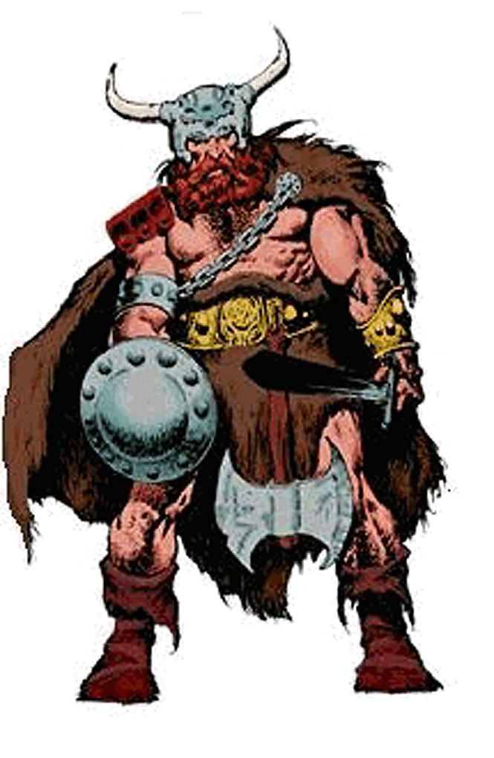
Introduction to Barbarians
Who were these guys and what did they look like?
They were neither the comic book characters nor the Hollywood barbarians.
Initially they were Northern Europeans, Middle Easterners, and North Africans that the ancient Romans were familiar with.
By "early barbarian" we mean those folks that the Romans fought against on
the fringes of the Roman Empire.
When barbarians were coopted into fighting on the side of the Romans the
were deemed to be "foederati", i.e., independent groups "federated" with Rome
If they were conquered or "provincialized" they were deemed to be inside of
and part of "Greater Rome", the empire.
Status of groups was somewhat fluid --
they could slip from one category to another

Ancient Romans called everyone who wasn't them "barbarians"

Etymology of "barbarian":
theory 1 -- Onomatopoeia: foreign languages sounded like "bar-bar-bar"
theory 2 -- facial hair: Latin word for beard was "barba"
theory 3 -- nobody really knows and 1 and 2 are ex post facto guesses
Romans exported Latin and were jingoistic about other languages --
except Greek
Romans were almost always clean-shaven --
except philosophers who were expected to have a beard (that's why
Marcus Aurelius is often shown with a beard that he probably didn’t have.)
Later Romans -- even emperors -- might be barbarian enough for beards
Romans themselves didn't know and debated the origin of the word
"barbarian"
We needn't worry about our Ignorance
So most early barbarians were long-headed caucasoid types or round-headed
Mediterraneans -- By caucasoid here we mean either "caucasian" or "from
the Caucasus region", i.e., slavs.

Later barbarians might be more oriental --
the Huns are sometimes thought of as Chinese
the Goths were pushed into Europe from the TransCaucasus by the Huns
the Lombards were Central Asians

Or they might be from the far north --
The Normans, as their name implies, were "North-" or "Norse-men":
They actually were peripatetic "Vikings" who conquered northern France and then sold their services as freebooters -- later versions were called "Condottieri".
As might be expected, they overthrew their employers.
And that was a well-established pattern.

Before talking about the sequential barbarian "invasions", we need to remind ourselves of several things:

The special case of the Franks -- It's hard to distinguish Franks from "barbarians"
but they usually are looked at differently and separately, maybe as heirs -- perhaps
because of Charlemagne and the founding of the Holy Roman Empire (not holy,
nor Roman, nor even imperial).
We will adhere to the "different/separate" convention.

Barbarian groups (often really just ad hoc confederations)
changed their names due to:
Population movements -- acquiring new place names
Expansion or contraction
Conquering or being conquered
Different names at different times
Different names in different languages
Different versions of "history"
Intentional ideological mislabeling -- as in "enemies" always equal ""
barbarians (of some stripe), and in modern times equal "terrorists"

"Historical" names for the large groups might be names that were applied by
enemies or by later writers/historians. They might not be what the folks
involved called themselves: we may not even know what they called
themselves.

This was already a long standing pattern and it still goes on today: American/English names of peoples, nations, communities, and states may bear little resemblance to what folks call themselves.
Italy/Italia;
Germany/Deutchland;
Switzerland/Helvetzia;
Greece/Hellas;
"Macedonian" claimed by two enemy groups;
Who are the "hilf tahrir falastinii"?;
etc.)

We can swallow all the historical naming variations, keeping in mind that
what is really important is coming to some conclusion about how the
peoples and events affected Medieval Rome (for the sake of this course) and
the end product us. (We'll keep asking that!)

Note also that there is a temporal organization here, but it is based on when the groups had their major interactions with Rome, not when the groups were formed, or had their most exciting events from an "in-group" viewpoint, or when they dissolved.

There will necessarily be loose ends -- there are just too many folks coming from too many directions to talk about everything and everyone. Our topics in this unit will therefore be somewhat illustrative rather than exhaustive. As usual, some of the more bizarre events will be included so that everyone doesn't just go to sleep.

Internal affairs, the predisposition of the Romans at various times and what was going on in Roman politics, often had more influence on their encounters with barbarian invasions than did the actions and strengths of the Barbarians.

Who's on first?????

A timeline/scorecard, even the bits that have little or nothing to do with Rome, using as many names of the teams and players as we can find (to confuse the innocent and conflate the guilty) is on the Internet at: http://www.mmdtkw.org/ALRItkwRom303_2BarbTimelin.html

Barbarian Groups and their Roman Interactions:

Visigoths -- Alaric trashes Rome -- 410 AD
http://www.mmdtkw.org/VAlaric.html
Galla Placida -- a woman with connections
http://www.mmdtkw.org/VGallaPlacida.html

Vandals -- Gaiseric nips off Spain, then N. Africa --
409-429 AD, Plunders Rome -- 455 AD
http://www.newadvent.org/cathen/15268b.htm
http://www.wikipedia.org/wiki/Geiseric
http://www.wikipedia.org/wiki/Vandal

Huns -- Attila dissuaded from attacking Rome by Leo 1 --
450's AD
http://www.mmdtkw.org/VAttila.html
Leo 1:
http://www.newadvent.org/cathen/09154b.htm

Visigoths (Sciri) again -- Odoacer, a mercenary, rules Rome --
476 AD
Romulus Augustulus and Orestes
http://www.mmdtkw.org/VRomulusAug.html
http://www.roman-emperors.org/auggiero.htm

Ostrogoths -- Theodoric boots out Odoacer -- 493 AD
http://www.fordham.edu/halsall/source/jordanes-theodoric1.html
http://historymedren.about.com/library/who/blwwtheogrt.htm
http://www.wikipedia.org/wiki/Ostrogoths
http://www.wikipedia.org/wiki/Theodoric_the_Great
Amalasuntha, Daughter of Theodoric, Regent for Athalric -- 526 AD
http://www.wikipedia.org/wiki/Amalasuntha
http://womenshistory.about.com/cs/medrenqueens/p/amalasuntha.htm

Lombards -- Alboin takes most of Italy -- 568-570
Lombards hold it for two centuries
http://www.boglewood.com/timeline/alboin.html
http://www.wikipedia.org/wiki/Alboin
The Movie:
http://www.cinemedioevo.net/Film/cine_rosmunda_alboino.htm
http://www.cinema-shop.com/Filme/Adventure/X_Plakate/alboin_11.jpg
http://www.imdb.com/title/tt0056427/

Franks -- Merovingians and Carolingians -- "protectors" not
barbarians -- 8th, early 9th century
See Unit 6

Saracens -- Pirates become occupiers -- 9th Century
http://www.ccel.org/g/gibbon/decline/volume2/chap52.htm Gibbon, east, chapter 52
http://www.ccel.org/g/gibbon/decline/volume2/chap56.htm Gibbon, east, chapter 56
http://www.bbc.co.uk/dna/h2g2/alabaster/A275492 Gibralter
http://www.angelfire.com/md/8/moors.html Many images
http://the-tech.mit.edu/Shakespeare/othello/index.html Othello
http://the-tech.mit.edu/Shakespeare/ All Shakepeare's plays

Normans -- Robert Guiscard -- expels Saracens, saves
then sacks Rome -- mid-11th century
http://www.roangelo.net/valente/conquest.html

Summing up:
Waves of "barbarians", all seeking the better life of southern Europe, brought new ideas into this "desirable" area. For the most part the barbarians wanted to preserve (for themselves) rather than to destroy the system in place.

The greener pastures and better organization that they sought in western and southern Europe were real, and by the end of the period of "invasions" everyone was much better off than ever before -- except, perhaps for the very thin veneer that had constituted the Ancient Roman ruling class. Remember that most of Ancient Rome's population was slave or downtrodden workers and that the "high culture" of the ancient civilization belonged only to a few.

And Medieval "culture" was more civilized than the Ancient Rome, which, by end, was chaotic, riven by civil wars and disputes, engorged and fascinated with human blood-sports, wrong (even evil) in so many ways. (Think about how few of us would have any chance of being what we are today in an "Imperial Roman" civilization.)

There were several reasons for this -- Christianity, removal of several layers of the ruling class to Constantinople, better land use, immunities to known diseases, etc. -- but not least among them were the new blood and ideas and more egalitarian social and legal organizations that arrived with the barbarians.

But then in the 13th/14th centuries, things came crashing down, first due to economic setbacks -- too many people and overcropped land led to food crises -- and then came the plagues with the opportunities that followed. More about that in unit 10.

Unit 3
Gregory and Other Christians
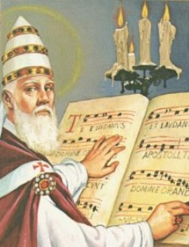

Many, perhaps most, historians give Pope Gregory I, "The Great", the crown as the most important Christian influence in Medieval times.
Some make him the dividing point between "Late Roman" and Medieval

They all may well be right, but there were others before and after him that deserve
some credit.

After Gregory, many of the same historians place Leo I, and not only because he talked Attila out of a jaunt into Rome (with or without the help of sword-bearing Peter and Paul).
He took actions that implied and explicitly claimed papal primacy.

Working with the Emperor, he exerted papal temporal authority.

Clearly we can't deal with all the relevant Christian players
As with the Barbarian groups, we'll pick a few persons who were particularly
influential:
Not movers and SHAKERS, but movers and SHAPERS -- i.e., the "orthodox"
(winners) not the heretics

Among those discussed below are the four great "Latin Fathers of the Church":
Abrose, Jerome, Augustine, and Gregory 1. The four great "Greek Fathers",
Athanasius, Basil (The Great), Gregory of Nyssa, and John Chrysostom are
not included, because it would be hard to include them an a "Rome" course.
The study of the lives and works of the "Fathers", great and small, is called
"Patristics".

Note that any one of the persons chosen could be the subject of a lifetime of study.
Don't expect more than a brief (and dogmatic) precis here.

Christian players:
PETER and PAUL -- before our period, but definitive
Was peter in Rome?
He probably was, although still a few Protestant objections
Many 19th century doubters
Paul's time in Rome is better documented
"Postmarks" on his letters
Addresses of his letters
Contents of his letters
Icons/personifications of the two Christian communities;
The Circumcised -- i.e., "converted" Jews
The Gentiles -- Latin gentilis from gens, gentis
[Goy, -im: TRILITERAL: gwy. DEFINITION: (Central Semitic noun *gy-) tribe. Goy, from Hebrew gôy, nation people (usually, and later exclusively, of non-Israelite, and then non-Jewish]

DAMASUS (3??- 383) -- Pope from 366-383, commissioned Jerome
Had to overcome the first known "anti-Pope" (Ursinus), and was
accused of being worldly (even adultery), criminal (murder), ridden with
peccadilloes.

But he commissioned Jerome's Vulgate,
set a calligrapher to work engraving epigrams in tombs and catacombs, and
embellished and enriched churches.

First known Bishop of Rome to invoke the "Petrine text" -- (Mathew 16:18--"thou
art Peter and upon this Rock I build my Church").

AMBROSE (339-397) -- Bishop of Imperial Milan, unbendingly Orthodox, humiliated
Theodosius, music man, converted Augustine

[Note 1: During his Tenure, the Western Empire court settled in Milan (Gratian,
then Valentinian 2)].

[Note 2: Arianism, the first of the great "heresies", defined Christ (according to
its "orthodox" enemies) as a second, inferior god standing midway between the
"First Cause" and creatures. The Council of Nicea condemned Arianism and the
Nicene Creed is the expression of the "orthodox" and what became the
"Catholic" view.

Ambrose defined differences between Orthodoxy and Arianism -- public relations
and manifestations prevented imperial (Valentinian) efforts to allow/order debate
between the two streams.

Ambrose was clearly anti-liberal -- no reason to debate with Arians -- and even
argued that violence was justified in defense of faith.

Some writings were clearly "anti-Semitic": this was many centuries before the
Church announced (at Vatican 2, 1962-65) that what the Gospels clearly said
about responsibility of Jews for Christ's death was not what they meant. [Keep in
mind that this issue is still current: Mel Gibson's movie on the life of Christ is said
to, once again, blame the Jews.]

Dispute between Ambrose and Theodosius (Eastern Emperor, appointed by
Gratian). Although Theodosius was clearly a supporter of Ambrose's anti-Arian
crusade, they fell out over Theodosius' punitive executions of Thessolonica
rioters. Ambrose demanded and got public penitence.

Anticipated and directly influenced Augustine in many respects. Augustine had
gone to Milan and, according to his own account, was overcome by Ambrosian
music.

Great literary and musical achievements.

JEROME (340-420) -- "Cardinal", lion-tamer, historian, polemicist, biblical
translator/popularizer, biblical commentator, Latin, Greek, and "Hebrew"
(Semitic) linguist, ran a "research institute" in Bethlehem. Sponsored by
Damasus and funded by Paula.

Studied "classical" literature and wrote histories before imbibing the scriptures.

Early contact with Antioch's Jewish Christians (? First study of Hebrew?)

In Rome (ca 382) came under influence of Damasus and became an influential
Papal staffer. Started to revise the Latin bible based on Greek texts. Surrounded
by Pus Roman women, including Paula. When Damasus died (Dec 10, 384 -- but
note vagaries of pre-Gregorian dates), the "irascible", polemical and critical
Jerome (he'd derided Ambrose, for example) decamped again for the Middle
East, taking with him his coterie of Roman women. (Never any accusation of sin -
unlike his theretofore patron, Damasus).

The Bethlehem "research institute" -- by 338 they and some Antiochenes picked
up en route were ensconced in Bethlehem. Thirty-four years of literary output
from his hermit's cell (traditionally in a cave under the courtyard of the current
Latin Church of St. Catherine, adjacent to the Greek Orthodox Church of the
Nativity)

Most important product was the Vulgate -- not the first Latin translation, but it
was the first Latin translation using Semitic language sources as well as Greek.
Therefore considered more authentic. His biblical commentaries (i.e.,
exegetical treatises) also benefited from his knowledge of Hebrew. Note that
Jerome’s “Latin” was the simple inelegant contemporary (i.e., vulgar) language and
not the Latin of Cicero, which was later canonized by “Ciceronian” renaissance
humanists.

He’s one of the most depicted of all Christian Saints

AUGUSTINE (354-430) of Hippo (see note below on Hippo location) -- penitent playboy,
Teacher, bishop, Christian theoretician

Academic advancement in N. African Universities after an impoverished middle
class upbringing (a "scholarship" from a wealthy family friend made it possible).
Early on, he was an academic pedant and imitator of Cicero's style

"Looking for himself" he first became a Manichaeian (Manichaeians believed in
two competing powers, the perfectly good creator and the absolutely evil
destroyer) but soon saw through the mythology and was affronted by the
ignorance of Manichee teachers. Drifted back home, but soon headed back to
Carthage seeking new inspiration.

Augustine prospered there as an itinerant teacher but soon sought a bigger
market -- Rome. Jerome used Manichee contacts to get an interview from
Roman Prefect Symmachus, who hired him as a teacher for the Imperial Court in
Milan. Rapid advancement there and an society marriage arranged by his mom.

Still unhappy, perplexed, (maybe a depressive?), started to study Christianity:
eventually converted by Ambrose (-- he was "transfixed" by Ambrose's music.)

After conversion, recognizing the hollowness of temporal advancement,
Augustine and his companions returned to N. Africa seeking a quiet
contemplative life.

Soon "drafted" into the priesthood, then into a bishopric. Most of his efforts were
on local pastoral matters, but he intervened in three big controversies.
Donatism, which demanded rebaptism of those who had compromise
under persecution. Augustine initially tried to talk the Donatists around ,
but when they refused, he organized Imperial intervention, which after long
hearings suppressed the Donatists. Principle: sinners don't need
reconversion

The Cause of the fall of Rome (to Alaric) and the City of God: after the
sack, some upper class pagan Romans retired to N. African estates,
bringing with them the theory that neglect of the old Roman gods (i.e., rise
of Christianity) had caused the fall. Early books of The City offered
consolation and refuted that theory. Later volumes issued over 15 years
eloquently and elegantly continued to expound on Christian principles.

Pelagians who advocated asceticism at a level that Augustine thought was
extreme. Augustine eventually invoked papal and imperial authority and
won the day, but he then had to constantly defend the level of asceticism of
which he himself approved.

The mortal decline of Augustine coincided with the arrival of the Vandals in North
Africa, their having been invited by a local Roman governor seeking allies in
rebellion. They inevitably evaded the governor's control and took over. They Took
over Hippo a few days after his death and Carthage fell shortly thereafter.

The Vandals were Arians, so, locally, at least for the hundred -year tenure
of the Vandals, Augustine's efforts were for naught. On the broader and
especially on the Roman stage, his works, especially The City of God had
great influence.

LEO 1, "The Great" (4??-461) -- Pope, barbarian tamer, "2nd to Gregory"

Leo's pontificate, next to that of St. Gregory I, is the most significant and
important in Christian antiquity. At a time when the Church was experiencing the
greatest obstacles to her progress in consequence of the hastening
disintegration of the Western Empire, while the Orient was profoundly agitated
over dogmatic controversies, this great pope, with far-seeing sagacity and
powerful hand, guided the destiny of the Roman and Universal Church.
Catholic Encyclopedia

A formidable writer as a deacon under Celestine 1 (422-32), he was a problem-
solver/diplomat for Sixtus 3 (432-40). In Gaul on a mission when Sixtus 3 died, he
was elected in absentia.

As Pope, Leo led the charge against Pelagian and Manichaeian heresies.
(Pelagians had originated in Rome and Manichees had fled to Rome when the
Vandals had taken North Africa.)

Leo sought out ways to interfere in extra-Roman, extra-Italian affairs, sending out
"warnings" to external dioceses about heresies and intervening in disputes
between rival claimants to bishoprics.

"Disciplinary decrees" were designed to enforce uniformity of rules and liturgies.

BOETHIUS (480-524) "The last of the Romans" -- Mathematician/scientist/musical
theorist, philosopher, Medieval and Renaissance role model,

[Note: at this time Christianity was divided between Arians and "orthodox", the
latter group claiming that designation ex post facto to the appearance of the
Arians. These "orthodox" have nothing to do with the "Orthodox" (upper case
"O") Greek Christians who appeared later.]

Boethius was clearly the best educated Roman of his day

Student, translator, and commentator of an on Neoplatonism, began a project to
translate and interpret all works of Plato and Aristotle, a project cut short by his
death.

Office Director (Magister Officiorum) for Theodoric, the Ostrogothic king of Italy,
for whom he also performed diplomatic missions.

Jealous enemies accused him of treason and of sacrilegious astrology and, most
importantly of being an orthodox Catholic. Since Theodoric was and Arian and
the Eastern Emperor (Justin) was orthodox, this was clearly the most dangerous
charge.

Boethius was eventually executed after an imprisonment during which he wrote
his most important philosophical work, Consolations of Philosophy. The
orthodox (lower case) church immediately claimed him as a martyr even though
his Consolations give no real indication that he was even a Christian -- the Church
still gives some labored arguments that the Consolations were orthodox, but it's
a long stretch, and it certainly has always been in the interest of the Church to
claim "the last Roman" as her own.

After his death and through the Medieval and Renaissance periods, Boethius was
held up as an educated Christian role model for Christians/Catholics.

Boethius was one of the main sources of material for the quadrivium, an
educational course introduced into monasteries consisting of four topics:
arithmetic, geometry, astronomy, and the theory of music. On this last topic
Boethius wrote on the relation of music to science, suggesting that the pitch of a
note one hears is related to the frequency of sound. (Vincenzo Galilei, the father of
the famous Galileo Galilei. did the definitive work on musical mathematics,
harmonics, string tensions and frequencies, ca. 1588.)

BENEDICT (ca480-ca547) -- "Monk" (=a singlton fr. Gr. monos),
Western Christian monastic founder

Not the founder of Christian Monasticism, but of Western Christian Monasticism.
There were Christian monasteries in the Middle East almost from the beginning
as pre-existing Jewish monasteries converted.

Didn't set out to be a hermit -- took his old nurse along as a maidservant when he
left Rome and joined a company of "virtuous men" at Enfide -- supposed site of
his first miracle, mending a broken earthenware wheat sifter. Notoriety of the
event caused him to seek a more remote retreat at Subaico (nurse still went
along). He spent three years in the cave helped by a local monk named
Romanus. Eventually called out by monks to replace a local abbot who had died.

The monks eventually tried to poison him -- he was more strict than they had
bargained for. Benedict went back to his cave.

Miracles then came fast and thick, and eventually 13 Monasteries grew up
around him. Schools and homes for children followed.

Benedict set up a lay Rule, but the Church later imposed a clerical character on
the Benedictines.

The only "authentic" biography of Benedict was written by Gregory The Great
and comprises 38 chapters of the second volume of Gregory's Dialogues.

GREGORY 1, "The Great" (540-604) -- the watershed, first Medieval Christian

[Note: the "Exarch" (= "outside ruler") was the chief local administrator for the
Eastern Emperor, who was nominal ruler of Italy -- kind of a viceroy, but with
more closely defined powers (limited rather than general power or regency). De
facto the exarchs' powers were even more limited by circumstance than by the
Emperors directives. Unit 4 is about these guys and how and when they could
wield power.]

By about age 33 (in 573) he was already "Prefect" of the city of Rome -- de facto
mayor -- unusual advancement for a person of that age
But he had family connections: probably of gens Amicia, with a large villa
on the Caelian Hill, ruins of which are under the Church of Gregorio Magno.

Little known of his mother Silvia, except that she also came from wealth.

In 574, he dropped out and became a monk -- presumably a Benedictine, since he
wrote a biography of Benedict.

Family estates in Sicily were given over to found 6 monasteries. Caelian villa
converted into the Monastery of St. Andrew. Debate over whether the
Monasteries were Benedictine is only important in that the outcome would
determine what kind of monasticism Augustine of Canterbury introduced into
England.

Drawn out of austere life in 578 and appointed "regionary " deacon. Then sent to
Constantinople/Byzantium as the Pope's Ambassador in the hopes he could get
imperial help (Tiberius 2 Constantine, 578-82) against the advancing Lombards.

Famous dispute with Patriarch Eutychius over "palpability" of risen bodies of the
Elect while in Comstantinople -- and no help against Lombards. Lesson was that
Rome had to save itself.

Back to St. Andrew's by 586 -- writing and lecturing.

Exact date unknown -- meets Angles in the Forum and petitions the Pope for a
missionary assignment in England. According to legend he actually set out, but
was called by popular demand. (He eventually sent Augustine.)

Elected pope in 590 after an anno nero -- plagues, floods, famines, wars, dead
Pope. Gregory tried to beg off. During the wait for an imperial decision, in the
face of ongoing plague in the city and surrounding areas he organized the
"sevenfold procession" (seven regionary deacons) during which the eponymous
angel appeared over Hadrian's mausoleum/Castel Sant'Angelo.

The Emperor finally decided to confirm Gregory's appointment, against his
wishes. Stories that he fled and hid were later inventions.

There followed 14 years as Pope -- but he still lived as a monk in the Lateran after
dismissing all the lay attendants and pages and staffing the place with clerics.

Despite ill health, he worked tirelessly (c.f., current Pope) organizing the defense
of Rome against the Lombards, provisioning Rome from his former Cicilian
estates, reorganizing the liturgy (extent of which is debated), establishing weekly
"station churches" to bring the Papacy to the people , managing the churches
vast and widely separated estates, arguing with the (Arian) Lombards -- in short
he was a general manager: a COO rather than a CEO.

Actual hostilities between the Western Emperor and the Lombards began in 592.
Noting the exarch's inaction after a few Papal diplomatic moves, Gregory made a
separate peace with the Lombards, details of which are unknown. But the fact of
the existence of a treaty was thereafter an argument for sovereign Papal
temporal power.

That position, in turn roused the exarch who came roaring back into Rome, only
to leave with his garrison a year later. Rome was now again exposed to the re-
aroused northern Lombards who came back to the gates of Rome. There was a
meeting between Gregory and the northern leader, and Gregory later wrote that
he had been "paymaster to the Lombards": he presumably bought them off with
cash (and thereby allowed them to re-equip/re-arm to face their perceived
secular rival, the Eastern Emperor and his exarch.)

Gregory also established relations with the emerging Franks, but they lapsed at
his death and there was no lasting effect -- yet

“Bad” Popes – 9th 12th centuries – Until the “Avignon captivity” (1309 – 77)

One of several periods of internal strife that the Catholic Church characterizes as periods during which political actors imposed themselves on control of the Church

Essentially, the church is right, but it begs the question of just what the Church is – Is it only responsible for its acts when it conforms to later views of “morality”.

Period from 900 to 1000 is indicative.

Background: Charlemagne’s kids and grandkids had torn apart the Carolingian “Holy Roma Empire and the scuffles among their heirs continued for centuries – East, Middle, and West Carolingians became Germany, Lotharingia/Italy, and France. There were still Visigothic remnants in Spain.

In the cracks between these states, especially around Rome, local families allied with the contending Carolingian successor states.

End of 800s –

Formosus was Pope from 891 – 896. He had conections in both the “French” and “German” wings fo the Carolingian successors, but as Cardinal, he fled a French supporter – He may initially have been pro-French, and that could have made him a rival of the pro-French incumbent.

Formosus died of a stroke and his successor, Boniface 6, reigned 15 days.

Steven 7 exhumed, condemned, desecrated Formosus.

900s

Successive popes in the 900s rehabilitated and re-desecrated Formosus as power shifted among the contending external powers. For a while, he was the bellwether of which wy the flock was moving.

Not just an “external” problem – local nobles in Rome were working the situation to their own advantage.

In some cases the women were the apparent power brokers.

Theodora was married to Theophylact but apparently in bed with John 10, for whom, I was said, she acquired the Papacy using her husbands influence.

Theodora arranged a marriage between her daughter, Marozia, and Alberic (elder).

When Theodora and Theophylact died (ca. 928) Marozia had John 10 imprisoned and murdered. Marozia had kids with Pope Sergius, and their son became Pope John 11.

Alberic died and Marozia married his half brother, King Hugo of Provence – her bastard son, John 11 officiating.

Her son by Alberic, another Alberic, worried that he was about to be killed and appealed to the Roman mob. He imprisoned his half brother (John 11) and Marozia, the latter being kept in Castel Sant’Angelo for 50 years.

It goes on and on – read all about it in the Papal biographies.

The “German” – “French” rivalry goes on into the 20th century (and probably beyond, after they get over their current “anti-US” axis.)

The Church’s problem in dealing with this stuff:

The church doesn’t want to condone what went on in the Papacy at this time, but it does want to claim all of these “bad popes” or “imposed” popes to establish the “unbroken succession” from Peter (the foundation Rock) and the popes in power at the time of the Protestant Reformation.

Pope Joan: the Papessa who never was

Supposedly in the 800’s but doesn’t appear in legend until centuries later.

May well be a later distortion, witting or unwitting, of the whole Theodora/Marozia balagan

Suppoesedly she masqueraded as a man/monk to be with her monkish lover who eventually went to Rome accompanied by her. When he died, she blossomed into a learned scholar and then was made Pope. She delivered her lover’s child in her inaugural procession to the Lateran Palace – there’s a street nearby called Via Papessa – and was exposed. Etc.

THOMAS AQUINAS (1224-1274) -- philosopher, logician, reasoner (from Latin: rationor)
[Note: Persons previously discussed were on our list mostly because of how
the affected the period under discussion. Thomas', coming as he did nearer to
the end of the period, had his influence in later -- much later -- periods, and mostly
in the last hundred or so years. The cause of this was the decline, in the years
following his lifetime, in recourse to reason. Many modern theorists ascribe this
decline to the die-off of thinkers in the famines and plagues that swept Italy and
the rest of Europe starting at about the time of his death.]

Coming as he did from a large, rich, and noble family (youngest son of the Duke of
Aquino), Thomas had great education opportunities. At age 5 he was sent off to
the Benedictine Monastery at Monte Casino to be educated for a career in the
Church.

Stories that he was a slow learner simply are not true. At 14 he was sent to the
University of Naples where he excelled, studying in particular the newly
rediscovered works of Aristotle. Thomas became a logician.

At about age 19, he joined the Dominicans (OFP = Order of Friars Preachers).
Displeased by his choice -- not wanting a Monk, and especially an "inferior" one --
his family kidnapped him and tried to "de-program" him, going so far as
introducing a prostitute to his prison cell. Finally giving up, the family released
him and he took the Dominican Friars' vows.

He quickly left for the University of Paris where he studied under Albertus
Magnus. When Albertus transferred to Cologne, Thomas followed. Other
students of Albertus nicknamed him "Dumb Ox" because he spoke little and was
very large. Albertus declared that the Ox's bellows would be heard around the
world. In Cologne, probably around 1250 he was ordained as a pries.

Within a few years he was back in Paris lecturing at the University and working
on his own Doctorate in Theology. His degree (and degrees of other clerics) was
delayed when University administrators objected to his (their) unwillingness to
participate in street battles between the University and the "townies." Both
Papal and French Royal (Louis 9) interventions were needed to release the
degrees.

From 1257 though 1273 he produced over 50 major philosophical , theological,
and Aristotelian and scriptural exegetical works, meanwhile also actively
preaching and teaching. Among the written works was the Summa Theologica,
from the time of the Counter Reformation until now has been the major source of
Catholic theology.

Thomas was, above all, a supporter of "reason" as opposed to "faith" as a
method of philosophy and theology. Shortly after his death, circumstances (as
noted above) led the Church away from reason and toward faith -- and mostly of
the ecstatic variety.
Other circumstances led to the Protestant Reformation and the Church
responded by favoring a new "preaching order", the Jesuits, who
immediately seized on "Thomistic Philosophy" -- logical reasoning -- to
counter the Protestant emphasis on salvation through "faith".

CATHERINE OF SIENA (1347-1380) Mystic, Ascetic, Anorexic

Finally, a woman crosses the stage. Unfortunately, she represents the rise of
unreason in the Church and in Medieval society. It was mostly women who had
the ecstatic experiences that were so popular in the disastrous 14th and 15th
centuries, but remember, that Francis of Assisi was an early participant in the
previous century. Francis will be covered in unit 5 on the survey of monasticism.

[Note 1: Among other things she is the Patron Saint of persons ridiculed for their
faith -- a sign that since the beginning she has been derided for her claims of
intercourse" with Christ. Many modern psychologists see her ecstasies as a
result of long fasts, and some have diagnosed her as an end-stage anorexic --
i.e., someone to be pitied rather than ridiculed.]

[Note 2: Some modern editions of her works are "condensed" or sometimes
simply Bowdlerized to remove sections that are much too sensual and sexual for
a "religious" context: Catherine's descriptions of her ecstatic encounters with
Christ are explicit and livid.]

[Note 3: Catherine was born the year before the "Black Death" plague swept
through Italy. An economic depression, caused by over population and agricultural
soil exhaustion was already under way. In January of 1348 plague entered Italy
through Genoa and it reached Siena the following month. May 1348 as the month
of highest mortality in Siena, and, according to contemporary reports more than
half of the city's population was dead within one year. Social order rapidly broke
down leading to tradesmen's and agrarian revolutions, and the mental state of
the survivors was understandably fragile. In the early 1360s plague swept
Europe again: the pestis secunda or pestis puerorum took out the younger
generation who had not acquired immunity by surviving the first pandemic.
More on the plague(s) in unit 10.]

Catherine was the last or 23rd of 25 children of Giacomo and Lapa Benincasa,
members of the "Party of the Twelve", a lower middle-class group that took over
Siena between 1355 and 1368 between revolutions (i.e., when Catherine was
already in her nunnery.)

Visions and austerities were said to have begun in her childhood (age 7?). At age
16 she entered a Dominican nunnery and continued to have visions and ecstatic
experiences, including "spiritual espousals".

About 1366 she left the convent and began to work with the sick -- especially
victims and survivors of the plague (pestis secunda).

Thereafter, she was reportedly "persecuted" by her former Dominican sisters
and brothers who doubted the reality of her claims. Soon a small community of
disciples, men and women, began to agregate around her and her popularity
increased.

In summer of 1370 another series of visions and ecstasies culminated in a
"command" to enter public life. In a short time she was meeting with and
corresponding with the civil and religious aristocracy.

In 1375 she received the "secret" stigmata -- i.e., no outward signs while she
lived. The marks were visible on her body only after she died.

Like a modern politician, she seemed to turn up at every local and national crisis.

She died, as might be expected, at a very young age during one of he long and
rigorous fasts.

Donation of Constantine (Lat., Donatio Constantini).
Although it was already known that the donation was a forgery (see below), Lorenzo Valla is usually given credit for producing, in 1440, the definitive proof that it was a fake. For an English translation of Valla's full text (with a translation of the "Donation") see: http://history.hanover.edu/texts/vallatc.html

From the Catholic Encyclopedia: http://www.newadvent.org/cathen/05118a.htm
By this name is understood, since the end of the Middle Ages, a forged document of Emperor Constantine the Great, by which large privileges and rich possessions were conferred on the pope and the Roman Church. In the oldest known (ninth century) manuscript (Bibliothèque Nationale, Paris, MS. Latin 2777) and in many other manuscripts the document bears the title: "Constitutum domni Constantini imperatoris". It is addressed by Constantine to Pope Sylvester I (314-35) and consists of two parts. In the first (entitled "Confessio") the emperor relates how he was instructed in the Christian Faith by Sylvester, makes a full profession of faith, and tells of his baptism in Rome by that pope, and how he was thereby cured of leprosy. In the second part (the "Donatio") Constantine is made to confer on Sylvester and his successors the following privileges and possessions: the pope, as successor of St. Peter, has the primacy over the four Patriarchs of Antioch, Alexandria, Constantinople, and Jerusalem, also over all the bishops in the world. The Lateran basilica at Rome, built by Constantine, shall surpass all churches as their head, similarly the churches of St. Peter and St. Paul shall be endowed with rich possessions. The chief Roman ecclesiastics (clerici cadinales), among whom senators may also be received, shall obtain the same honours and distinctions as the senators. Like the emperor the Roman Church shall have as functionaries cubicularii, ostiarii, and excubitores. The pope shall enjoy the same honorary rights as the emperor, among them the right to wear an imperial crown, a purple cloak and tunic, and in general all imperial insignia or signs of distinction; but as Sylvester refused to put on his head a golden crown, the emperor invested him with the high white cap (phrygium). Constantine, the document continues, rendered to the pope the service of a strator, i.e. he led the horse upon which the pope rode. Moreover, the emperor makes a present to the pope and his successors of the Lateran palace, of Rome and the provinces, districts, and towns of Italy and all the Western regions (tam palatium nostrum, ut prelatum est, quamque Romæ urbis et omnes Italiæ seu occidentalium regionum provinicas loca et civitates). The document goes on to say that for himself the emperor has established in the East a new capital which bears his name, and thither he removes his government, since it is inconvenient that a secular emperor have power where God has established the residence of the head of the Christian religion. The document concludes with maledictions against all who dare to violate these donations and with the assurance that the emperor has signed them with his own hand and placed them on the tomb of St. Peter.

This document is without doubt a forgery, fabricated somewhere between the years 750 and 850. As early as the fifteenth century its falsity was known and demonstrated. Cardinal Nicholas of Cusa (De Concordantiâ Catholicâ, III, ii, in the Basle ed. of his Opera, 1565, I) spoke of it as a dictamen apocryphum. Some years later (1440) Lorenzo Valla (De falso credita et ementita Constantini donatione declamatio, Mainz, 1518) proved the forgery with certainty. Independently of both his predecessors, Reginald Pecocke, Bishop of Chichester (1450-57), reached a similar conclusion in his work, "The Repressor of over much Blaming of the Clergy", Rolls Series, II, 351-366. Its genuinity was yet occasionally defended, and the document still further used as authentic, until Baronius in his "Annales Ecclesiastici" (ad an. 324) admitted that the "Donatio" was a forgery, whereafter it was soon universally admitted to be such. It is so clearly a fabrication that there is no reason to wonder that, with the revival of historical criticism in the fifteenth century, the true character of the document was at once recognized. The forger made use of various authorities, which Grauert and others (see below) have thoroughly investigated. The introduction and the conclusion of the document are imitated from authentic writings of the imperial period, but formulæ of other periods are also utilized. In the "Confession" of faith the doctrine of the Holy Trinity is explained at length, afterwards the Fall of man and the Incarnation of Christ. There are also reminiscences of the decrees of the Iconoclast Synod of Constantinople (754) against the veneration of images. The narrative of the conversion and healing of the emperor is based on the apocryphal Acts of Sylvester (Acta or Gesta Sylvestri), yet all the particulars of the "Donatio" narrative do not appear in the hitherto known texts of that legend. The distinctions conferred on the pope and the cardinals of the Roman Church the forger probably invented and described according to certain contemporary rites and the court ceremonial of the Roman and the Byzantine emperors. The author also used the biographies of the popes in the Liber Pontificalis (q.v.), likewise eighth-century letters of the popes, especially in his account of the imperial donations.

The authorship of this document is still wrapped in obscurity. Occasionally, but without sufficient reason, critics have attributed it to the author of the False Decretals (q.v.) or to some Roman ecclesiastic of the eighth century. On the other hand, the time and place of its composition have lately been thoroughly studied by numerous investigators (especially Germans), though no sure and universally accepted conclusion has yet been reached. As to the place of the forgery Baronius (Annales, ad. an. 1081) maintained that it was done in the East by a schismatic Greek; it is, indeed, found in Greek canonical collections. Natalis Alexander opposed this view, and it is no longer held by any recent historian. Many of the recent critical students of the document locate its composition at Rome and attribute the forgery to an ecclesiastic, their chief argument being an intrinsic one: this false document was composed in favour of the popes and of the Roman Church, therefore Rome itself must have had the chief interest in a forgery executed for a purpose so clearly expressed. Moreover, the sources of the document are chiefly Roman. Nevertheless, the earlier view of Zaccaria and others that the forgery originated in the Frankish Empire has quite recently been ably defended by Hergenröther and Grauert (see below). They call attention to the fact that the "Donatio" appears first in Frankish collections, i.e. in the False Decretals and in the above-mentioned St-Denis manuscript; moreover the earliest certain quotation of it is by Frankish authors in the second half of the ninth century. Finally, this document was never used in the papal chancery until the middle of the eleventh century, nor in general is it referred to in Roman sources until the time of Otto III (983-1002, i.e. in case the famous "Diploma" of this emperor be authentic). The first certain use of it at Rome was by Leo IX in 1054, and it is to be noted that this pope was by birth and training a German, not an Italian. The writers mentioned have shown that the chief aim of the forgery was to prove the justice of the translatio imperii to the Franks, i.e. the transfer of the imperial title at the coronation of Charlemagne in 800; the forgery was, therefore, important mainly for the Frankish Empire. This view is rightly tenable against the opinion of the majority that this forgery originated at Rome.

A still greater divergency of opinion reigns as to the time of its composition. Some have asserted (more recently Martens, Friedrich, and Bayet) that each of its two parts was fabricated at different times. Martens holds that the author executed his forgery at brief intervals; that the "Constitutum" originated after 800 in connection with a letter of Adrian I (778) to Charlemagne wherein the pope acknowledged the imperial position to which the Frankish king by his own efforts and fortune had attained. Friedrich (see below), on the contrary, attempts to prove that the "Constitutum" was composed of two really distinct parts. The gist of the first part, the so-called "Confessio", appeared between 638 and 653, probably 638-641, while the second, or "Donatio" proper, was written in the reign of Stephen II, between 752 and 757, by Paul, brother and successor of Pope Stephen. According to Bayet the first part of the document was composed in the time of Paul I (757-767); the latter part appeared in or about the year 774. In opposition to these opinions most historians maintain that the document was written at the same time and wholly by one author. But when was it written? Colombier decides for the reign of Pope Conon (686-687), Genelin for the beginning of the eighth century (before 728). But neither of these views is supported by sufficient reasons, and both are certainly untenable. Most investigators accept as the earliest possible date the pontificate of Stephen II (752-757), thus establishing a connection between the forgery and the historical events that led to the origin of the States of the Church and the Western Empire of the Frankish kings. But in what year of period from the above-mentioned pontificate of Stephen II until the reception of the "Constitutum" in the collection of the False Decretals (c. 840-50) was the forgery executed? Nearly every student of this intricate question maintains his own distinct view. It is necessary first to answer a preliminary question: Did Pope Adrian I in his letter to Charlemagne of the year 778 (Codex Carolinus, ed. Jaffé Ep. lxi) exhibit a knowledge of the "Constitutum"? From a passage of this letter (Sicut temporibus beati Silvestri Romani pontificis a sanctæ recordationis piisimo Constantino magno imperatore per eius largitatem sancta Dei Catholica et Apostolica Romana ecclesia elevata et exaltata est et potestatem in his Hesperiæ partibus largiri dignatus, ita et in his vestris felicissimis temporibus atque nostris sancta Dei ecclesia, id est beati Petri apostoli, germinet atque exultet. . . .) several writers, e.g. Döllinger, Langen, Meyer, and others have concluded that Adrian I was then aware of this forgery, so that it must have appeared before 778. Friedrich assumes in Adrian I a knowledge of the "Constitutum" from his letter to Emperor Constantine VI written in 785 (Mansi, Concil. Coll., XII, 1056). Most historians, however, rightly refrain from asserting that Adrian I made use of this document; from his letters, therefore, the time of its origin cannot be deduced.

Most of the recent writers on the subject assume the origin of the "Donatio" between 752 and 795. Among them, some decide for the pontificate of Stephen II (752-757) on the hypothesis that the author of the forgery wished to substantiate thereby the claims of this pope in his negotiations with Pepin (Döllinger, Hauck, Friedrich, Böhmer). Others lower the date of the forgery to the time of Paul I (757-767), and base their opinion on the political events in Italy under this pope, or on the fact that he had a special veneration for St. Sylvester, and that the "Donatio" had especially in view the honour of this saint (Scheffer-Boichorst, Mayer). Others again locate its origin in the pontificate of Adrian I (772-795), on the hypothesis that this pope hoped thereby to extend the secular authority of the Roman Church over a great part of Italy and to create in this way a powerful ecclesiastical State under papal government (Langen, Loening). A smaller group of writers, however, remove the forgery to some date after 800, i.e. after the coronation of Charlemagne as emperor. Among these, Martens and Weiland assign the document to the last years of the reign of Charlemagne, or the first years of Louis the Pious, i.e. somewhere between 800 and 840. They argue that the chief purpose of the forgery was to bestow on the Western ruler the imperial power, or that the "Constitutum" was meant to indicate what the new emperor, as successor of Constantine the Great, might have conferred on the Roman Church. Those writers also who seek the forger in the Frankish Empire maintain that the document was written in the ninth century, e.g. especially Hergenröther and Grauert. The latter opines that the "Constitutum" originated in the monastery of St-Denis, at Paris, shortly before or about the same time as the False Decretals, i.e. between 840 and 850.

Closely connected with the date of the forgery is the other question concerning the primary purpose of the forger of the "Donatio". Here, too, there exists a great variety of opinions. Most of the writers who locate at Rome itself the origin of the forgery maintain that it was intended principally to support the claims of the popes to secular power in Italy; they differ, however, as to the extent of the said claims. According to Döllinger the "Constitutum" was destined to aid in the creation of a united Italy under papal government. Others would limit the papal claims to those districts which Stephen II sought to obtain from Pepin, or to isolated territories which, then or later, the popes desired to acquire. In general, this class of historians seeks to connect the forgery with the historical events and political movements of that time in Italy (Mayer, Langen, Friedrich, Loening, and others). Several of these writers lay more stress on the elevation of the papacy than on the donation of territories. Occasionally it is maintained that the forger sought to secure for the pope a kind of higher secular power, something akin to imperial supremacy as against the Frankish Government, then solidly established in Italy. Again, some of this class limit to Italy the expression occidentalium regionum provincias, but most of them understand it to mean the whole former Western Empire. This is the attitude of Weiland, for whom the chief object of the forgery is the increase of papal power over the imperial, and the establishment of a kind of imperial supremacy of the pope over the whole West. For this reason also he lowers the date of the "Constitutum" no further than the end of the reign of Charlemagne (814). As a matter of fact, however, in this document Sylvester does indeed obtain from Constantine imperial rank and the emblems of imperial dignity, but not the real imperial supremacy. Martens therefore sees in the forgery an effort to elevate the papacy in general; all alleged prerogatives of the pope and of Roman ecclesiastics, all gifts of landed possessions, and rights of secular government are meant to promote and confirm this elevation, and from it all the new Emperor Charlemagne ought to draw practical conclusions for his behaviour in relation to the pope. Scheffer-Boichorst holds a singular opinion, namely that the forger intended primarily the glorification of Sylvester and Constantine, and only in a secondary way a defence of the papal claims to territorial possessions. Grauert, for whom the forger is a Frankish subject, shares the view of Hergenröther, i.e. the forger had in mind a defence of the new Western Empire from the attacks of the Byzantines. Therefore it was highly important for him to establish the legitimacy of the newly founded empire, and this purpose was especially aided by all that the document alleges concerning the elevation of the pope. From the foregoing it will be seen that the last word of historical research in this matter still remains to be said. Important questions concerning the sources of the forgery, the place and time of its origin, the tendency of the forger, yet await their solution. New researches will probably pay still greater attention to textual criticism, especially that of the first part or "Confession" of faith.

As far as the evidence at hand permits us to judge, the forged "Constitutum" was first made known in the Frankish Empire. The oldest extant manuscript of it, certainly from the ninth century, was written in the Frankish Empire. In the second half of that century the document is expressly mentioned by three Frankish writers. Ado, Bishop of Vienne, speaks of it in his Chronicle (De sex ætatibus mundi, ad an. 306, in P.L., CXXIII, 92); Æneas, Bishop of Paris, refers to it in defence of the Roman primacy (Adversus Græcos, c. ccix, op. cit., CXXI, 758); Hincmar, Archbishop of Reims, mentions the donation of Rome to the pope by Constantine the Great according to the "Constitutum" (De ordine palatii, c. xiii, op. cit., CXXV, 998). The document obtained wider circulation by its incorporation with the False Decretals (840-850, or more specifically between 847 and 852; Hinschius, Decretales Pseudo-Isidorianæ, Leipzig, 1863, p. 249). At Rome no use was made of the document during the ninth and the tenth centuries, not even amid the conflicts and difficulties of Nicholas I with Constantinople, when it might have served as a welcome argument for the claims of the pope. The first pope who used it in an official act and relied upon, was Leo IX; in a letter of 1054 to Michael Cærularius, Patriarch of Constantinople, he cites the "Donatio" to show that the Holy See possessed both an earthly and a heavenly imperium, the royal priesthood. Thenceforth the "Donatio" acquires more importance and is more frequently used as evidence in the ecclesiastical and political conflicts between the papacy and the secular power. Anselm of Lucca and Cardinal Deusdedit inserted it in their collections of canons. Gratian, it is true, excluded it from his "Decretum", but it was soon added to it as "Palea". The ecclesiastical writers in defence of the papacy during the conflicts of the early part of the twelfth century quoted it as authoritative (Hugo of Fleury, De regiâ potestate et ecclesiasticâ dignitate, II; Placidus of Nonantula, De honore ecclesiæ, cc. lvii, xci, cli; Disputatio vel defensio Paschalis papæ, Honorius Augustodunensis, De summâ gloriæ, c. xvii; cf. Mon. Germ. Hist., Libelli de lite, II, 456, 591, 614, 635; III, 71). St. Peter Damian also relied on it in his writings against the antipope Cadalous of Parma (Disceptatio synodalis, in Libelli de lite, I, 88). Gregory VII himself never quoted this document in his long warfare for ecclesiastical liberty against the secular power. But Urban II made use of it in 1091 to support his claims on the island of Corsica. Later popes (Innocent III, Gregory IX, Innocent IV) took its authority for granted (Innocent III, Sermo de sancto Silvestro, in P.L., CCXVII, 481 sqq.; Raynaldus, Annales, ad an. 1236, n. 24; Potthast, Regesta, no. 11,848), and ecclesiastical writers often adduced its evidence in favour of the papacy. The medieval adversaries of the popes, on the other hand, never denied the validity of this appeal to the pretended donation of Constantine, but endeavoured to show that the legal deductions drawn from it were founded on false interpretations. The authenticity of the document, as already stated, was doubted by no one before the fifteenth century. It was known to the Greeks in the second half of the twelfth century, when it appears in the collection of Theodore Balsamon (1169 sqq.); later on another Greek canonist, Matthæus Blastares (about 1335), admitted it into his collection. It appears also in other Greek works. Moreover, it was highly esteemed in the Greek East. The Greeks claimed, it is well known, for the Bishop of New Rome (Constantinople) the same honorary rights as those enjoyed by the Bishop of Old Rome. By now, by virtue of this document, they claimed for the Byzantine clergy also the privileges and perogatives granted to the pope and the Roman ecclesiastics. In the West, long after its authenticity was disputed in the fifteenth century, its validity was still upheld by the majority of canonists and jurists who continued throughout the sixteenth century to quote it as authentic. And though Baronius and later historians acknowledged it to be a forgery, they endeavoured to marshal other authorities in defence of its content, especially as regards the imperial donations. In later times even this was abandoned, so that now the whole "Constitutum", both in form and content, is rightly considered in all senses a forgery.

Popes and the Church in the Period 900 – 1000 CE

Pope Sergius III
The first pope of the 10th century was Benedict IV (900-03). His successor, Leo V, reigned for just one month when he was seized and imprisoned by a usurper, Cardinal Christopher. Meanwhile Cardinal Sergius who had tried for the papal office some seven years earlier now tried again. His supporters got both Leo and Christopher murdered and their leader became Pope Sergius III in 904.
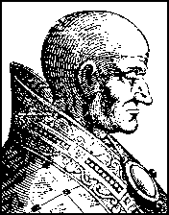
Sergius had taken part in the Synod Horrenda [which had tried and condemned the exhumed body of Pope Formosus – tkw] and one of his first acts as pope was to honour Pope Stephen VII [who had officiated at the Synod] with a handsome epitaph and to overturn the [later] judgement that had re-instated Pope Formosus’ character. In fact, Sergius had Formosus, now ten years dead, re-exhumed and condemned once again. The corpse was then beheaded, three more fingers cut off and thrown into the river Tiber. The headless body was caught in a fisherman’s net and returned a second time to St Peter’s.

Sergius

Theodora & Marozia
At the time one Theophylact was the senator of Rome (and civic head of the city). He had supported Sergius’ party in the battles that followed the Synod Horrenda and the family (wife Theodora and daughters Marozia and Theodora) came to know Sergius well. It is believed that Sergius seduced Marozia in the Lateran Palace and she became his mistress around 905 (the year after he became Pope) when she was 15 and he was 45. She soon had a son by him who was later to become pope. Meanwhile her mother Theodora’s influence had grown and it was her nominees who became the next two popes, Anastasius III and Lando. One of her lovers was reportedly John, Bishop of Bologna. Under her infuence, he rose to become Archbishop of Ravenna. According to a contemporary, Bishop Liudprand of Cremona, she missed John’s absences in Rome. “Thereupon Theodora like a harlot fearing she would have few opportunities of bedding with her sweetheart forced him to give up his bishopric and take for himself - Oh, monstrous crime - the papacy of Rome.” The bishop of Ravenna became Pope John X in 914.

Popes John X and XI
At this time, a northern soldier of fortune, Alberic, bearing the title marquis of Camerino came to Rome. He was a good ally to Theophylact, and Theodora got him married to her daughter Marozia. After the deaths of Theodora and Alberic (both around 928), Marozia had Pope John (her mother’s lover) imprisoned and reportedly suffocated to death. The next two popes, Leo VI and Stephen VIII, reigned for less than a year and three years respectively. Both disappeared mysteriously.

Marozia’s first son (by Pope Sergius) became Pope John XI in 931. She married again and when her second husband died, she married his half-brother King Hugo of Provence, a wedding officiated by her son Pope John XI in 932. Meanwhile her second son called Alberic [II], after his father, was feeling increasingly left out. He came to know that Hugo had planned to render him helpless by blinding him. Alberic appealed to the Romans to rise against Hugo, an outsider. When the Romans responded and got ready for battle, Hugo abandoned his wife and fled.

Alberic put the pope (his half-brother) under permanent arrest in the Lateran Palace and imprisoned his mother Marozia in Hadrian’s mausoleum where she remained for over 50 years [undoubtedly and exaggeration - tkw]. Alberic’s greatest achievement was to strip John XI (and his successors LeoVII, Stephen IX, Marinus II and Agapitus II) of all temporal power. This allowed the popes to concentrate on their spiritual duties and the good effects were felt far and wide. Alberic died in 954 at the age of 40 but not before he had made the nobles swear at the tomb of St Peter that they would make his son Octavian pontiff on the death of Agapitus II.

Pope John XII
And so Octavian became Pope John XII in 955 about the age of 18. He promptly assumed temporal powers, again making the papacy a lucrative position to aspire to. Dormant factions became active and street battles and intrigues became commonplace. John XII became one of the most profligate popes known. He was a great gambler and kept a stud farm of 2000 horses which were fed on almonds and figs soaked in wine. He pilfered pilgrims’ offerings and violated female pilgrims in the basilica of St Peter. He kept a harem at the Lateran Palace and rewarded his paramours with golden chalices taken from St Peter’s and even land. Women were warned not to enter St John Lateran if they prized their honour. King Otto of Germany (936-73) came to John’s aid when Berengar II, king of Italy, occupied the papal states. John made him emperor of the ‘Holy Roman Empire’ in 962.

Otto asked John to mend his ways. Fearing both the wrath of the people of Rome and Otto’s imminent arrival, John fled to Tivoli after plundering the treasury of St Peter’s. Otto promptly called a Synod at which 16 cardinals and numerous bishops were present, in effect to try John. Bishop Liudprand of Cremona read out a list of the pope’s misdeeds: celebrating mass without communion, charging for ordinations, fornicating with numerous women, blinding his spiritual director, castrating a cardinal etc.

King Otto then communicated the decisions of the Synod to John:
“Everyone, clergy as well as laity, accuses you, Holiness, of murder, perjury, sacrilege, incest with your relatives including two sisters and of having invoked Jupiter, Venus and other demons.”

Pope John wrote back promptly.
“To all the Bishops:
We hear that you wish to make another Pope. If you do, I excommunicate you by Almighty God and you have no power to ordain or to celebrate Mass.”

John was warned to return and when he didn’t, he was formally deposed by the Synod and Otto proposed Leo VIII (a German) as the next pope. The Romans were not pleased and John was persuaded to return. Thereupon Leo fled to Germany and was excommunicated. Several of those responsible for deposing him were summarily maimed or executed.

John then resumed his old ways. One night he was caught in bed with another’s wife by the husband. The latter is reported to have taken a hammer and killed him on the spot by smashing the back of his head. John was only about 26 and it was his 8th year as pope.

Successors of John XII
There was a dispute about John’s successor. The Romans chose Benedict V while Emperor Otto who insisted that choice of pope needed his approval preferred Leo VIII, whereupon Benedict knelt at Otto’s feet, stripped off his papal garments and agreed that Leo was the lawful successor. Both Leo and Benedict lasted no more than a year. Otto then selected John XIII as the next pope. The Romans found this pope provoking wars and treating his enemies with extreme cruelty (for example, gouging out their eyes). They packed him off to Germany whereupon Otto sent him back. John XIII remained pope was seven years. He was followed by Benedict VII. Like John XII, he was noted for his sexual excesses and is believed to have died in the act of adultery.

All these years Marozia languished in prison. In 986 when she was in her mid-90s, she was at last released by order of Pope John XV and King Otto III (grandson of Otto I). A bishop exorcised her of any demons she possessed and she was absolved from her sins. She was then executed.

The same Otto III became Holy Roman Emperor in 996 at the age of 16. He went to Rome and appointed his cousin Bruno as Pope Gregory V and when Gregory died in 999 made his former tutor Gerbert pope as Sylvester II, the last pope of the 10th century.

Dark Period of the Papacy
Historians agree that the 10th century was one of the darkest periods of the papacy. Cardinal Baronius, the church historian who wrote Ecclesiastical Annals in the 16th century called the pontiffs of this period: “invaders of the Holy See, less apostles than apostates…vainglorious Messalinas filled with fleshy lusts and all sorts of wickedness governed the Chair of St Peter for their minions and paramours.”

Cardinal Bellarmine of the 17th century was a great defender of the papacy but he considered John XII to be abominable. Nevertheless, he wrote in his book De Romano Pontifice: “The Pope is the supreme judge of faith of morals…If the Pope were to err by imposing sins and forbidding virtues, the church would still have to consider sins as virtues and virtues as vices…”

References:

1. Peter de Rosa, Vicars of Christ, Corgi Books 1994
2. E R Chamberlain, Bad Popes, Barnes & Noble 1993
- History of the Popes, Cheetham, Nicholas, 1992
[Note that the above article and all three of its sources are considered to be “non-academic”, i.e., none of them carry the normally accepted academic “apparatus” that would give them “authority” in academia. Nonetheless, they do give the flavor, if not the exact detail, of what went on in the papacy of the 10th century, during which the office was controlled by local and foreign noble factions. The situation didn’t improve much in the next centuries. – tkw]

Table of 10th Century Popes
(Recognized as Popes 118 - 140 )
(Purported pictures and bio notes for all 22 Popes of the 10th century are at http://www.italycyberguide.com/History/popes/10th.htm)
118) Benedict IV 900-03
119) Leo V 903
120) Sergius III 904-11
# Christopher 903-04
121) Anastasius III 911-12
122) Lando 913-14
123) John X 914-28
124) Leo VIII 928
125) Stephen VIII 928-31
126) John Xl 931-35
127) Leo VII 936-39
128) Stephen IX 939-42
130) Agapitus II 946-55
129) Marinus II 942-46
131) John XII 955-63
132) Leo VIII 963-64
133) Benedict V 964
134) John XIII 965-72
135) Benedict VI 973-74
# Boniface VII 974
136) Benedict VII 974-83
137) John XIV 983-84
138) John XV 985-96
139) Gregory V 996-99
# John XVI 997-98
140) Sylvester II 999-1003
Note: # indicates unrecognized (un-numbered) rival popes

Unit 4 -- The Exarchs and other "Eastern Influences"on Medieval Rome
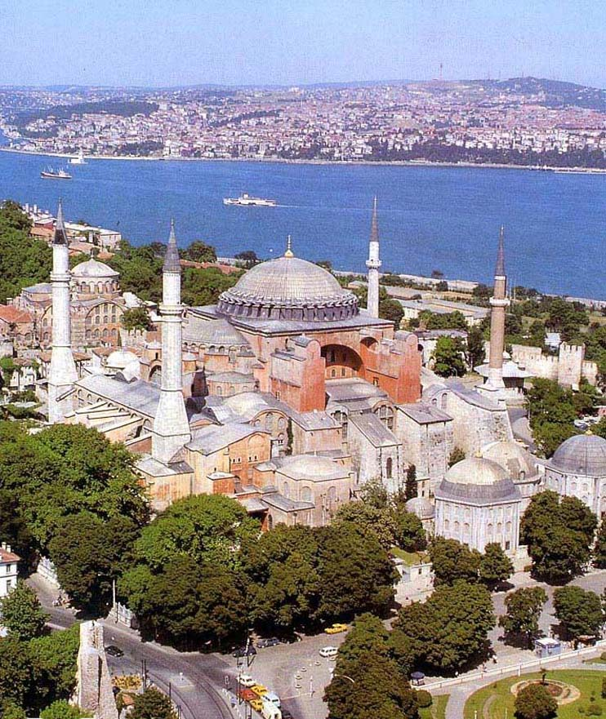
Hagia Sophia -- Istanbul (Constantinople)
The Exarchs and other "Eastern Influences"
on Medieval Rome

"Exarch" in the title of this unit is the bait -- something unfamiliar to pique the interest -- but we won't get to them for a while.

We actually start way before the time of the Exarchs, but before we do, here's the familiar disclaimer: we clearly can't cover everything in this short survey of Eastern influences. Representative people and events will be included, and, along with them, info on where to find fodder for insatiable appetites for more knowledge.

1. Julian the Apostate (331 - 363, Emperor 361 -363)-- if he'd had his way we might all be worshipping Zeus today

He was born in Constantinople in 331, and that's significant -- first "Byzantine" Emperor actually born there.

Son of Julius Constantius, a half-brother of Constantine 1,the Great, and managed to escape the massacre of his branch of the family in Constantinople when Constantine died.

Emperor Constantius immured him in the castle of Macellum in Cappadocia and ensured he had a Christian education, but Julian grew up hating the Christians who murdered his family and, by extension, Christians in General

Julian eventually was allowed to return to Constantinople, but then was sent away again in 350 to Nicomedea where he imbibed neo-Platonism. One of his teachers, Maximus of Ephesus legendarily prophesied that Julian would restore paganism.

Constantius executed Gallus, a step brother of Julian (who had also survived the family massacre), because of Gallus' cruelty as a military commander and sent Julian to Milan as a state prisoner. Empress Eusebia got him permission to travel, and he studied more Greek philosophy in Athens, eventually being initiated three into the Eleusian mysteries.

In 355 Julian was "rehabilitated" and presented to the Army as a "Caesar". He married the Emperor's youngest sister, Helena, and went of to Gaul where he was a very successful soldier and administrator. This once again scared the Emperor, who tried to remove some of Julian's troops. They refused to go and declared Julian Augustus.

Julian sought to accommodate the Emperor but the Emperor demanded unconditional surrender, to which neither the army nor the people would agree. After trouble in the east ended, Constantius turned to confront Julian, but died while on the march. Julian advanced unopposed on Constantinople (361).

Julian now began his anti-Christian campaign, using force to remove Christians from authority, confiscating their property, abrogating grants and benefices, and demanding that payments previously made to churches be returned. Nonetheless, he set up a hierarchical priesthood for the Roman/Greek gods headed by the Pontifex Maximus (himself, naturally) and urged pagans to practice the same virtues that the Christians had preached. Natural disasters, earthquakes and fires, prevented him from carrying out his plan to rebuild the Roman temple in Jerusalem

In 362 he went to Antioch to prepare for yet another war against Persia. While there he wrote his tracts against the Christians. In March 363 the expedition departed and was initially victorious. He advanced too quickly overstretching his supply lines and had to retreat. Persian mounted archers harassed his retreating forces. On June 26 363 he took an arrow in his side and died before sunrise the next day.

Both Christians and Pagans believed the legend that sprung up immediately: Julian's last words were said to have been a cry that the Galilean (Christ) had conquered. This has been read as either a cry of despair or a recantation of his apostasy.

Julian was the last of the Constantinian Dynasty. His good beginnings as an administrator in Gaul didn't last through his career, and when e was the sole authority he was "passionate, arbitrary, and prejudiced, blindly submissive to the rhetoricians and magicians" (Catholic Encyclopedia).

Although no immediate influence -- his attempts to "re-paganize" the empire having failed -- many Western Christians and especially Romans traced their distrust of "the East" on his shoulders. They had already seen the Constantinian Dynasty decamp from Rome taking with it wealth, prestige, and political clout. Now, at the end of the dynasty, and just as the Romans were embracing Christianity, the had the spectacle of Julian's apostasy and attempt a pagan restoration to edify them.

2. Theodosius (346? - 395, Emperor 379 - 395) Goth pacifier, heretic persecutor, Pagan destroyer, dynasty founder

Son of Comes ("Count") Theodosius, later called The Elder, and Thermantia, both "Nicaean" (i.e., non-Arian) Christians. Born in Cauca (now in Spain).

Theodosius (The Younger, later The Great) had an early successful military career, but was forced into retirement after near destruction of his Legio Moesiaca in Valeria province in 374: he and two other local legionary commanders didn't work together to defeat Sarmatian raiders and took high casualties. Theodosius eventually drove back the raiders but was sent home in disgrace. Comes Theodosius was executed shortly thereafte, perhaps for tyring too hard to have his son rehabilitated.

Emperor Gratian (375-383) recalled Theodosius to service as Augustus for the East after the death of Valens (378), but it was his generalship that was really wanted. Theodosius immediately began his defense against Gothic incursions.

By 380, he had pacified the Goths and held his triumph in Constantinople on Nov. 24, 370. But the pacification consisted of settling the Goths inside the Empire to serve as a buffer against other barbarians -- really a very risky strategy. Theodosius, in fact, continued to try to use barbarians against barbarians: there wasn't really much else that he could do. Among his Generals was Stilicho, and among the barbarians under Stilicho's command were Alaric and his Visigoths.

Some modern historians have concluded that Theodosius simply pushed the barbarian problem westward into the other half of the Empire, and some go further conjecturing that he may have done so purposely with the purpose of destabilizing the West.

After a bout of severe illness, Theodosius was baptized early in 380 by the catholic bishop of Thessalonica. He immediately set out on his campaign against Arian heretics. He returned to Constantinople and expelled the Arian bishop and began a genuine persecution. All Arian institutions were forcibly shuttered and those who served them were expelled. Many institutions were turned over to rival catholics. He threatened, but apparently didn't carry out, dire threats of death and torture. Unfortunately, laws he put on the books "to frighten" were used in earnest by later rulers

Similar sanctions against the old pagans were carried out in earnest -- it was during this period that the Serapaeum in Alexandria was destroyed -- and troops were sent off in various directions to destroy the last temples and break up rites. When Valentinian 2 was assassinated, his replacement Eugenius (a nominal Christian) tried to rally Rome's remaining pagans to his defense. Theodosius put down the revolt and wiped out all remaining paganism from Rome and the Italian Peninsula.

Theodosius, apparently influenced by Ambrose in Milan, promulgated more laws against heretics and pagans, including Jews. But Ambrose rebuked Theodosius over excesses, including, most famously, by banning him from entering the Milan cathedral after Theodosius' troops killed several thousand residents of Thessalonica in a reprisal, after a military officer was killed. Theodosius had to beg forgiveness publicly and perform public penance to get back in. This all happened in Milan, but that was then the Emperors seat in Italy, and Ambrose was a leading Bishop. Precedents obviously were set.

Theodosius married Galla, a daughter of Valentinian 1, after his first wife died and by her had a daughter, Galla Placida. We've heard about her adventures before. Children by his first wife included Arcadius who became Emperor in the East and Honorious (a minor) who was emperor of the West under the guardianship of Stilicho.

3. After Theodosius: From this point forward, the Western Emperors were essentially figureheads, and Church and papal power grew into the Western vacuum.

Romulus Augustulus (Emperor late October 475 - early September 476) Last Western Emperor -- not really an easterner, but his story follows on from the above, and the non-response of the East to his plight is very important.

His father Orestes, who may or may not have been a barbarian, but who certainly had served as Attila's clerk/staff assistant, you'll recall, installed Romulus, as Western Emperor.

Odoacer killed Orestes and put little Romulus under house arrest.

Romulus, under duress, abdicated in favor of the Eastern Emperor Zeno (474-491) and Odoacer sent the regalia to Constantinople. That was the end of the Western line of Emperors.

If you buy the theory that Theodosius and his successors were working to destabilize and weaken the West by shoving the "barbarian problem" in that direction, this would be the culmination of that plan. (However, it's still somewhat of a stretch -- several successive Eastern emperors would have had to carry out the "plan", and there would not have to be a plan: natural forces would have accomplished the same thing -- Eastern emperors pushing trouble away from themselves and pressure from further east would have kept the barbarians on the westward track toward softer targets. The "conspiracy theory" was, of course, invented by Westerners who didn't want to admit how soft a target the West really was.

More info:
http://www.mmdtkw.org/VRomulusAug.html

4. Count Belisarius retakes Rome, unites the Empire under Justinian (536)
-- Rome thereafter changes hands several times

[Reminder: Odoacer had thrown out Romulus Augustulus and his father, Orestes. Odoacer was, I turn, overthrown by Theodoric, and so the Ostrogoths had Rome.]

[Rome by this time had already lost most of its population and vast areas were "disabitato". There were cattle in the forum and buildings destroyed in Visigoth and Vandal sacks had never been repaired. It was still the biggest city in the West, and even in its ruins it was still awe inspiring. Of extreme importance to what was about to happen was the fact that the disabitato provided agricultural "hinterlands" within the walls.]

In 536, Belisarius marched his expeditionary force of 5000 troops into the Asinarian Gate, next to St. John Lateran, and 4000 Goths marched out the other side of the city through the Flaminian Gate. It was a pre-arranged surrender. Belesarius's force included Hun and Moorish auxiliaries and they had long stretches of walls to defend. A much greater Gothic force -- perhaps 50,000 were assembling for a return to Rome. [But 10 to 1 is what you need to attack a defensive position, and Belesarius's troops were better disciplined and knew how to "sally forth" with great effect from defensive positions.]

Belisarius was able to take Rome easily, because the Goths initially had an inept leader in Rome, a Romanized, i.e., softened, man named Theodatus, who was quickly killed by his own men while trying to flee. His successor Vittigis withdrew to settle a dispute with the nearby Franks before turning back toward Rome. The Pope, Silverius, had welcomed the arrival of Belisarius, a prudent move after witnessing the destruction in Naples when Belisarius took that town.

When Vittigis came back over the horizon with his huge force, Romans were dismayed to discover that Belisarius would stand and fight and that Rome would be besieged. Belisarius walled up some city gates to avoid having them opened by Roman townsmen. A year long siege ensued with many adventures and a few misadventures for the Byzantines, but they outlasted the Goths outside the city, killing tens of thousands of them in successive sallies. (see the handout.)

The Goths during the siege destroyed the aqueducts, but the River still flowed, so there was water. Mills formerly run by aqueduct power were mounted on boats in the Tiber, and there were still such "river mills" until the dikes were built along the Tiber in the late 19th century.

But although Belisarius had Rome, the Goths still had the "imperial capital" at Ravenna. In 539 the Goths offered to support Belisarius as emperor in the West, and he agreed, but it was a ruse to get his forces into Ravenna. Belisarius captured Vittigis and sent him back as a prisoner to Constantinople.

But the ruse had scared the daylights out of Justinian, who recalled Belisarius in 541. The fact that Belisarius quickly returned to Constantinople should have reassured Justinian, but Justinian, who by this time clearly wasn't thinking very straight, kept Belisarius in Constantinople while the Goths under Totila (a nephew of Vittigis) took back everything except Rome. In 544 Justinian finally sent him back, but with an even smaller expeditionary force -- 4000 men.

In 545 Rome fell to Totila, but he lost it to Belisarius again very quickly. Another Gothic siege was withstood in 546 but in late 549 Justinian recalled Belisarius again and this time kept him in Constantinople. Justinian was by this time more frightened of Belisarius than of any external enemy.

The Gothic war dragged on for years. The Byzantines eventually wore down the Goths -- beat them by attrition -- but then came the Franks who just ate up the Gothic remains in the north. Unwilling to keep fighting, the Byzantines withdrew into Ravenna and a several other mainland and Island enclaves. Ravenna was to be ruled by an exarch

Destruction in Rome from the battles and sieges was immense, but as the population was also much reduced, this was not as big a problem for those remaining as it might have been -- it was still a big city with a small population and its "hinterlands" -- areas to produce food -- were inside the walls.

The Romans also had learned that Byzantine "help" and "protection" might be more costly than it was worth, and a new protector was would eventually be found to their west rather than to the east.

But the process was delayed while the Franks got themselves organized -- and meanwhile, the Exarchate of Ravenna would "rule" and the Lombards would rise to fill the space the Goths had filled in the north.

5. The Exarchate (552-752, [or 539-752 if you start counting when Belisarius tricked Vittigis into letting the Byzantines into Ravenna])-- after Belisarius, another 200 years of non-entities in Ravenna to reinforce the lesson to the Romans that the Byzantines could or would do nothing to help.

[An exarch was someone who exerted authority outside the boundaries. Both the Byzantine Emperors and the Byzantine Patriarchs had exarchs. The Patriarchs still do, and they are essentially equivalent to Papal Legates.]

[The Exarch we are talking about was the Byzantine representative in Ravenna -- a legate with limited powers rather than a viceroy. The Exarchate was the Exarch's bureaucracy as well as the territory under its control. The building that was the headquarters in Ravenna was also called the Exarchate.]

[The Lombards began their incursions in the north at the same time as the beginning of the Exarchate, and the presence of the Lombards in expanding areas in and surrounding the Exarchate obviously circumscribed Exarchate power -- especially at the end of the Exarchate period in the second quarter of the 8th century when the iconoclasm controversy was raging and had weakened any lingering appeal of a Byzantine connection.]

As Lombard presence increased, the Papacy, which became the temporal power focus in the Roman "duchy" of the Exarchate, supported the Exarchate as a way to keep the Lombards under control. At the same time, the Papacy also moved to protect the population of its own territories by raising and arming its own Roman militia.

Popular support of the Papacy (even beyond its own territories) enabled Popes to defy the will of the emperor in Constantinople. In 715 Pope Gregory 2 was elected against the wishes of the Emperor.

Nevertheless, the Pope and the Exarch still cooperated to control the rising power of the Lombards, who, on occasion, even had attacked Rome.

But the Papal role was growing while the role of the Exarch was shrinking, particularly in matters concerning the defense of "Roman" territories, the city, lands around it, and papacy owned properties elsewhere. And by the end of the period the Papacy was the largest landowner in Italy.

In 728 a crisis occurred in Ravenna -- riots over the question of iconoclasm. Ravenna had (and still has) some of the most important medieval art in Europe (especially the mosaics in the San Vitale and Sant'Apollinare churches) and its citizens weren't about to let the Byzantine "foreigners" destroy it. Their successful defense of their art against the Byzantines and Papal opposition to iconoclasm ensured the end of the exarchate.

After the Iconodule (image adulator) riots, it was clear that the exarchate didn't even control the city where it was headquartered. This emboldened the Lombard, and the Papacy needed a new ally. Pepin of the Franks emerged to fill this role after he deposed the last Merovingian ruler and that put the final seal on the Exarchate and Byzantine power in the Italian Peninsula.

6. The Iconoclasm controversy (in the West 720s-750s, in the East much longer)

[Iconoclasts break images -- it's what the word means. Iconodules worship (adulate) images. Both words are Greek and both apparently were first used pejoratively by the opposite parties.]

[Iconoclasm can have positive connotations today. People who "break the mold", if they really did break a mold, would clearly go a step beyond iconoclasm. That can be positive or negative depending on the viewers' own philosophies. "Thinking outside the box" is encouraged in business and industry (but never in Academia) and that's closer to iconoclasm than many want to think about. While we're here, think about the original meaning of "conservatism".]

["Real" iconoclasm (as opposed to metaphorical) still makes news -- note worldwide outrage at the destruction of the Bamiyan bhuddas and subsequent anti-Islamic propaganda. Note that Islam does not require iconoclasm and many muslims were just as outraged as the rest of us.]

[There's more than one kind of iconoclasm -- you might destroy images used in your own religion, as did the Byzantine iconoclasts, or of someone else's religion, as did the Afghans at Bamiyan. What's the morality of pulling down monasteries in post reformation England -- or Swastikas in Berlin -- or statues of Saddam in Baghdad?]

[It should be noted that in Medieval times, although iconodule sentiment was almost universal in the West, there was no similar iconoclast solidarity in the East. The west had its own iconoclast controversy in the Reformation/Counter-Reformation period.]

[During the Medieval Iconoclasm period, both the Lombards and the Saracens also menaced Rome.]

Iconoclasm was an old Judeo-Christian issue that bubbled to the surface in the Constantinople for internal political reasons as much as for religious reasons.

Some contemporary and modern authorities traced Byzantine iconoclasm back to the concurrent Muslim version -- as if Muslims reminded the Byzantines of biblical injunctions. Others point out prior examples in the Judeo-Christian tradition as the trigger for both Islamic and Byzantine iconoclasm. There were clearly elements of both.

Byzantine churchmen and Emperors, for a time, were iconoclasts and actively persecuted (tortured, killed, banished) their opponents and destroyed their images. As political fortunes changed iconoclasm waned.

To some extent, this was a also a "monastic vs. diocesan" dispute in the east, and that colored reception of the issue in the West and especially in Italy, where monasticism already held a clear advantage.

By the time Iconoclasm reached its dénouement in the east (the iconodules won) it was irrelevant in the west. The Lombards had permanently captured Ravenna in 752 (after a temporary capture from 726-28) and Pepin of the Franks had given the exarchate to the Pope in 754. (The exarchate was retaken by the Lombards the next year, but Pepin took it again in 756. It was part of what became the Carolingian Empire until 1218, but the archbishops of Ravenna who were nominally subject to the Pope autonomously controlled it.

7. Schism! The East-West Schism-- Eastern and Western Christians go separate ways

[Not Shazam!, which was the pseudo-Egyptian word uttered by Billy Batson to invoke his powers as Captain Marvel. "Shazam!" in the Marvel context was actually an acronym for lists of gods that contributed their aspects and powers to the good Captain, to his sister, and to their Egyptian co-hero. The gods were: Solomon, Hercules, Atlas, Zeus, Achilles, and Mercury (for Billy B.); or Selena, Hippolyta, Ariadne, Zephyra, Aurora, and Minerva (invoked by Billy's sister, Mary, when she wanted to be Mary Marvel); or Shu, Heru, Amon, Zeh(u)ti, Aten, and Mehen (used by their Egyptian buddy, Adam). "Marvel", by the way, was an acronym for Marzosh, Ariel, Ribalvei, Veldai, Elbiaim, and Lumieum -- a bunch of proto-Semitic gods.]

[Schism is now pronounced as if the "ch" is a "k", but it wasn't always that way. Originally there was just a "c" and it was pronounced another "s", so the word was pronounced "sssism" with a very long "s" sound at the beginning (like it is in "scissors".) Nobody really knows when or why the "h" was added, but people who study this stuff think it was probably done by the French who still pronounce it like "shism." In English it was pronounced "sssism" until the middle of the 20th century even though the "ch" was there for centuries. Around 1970, dictionaries started to include the "skism" pronunciation as an acceptable variant, and today it is listed almost always as the preferred variant.]

[The word means separation, and it is, in fact, from the same root as the root for our "modern" word scissors {From alteration (influenced by Latin scissor, cutter), of Middle English sisours, scissors from Old French cisoires, from Vulgar Latin *csria, from Late Latin, pl. of csrium, cutting instrument, from Latin caesus, -csus, past participle of caedere, to cut. See ka-id- in Indo-European Roots.}]

[Is this "The Great Schism"? No, not, usually, if you're a Western Christian: that name is most often reserved for a split among the Western Cardinals in 1378 in a Papal succession dispute. After 1378, there was a period of "real Popes" and "anti-Popes", with quotation marks because each faction claimed to be "real" and that the other was "false" or "anti". The historical decision was usually made by who lived longer. That whole controversy had few repercussions in the present, although "Church Historians" persist in calling it "The Great".]

It's hard to find the roots of the East-West Schism. A number of disputes led toward the split, but most authorities agree that the West thought that the East was effete and that the East thought the west was to "rough", i.e., uncultured and semi-barbarous. If they indeed felt that way, they were pretty much on target.

We've already seen how the "iconoclast" controversy played out in the 8th and 9th centuries. Another dispute late in the 9th century was caused by the irregular appointment of a new patriarch for Constantinople (Photius, in 898) but that was just a manifestation of earlier troubles that went all the way back to 800 when Charlemagne was crowned "Emperor" in Rome. From the Eastern viewpoint, that looked like the Pope conspiring to set up a new rival to the Eastern Empire, and that would be a slap at the Byzantine Patriarch who crowned Emperors in the East.

Popes and Patriarchs, backed by their rival Emperors, had many issues, some of them looking silly to us, but others still topical today:

- beginning Lent on Ash Wednesday or on a Monday
- fasting on Saturdays during Lent
- marriage for Priests
- who could perform confirmations (priests or bishops)
- "filioque" -- adding the words "and the son" to the Nicene Creed
- Purgatory as a place distinct from Hell
- Leavened or unleavened bread for "communion"
- Many other issues of customs and teachings that previously had been treated as local options

Interestingly neither homosexuality nor pederasty was ever an issue -- nobody apparently felt qualified to cast the first stone.

Despite the disputes at the top, most Christians felt a strong sense of solidarity and it took more than four hundred years for the opposing hierarchies to lead their congregations in opposite directions.

Disputes had been solved before and anathemas had been withdrawn, so nobody thought the excommunication hurled (and they always seem to have been "hurled") by a hasty Papal legate at Patriarch Michael Cerularius would stick for long -- even when Michael hurled one back at the Pope. The cause was local and trivial -- to whom would abbots in "Latin" monasteries in the East go for dispute settlements.

The Crusades quickly intervened, however, and physical violence replaced the metaphysical kind. Eastern Patriarchs at various times asked the Popes and the West for help against Muslim incursions, but neither East nor west had expected the mass appeal of the Crusades. It wasn't long before the Eastern Empire was being overrun by masses of "inspired", often hungry, sometimes greedy Crusaders. Even more worrisome was the fact that Westerners were soon ruling kingdoms in the East -- on territory that had been "Byzantine" before the Muslims had conquered it.

The final blow to relations between Eastern and Western Christians came when Crusaders sacked Constantinople on April 13, 1204. Priests and soldiers raced through the Byzantine churches trying to get their share of the loot. The treasury of Santa Sophia Church and its golden altar are still proudly displayed in St. Mark's Cathedral in Venice.

It wasn't until the 20th century that a Pope finally met with a Patriarch, and no real progress has been made despite claims by both sides that they want reunification. There are many sticking points, the largest still being the "primacy" of the Pope.

From the beginning (and still today) both sides claimed to be the "real" Christian church and that the other side is "schismatic". Each side still seem to be willing only to accept the other side's profuse apology as a prelude to the other side coming back into the fold of the "true" church.

Some theorize that the split "empowered" the Papacy -- it no longer felt the need to share authority and could therefore go on to become a major secular power in Italy and Europe (by which they mean "The West" -- as if the Byzantines were not a part of Europe or the West.) This, of course is ex post facto Western psychologizing. It's easier to explain it the other way -- already "empowered" rival Western and Eastern churches found ways to split.

[Note: from the Western viewpoint both this East-West Schism and The Great Schism are pretty small potatoes compared to the Protestant Reformation and the Counter-Reformation.]

8. Crusades -- often but not necessarily a military expedition of European Christians who set out to recover the Holy Land from the Muslims. There were also crusades into North Africa and Spain (Muslim territories), and the final sanctioned crusade into the Baltic area by the Hanseatic knights (devoid of Muslims but plenty of poorly defended Slavic land.

Clearly we can't really discuss the Crusades themselves here -- another whole course for a later date! -- so we'll just throw out a few Papal and Western motivators.

- a response to Eastern requests for help. Emperor Alexius Comnenus is on record as asking for mercenaries to augment his own forces, which had never recovered after the Battle of Manzikert
- Eastern weakness, as indicated by Alexius pleas, opened the door for Western domination
- The desire of western naval powers (e.g., Venice, Genoa, Bari) to exploit their control of the Mediterranean for commercial advantage
- a desire annex the Holy Land to the West and ensure access to Jerusalem for Western Pilgrims
- Papal desire to exploit crusader enthusiasm to increase their own power -- the guy who calls or sanctions (i.e., blesses) crusades demonstrates his power by doing so, both within Europe and vis-à-vis his Eastern Patriarchal rival
- The masses, in a time of local famine and disease, were looking for a better life (hence, the larger than expected number of enlistees
- a safety valve to deflect violence away from Europe by giving the warrior class a moral venue for their warlike proclivities. (The second crusade actually prevented a war between France and England: Louis 7 of France and his charming wife Eleanor of Aquitaine headed for the Holy Land instead of fighting the British. Her crusading adventures are legendary.)

Those who didn't go -- for whatever reason -- contributed by paying taxes and making voluntary (and "voluntary") contributions with surprisingly few objections. Contributions could be individual or institutional, and were often made as investments that were expected to pay dividends in the future.

During the period of the crusades, conditions and general wealth and well-being improved markedly in Europe. Many reasons have been adduced, the most popular this year being that the wasteful wars inside Europe were deflected outward (the war/anti-war argument) and the fact that new diseases hadn't been introduced to Europe for some time and an immune population existed (the "scientific" argument). Both of these led to a rapidly growing population (more potential crusaders!) but by the 13th century, either weather or over-use of land led to dramatic reductions in agricultural production and that was followed closely by the introduction of plague -- topics for later units.

It's commonly said that the crusades introduced new knowledge into Europe as returning crusaders brought back long-lost information from the East and that this spawned the Renaissance. There is little evidence of this. New knowledge did come in from the Arab lands, but it's doubtful that it was brought back by crusaders. Most of it came in after the crusades when peace had been reestablished and travel again became possible because there were a number of liberal-minded Muslim Caliphs. The Italian Renaissance is yet another course for the future.

A complete college level Internet course on the crusades is available at

http://crusades.boisestate.edu/1st/
http://crusades.boisestate.edu/2nd/
http://crusades.boisestate.edu/3rd/
http://crusades.boisestate.edu/4th/
http://crusades.boisestate.edu/5th/
http://crusades.boisestate.edu/6th/
http://crusades.boisestate.edu/7th/

Unit 5
Monastics - Benedict, Francis, Dominic, Others

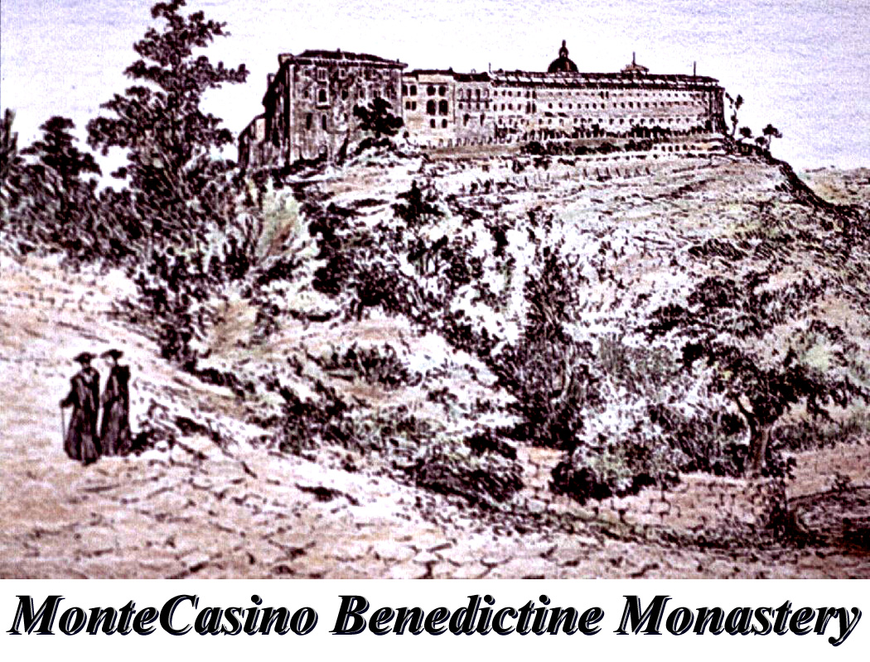

Monastics - Benedict, Francis, Dominic, Others

Definitions: (these are "Christian tradition" definitions because that is what we are concerned with here
Monism comes from Greek monos meaning single or alone. A person practices monism.

Monasticism is institutional monism and happens in monasteries, which are places where individuals practice monism.

A person who practices monism is also called a monk, which comes from Greek monokos, and translates as "loner". Monachism, also from monokos, is another word with the same meaning as monism

A monk can be a hermit if he's actually off alone somewhere (sometimes with a support staff) or a cenobite if he lives together with like minded others in a community. ("Hermit is derived from Greek, eremos, meaning "alone". "Cenobite" is derived from Greek, koinos bios, meaning "common life".) It's the cenobitic communities that are usually called monasteries, and the degree of solitude or "togetherness" can vary greatly -- groups of hermits living near each other and sharing some religious activities might be called a monastery.

A monk can be a priest but he doesn't have to be one: Clerical or Holy Orders are entirely separate, and in medieval times were only available to men -- the female deaconate had already been suppressed. Monks who are priests are usually called "Father" in Catholic circles. (Monks who are not priests are called "Brothers" or "Friars", the female equivalent being Sisters or Sorors). Monks can become Priests or can be named or elected to Higher Orders, i.e., they can become Bishops, Cardinals, even Popes, so "chains of command" (see below) can develop twists or loops.

A rule is just what it sounds like -- a behavior guide to persons who want to live as monists. Rules can, but don't always, contain sections that are mandatory or that make the whole rule mandatory -- if there are mandates, you must follow the rule to be in an Monastic order, which is, of course, the (figurative or literal) community of all those that subscribe to that "rule". Each order has its own rule although many of them are derivative.

Someone who lives under a rule might be called a canon (from Latin, canon, meaning "a rule") or a regular (also from Latin, regula, also meaning "a rule"). Sometimes they are redundantly called cannons regular.

A rule had to be approved by higher authority (like a Bishop, a Pope, or a Patriarch).

Some orders take vows, which are solemn promises to God. The most common vows are poverty, chastity, obedience, stability, and silence, but not all orders take all of them (or even any of them).

Poverty, chastity and silence are easily understood -- common definitions apply.

Obedience varies, but it usually is obedience both to the rule and to a local superior. Local superiors are obedient to their own superiors, so there is a chain of command, which

may go through a regional superior (often, in the Western Church, called a Provincial),

always goes through the head of the order (often called a General),

almost invariably goes through a Cardinal Protector (who might, himself, be a member of the order) and

ends at the Pope in the Western church.

You were OK if you obeyed your own immediate superior, even if he wasn't obeying his -- eventually, there were courts and tribunals, etc., to sort things out.

(These chains of command were broken, of course by the Reformation, but that doesn't apply in our period.) (In the Eastern Church the titles were different -- they spoke Greek, after all -- and the chain of command ended with a Patriarch in the East, More about this below.)

Stability means staying in your assigned place. You need release from your vow to move to another location. Stability, in some orders, is subsumed in obedience -- no separate vow or release needed.

A person who binds himself or herself with vows is known as a religious, and that word comes from Latin, religare or ligare, meaning "to bind" and "to tie" respectively.

A male religious is a monk and a female religious is a nun (from Late Latin, nonna, feminine form of nonnus, = "teacher", "tutor", or "monk" -- and it is the same root as for the Italian words nonna meaning "grandmother" and nonno meaning Grandfather).

Abbot comes from the Semitic word 'abba meaning father. Some orders call their local superiors Abbots (usually capitalized). Orders that call their superiors Abbots usually call their local communities Abbeys -- and Abbey can refer to the local community or to the building or compound that houses the community. Abbeys could be quite large, and smaller versions were sometimes called priories. (Those orders that don't have Abbots and Abbeys usually just talk about Priors and Priories or about Superiors and Houses.) (The feminine forms, Abbess, Prioress, Mother Superior, require no separate explanation.)

There were (almost invariably) completely separate (but possibly associated) Monastic orders for women, but they were always, in some way or another, subject to males and usually at a fairly low level -- heads of female local communities would most often have males as their immediate supervisors (if not as their formal superiors). In Western monasticism (i.e., after Benedict promulgated his rule) female communities lived separately from male communities, but perhaps right next door or on the same compound.

In some cases there were "First Orders" for men, "Second Orders" for women, and "Third Orders", with much relaxed rules, that accepted both.

Military Orders combine some aspect of "soldiering" or guarding (e.g., the Templars) or care for military people or for pilgrims (e.g., the Hospitalers) with a Monastic rule or life-style. Military orders still exist, but most often as charitable or service organizations with relaxed monastic rules.

This definition process can get a lot more detailed, but we don't need it for our purposes. In fact we probably don’t need most of the above -- it's "nice to know" information, not "need to know."

Some History:
Monasticism is ancient, having existed in India almost 10 centuries before Christ. It can be found in some form among most developed religions: Judaism, Hinduism, Buddhism, Jainism, Taoism, the Sufi branch of Islam, and Christianity. There were "priesthoods" in the Mediteranean Classical world, some of which practiced hermetic or communal living and asceticism (Orphics, Pythagoreans, Gallae, etc.).

In the time of Christ, the permanent or temporary hermetic Jewish tradition was already well established, and there also were already Jewish cenobitic communities in the valleys leading down to the Jordan Valley and in the deserts. Some of these communities converted to Christianity early on, and there are pre-Christian foundations and structures within and under some current buildings.

Christian monasticism is usually said to have begun with St. Anthony of Egypt (usually called "The Great" in the Eastern tradition) who is sometimes called the first Egyptian hermit in the early 4th century. Anthony was active in a hilly area above the Red Sa where Jewish ascetic hermits called Therapeutae were already established. St. Pachomius is said to have founded the first of the cenobitic communities, on an Island in the Nile River in the second quarter of the 4th century and to have prepared the first known monastic rule.. St. Basil (the Great), the Bishop of Cesarea, urbanized monasticism by introducing charitable service in towns as a work discipline. Despite the "first" designation attached to these persons, it is clear that they were following established traditions, some of which were already being followed by Christians. The Cenobites, in particular, were sometimes merely emulating life in the earliest Christian communities.

The beginning of Western Monasticism is often credited to St. Benedict of Nursia (6th century) whose Benedictine rule was the basis of most monastic life until the 12th century. But it is historically documented that Athanasius established cenobitic communities in Italy, Augustine in North Africa, and Martin of Tours in Gaul -- all before Benedict. The Carthusians (11th century), Cistercians (11th), Premonstratensians/Norbertines (12th), and Cistercians (12th) followed modified Augustinian or Benedictine rules. The big Military Orders were formed about the same time (Hospitalers 1070, Templars 1118). The Dominicans, Franciscans, and Carmelites (13th century mendicant orders, the first two in Italy and the third in the Holy land) followed different rules as did the Counter Reformation Jesuits (1540).

The first nuns are thought to have been Christian Roman widows who decided not to remarry, i.e., univirae (thereby retaining their inheritances). It's established that many early Christian "home churches" in Rome were founded by Christian widows.

Use an Internet search engine to look up "monasticism" or any of the other terms defined above or the names of the religious orders.

Once again, we can't cover everything and everyone, so we will discus some (mostly) Itallian or Rome connected exemplars:

Anthony of Egypt (251? - 356?: said to have lived 105 years)

What we know about Anthony, we get from a biography of his written by Athanasius, one of his disciples (yes, the same one who predated Benedict in Western monasticism).

After the standard "inspiration" (hearing a sermon on "selling what you have and giving to the poor" Matthew 19:21), he started an ascetic life (first providing for his orphaned sister -- a nicety that some others neglected).

He sought a hermetic retreat, but soon attracted a multitude of followers who he taught.

Anthony is said to have introduced manual labor to the contemplative life,, so as not to neglect societal duties.

When the local Roman governor started a persecution of Christian around 300 AD he abandoned his solitude to minister to prisoners in Alexandria until the persecution ended. He had another Alexandrian period when he preached against Arianism in support of Pope Athanasius (not the same Athanasius who wrote his bio).

He had no formal monastery or written rule -- only the informal rule of prayer and manual labor. The St. Anthony Monastery, which is still in use was founded by his disciples.

Before his death, Anthony specified a secret burial so his body would not become an object of veneration.

The Athanasian biography of Anthony was very popular and was instrumental in spreading the idea of monasticism in the Christian world.

Pachomius who founded the Nile Monastery was a disciple of Palaemon who may have been a disciple of Anthony. His rule, perhaps the first of its kind, was very influential, and experts have found 32 direct parallels with Benedict's later rule. A purported translation of the Pachomian rule is in the writings of Jerome, but it is not accepted by all experts as being solely his work.

[Note: The most famous Egyptian Monastery, St. Catherine's, in the Sinai Desert, is from two centuries later and was established on at the behest of Justinian the Great to guard the supposed site of the "burning bush" of Moses. Inscriptions on wooden beams supporting the original roof refer to Emperor Justinian and his "late Empress" Theodora. That puts the roof installation between her death in 548 and his death in 565. The monastery's document collection is second only to that of the Vatican.]

Benedict of Nursia (480? - 543)

Benedict's biographer was Pope Gregory 1, the Great, who was himself a monk and, perhaps, a Benedictine -- if not, certainly influenced by Benedict.

He had a twin sister, Scholastica, and was born into the Roman noble family that governed Nursia.

About 500, he went to Rome, but a short time later, he joined a group of virtuous men at Enfide. His supposed first miracle (fixing a pot his former nurse broke) occurred there. Shortly thereafter he sought solitude in a cave near Subiaco, a few miles form Rome, to escape the notoriety of his miracle.

After three years he agreed to be Abbot of a local monastery, but he was too rigourous for the monks who tried to poison him. He returned to his cave.

Many miracles followed and disciples gathered around him. He founded 13 monasteries in the Subiaco Valley, each with 12 monks.

About 529 he started the Monte Casino Monastery on the site of a Roman temple that he and his followers destroyed. Between the foundation and 543 he wrote the Benedictine Rule.

In 543 (the only sure date in his chronology) he rebuked the Gothic King Totila for cruelty and Totila reformed.

Probably the same year he had his famous vision of Christ, after which he announced his impending death. He died six days later and was buried in the same grave as his late sister, Scholastica. Some sources claim their bones were "translated" to the Abbey of Fleury (near Orleans), but the Monte Casino monks still claim to have the bones.

Most Western Christian monasteries until the 12th century followed some form of the Benedictine rule, but there was a gradual loosening of the rule. In the early 12th century, Bernard of Clairvaux restored the Benedictine rule after years of slippage. Bernard founded the Cistercians using the reformed Benedictine rule. Bernard later also later proposed the rule of the Templar knights. (See http://www.newadvent.org/cathen/02498d.htm in the Catholic Encyclopedia for Bernard's famous adventures and the competition among the Citeaux, Clairvaux, and Cluny Abbeys.)

Dominic Guzman (1170? - 1221)

Dominic had no definitive contemporary or near contemporary biographer -- his bio is a later reconstruction.

Castilian Spanish nobility, but not royalty, he was born among portents and prophesies of greatness. His mother was said to have dreamed of a dog running with a torch in its mouth before his birth (giving rise to the Dominican logo and to the fractured Latin satirical nickname applied by the Fransiscans, "The Lord's dogs", Domini cane. His mother (who was clearly excitable) also said she saw a light in Baby Dominic's breast at the moment of baptism.

At age 14 he began a 10 year education at the University of Palencia -- not n unusually long time since Spanish universities of the day included everything from High School through the doctoral dissertation. He was a serious student and didn't participate in the famous dissipation of the universities.

While still a student when he assisted in the reform of the Chapter of the Bishop at Osma bringing the other members under a monastic rule. In 1201 he became Prior at Osma.

While on a diplomatic mission for the King of Castile in 1203, he decided to form a new monastic order which would have the express purpose of Preaching against the Albigensian heresy.

By the end of 1204, Dominic was in Rome, and shortly thereafter he was deputed by the pope to go to Languedoc to help the Cistercaians against the Abligeois Cathars. Dominic saw that the Cistercians were making little progress because of their own indulgent habits. After persuading them to reform, they began to make progress.

Theological disputation was a key method of addressing the Albigenses for which Dominic was well suited. He also saw the need for non-heretical convent schools to combat the Albigensian institutions already in existence and it was to these convents that he offered his Second Order rule.

Dominic participated in the bloody "Crusade against the Albigenses" (begun 1208) after a Cistercian legate was killed, but was said to have tried to mitigate the butchery. According to legend (although his presence is not supported by historical analysis) Dominic tried to intercede for women and children during the massacre at Beziers. It was said that Dominic followed, rather than traveled with, the crusaders, offering "succor and salvation" in their wake. Whatever the circumstances, the crusaders appear to have considered his presence miraculous and necessary for their victories.

It is sometimes said that Dominic founded the Inquisition at this time and that he was the first Inquisitor. It's clear, however that the Inquisition was already at work at least a decade before Dominic's arrival in Languedoc. It's also clear that he participated in the Inquisition while there.

Dominic turned down several offers of Bishoprics in succeeding years and in 1214 he proposed a rule for himself and his followers -- this was the "First Order" rule. The 1215 Council of Rome decided on a mission similar to that which Dominic envisioned for his order -- preaching against the heretics -- but said that no new rule should be promulgated. Dominic therefore chose to use the loosely written rule of Augustine and the "Order of Preachers", commonly called the Dominicans, was formed.

Thereafter Dominic and his "preachers" spread out into various parts of Europe. It was averred by the Church that Dominic personally brought more than 100,000 heretics back into the fold with his preaching in and miracles in Lombardy. During this period, he formed the "Militia of Jesus Christ" as a third "Dominican" order.

Dominic died in Bologna in 1221 after a short illness.

Dominic is one of the Church's most controversial monastic founders. His participation in the Crusade against the Albigenses and the formation, if not foundation, of the Inquisition have seriously called his sanctity into question, especially, but not exclusively, among non-Catholics.

The "Dominicans" are often contrasted with the placid Franciscans (especially by those who want to forget how un-placid the Franciscans were in their later dealings with South and Central American natives.)

Dominic and Francis of Assisi were contemporaries and both Dominican, and Franciscan lore maintains that they met and knew each other. There are numerous artistic renderings of their supposed meetings.

Francis of Assisi (1181? 82? - 1226)

Son of a cloth merchant and "Lady Pica" a (possibly French) minor noblewoman whom he met on one of his business trips. Baptized as "Giovanni" in his father's absence -- another business trip -- but renamed Francis on the father's return.

He could read and write Latin, spoke French (perhaps imperfectly) and read French literature, enjoyed the works of the Provencal troubadours. He had a spirited, but apparently not a sinful youth (it would have been remarked later if he had) and was a leader of Assisi's young men.

In 1202 he was captured and imprisoned while fighting in a "war" between Assisi and Perugia (both small towns, so probably not much more than a skirmish) and kept in a Perugian prison for almost a year. He was apparently released because of illness.

Cutting short his convalescence, he was en route to join papal forces fighting against Frederick 2 in Apulia (1205) when he had a dream or vision which prompted that prompted him to return to Assisi. There he retreated to solitude and prayer waiting for God's further instructions. Within a short time there were more dreams. After experimenting with pretended poverty in Rome, including the famous episode of kissing the leper, he returned to the Assisi area where he had his most celebrated vision: the crucifix at the San Damiano chapel outside Assisi spoke to him telling him to "repair my house."

Francis took this as a command to rebuild churches (rather than to restructure "The Church"). He went to his father's warehouse and rode off with some expensive cloth, which he sold along with his horse and tried to give the money to the rector of San Damiano. The rector refused the money -- perhaps realizing the circumstances -- and Francis discarded the cash out the window. Francis's father, not amused by the episode, locked Francis in the house and brought a civil suit to restrain him. Francis didn't answer the summons so the Father brought him before Assisi's bishop.

At the audience with the Bishop, Francis stripped himself naked and renounced any connection with his family. The bishop covered him with a cloak and Francis fled for the woods above Mt. Subiaso above the city.

Eventually he came down, but not back to his family. He preached and begged in Assisi without license, and gathered followers, some of whom were wealthy. Francis used their money to repair and rebuild neglected chapels and churches.

Eventually large numbers of followers gathered around him and started to build the huge church and monastery which is still in the town. Papal sanction for the "Order of Friars Minor", commonly called Franciscans, was granted.

In 1212, he organized a "Second Order" around Clare (Chiara) a local noblewoman who had adhered to him, that order eventually being called the "Poor Clares". (In 1221 he organized his "Third Order".)

In subsequent years Francis traveled, including a trip to Egypt (1219) where he went into the camp of the besieged Sultan at Damieta. According to legend the Sultan was so impressed that he allowed Francis to visit the Christian holy sites in Jerusalem. Whether or not the visit to Jerusalem actually took place, shortly thereafter, the Muslim authorities granted custody of all the Christian sites in the Holy Land to the Franciscans. The "Custos", a Franciscan appointed by the Order, technically still maintains that custody.

On his return, Francis was faced with an organizational crisis. The Orders had grown dramatically but their administration hadn't kept pace. There were at least two new revisions of the rule, and Francis appointed administrators to run the organization. The second revision won Papal approval, and as the "Regula Bullata" (Rule with the Papal Seal) it still is used by the Franciscans.

From that point onward Francis withdrew increasingly from the administration of the Orders.

In 1223 the first "nativity scene" or crèche was erected in Assisi. Although it is commonly thought that Francis invented the idea, It is clear from his own writings that he had duplicated what he had seen in a nearby town. Nonetheless, it was Francis's personal popularity that spread the practice of setting up crèches first in Italy, then Europe and then around the world.

The next year he was said to have received the stigmata (September 14, 1224), which he carefully hid during his lifetime. The wounds were reportedly discovered after his death.

Francis died in 1226 after a two year illness that included blindness from disease apparently contracted during his Middle-East travels.

Many people today have extreme doubts about the miracles, visions, and stigmata -- Francis would probably be institutionalized or at least "de-programmed" today. But the doubts are essentially irrelevant, because his effect on Roman, Italian, and European (and later, "New World") thought and behavior depended on what his contemporaries thought. And they almost universally believed it all.

Doubters might make the case that the Papacy cynically exploited the "Francis fervor" of the time: if so, it still had its historical effect, which was to bolster the Roman Church's emotional and charismatic wing. The intellectual side was just about to get a boost -- Aquinas was born either the year before or the year after the death of Francis. But Thomistic logic took a long time to root because agricultural economic reverses followed by the onset of plagues would soon wipe out most of Europe's thinkers. (More on those topics in later units.)

The Basilica of St. Francis in Assisi houses some of Italy's best and most important art in the form of fresco cycles by Cimabue, Giotto, and Cavalini. There is some dispute about who painted what, but these three artists together are credited with revolutionizing Italian art by restoring the "classical" use of perspective and introducing the concepts of the "vanishing point" and "double perspective" and ending the flat and un-natural Byzantine conventions.

The 1997 earthquakes damaged some of the frescoes, but the fabric of the church was remarkably stable, perhaps due to steel girders added between the round tower buttresses after the previous serious earthquake in 1984. The cylindrical buttresses themselves also were studied carefully both in 1984 and in 1997: it appears that they may be better suited to withstand the twisting and rolling motion of earthquakes in mountainous regions than are buttresses with square or rectangular cross sections. Reconstruction after the 1997 quakes included adding more flexibility and strength to the fabric as well as removal of extraneous structures that had been built onto the outside of the basilica.

Fund-raising for the post-earthquake reconstruction was so successful that the Franciscans were able to share some funds with other damaged towns. Nonetheless there is lingering resentment that much money was collected for rebuilding churches (the original Franciscan goal) and not enough for housing renewal.

Ignatius Loyola (1491 - 1556)

Not really our period -- included here for a more complete picture and because I was partially educated by the Jesuits

Ignatius was another Spaniard, like Dominic. Like Francis, he started with a military career, but it was cut short by a serious wound -- hit by a cannon ball. While recovering, he was given religious materials to read (everyone thought he would die, so he was given the lives of saints to contemplate.)

Ignatius, by his own account, knew he could no longer be a military officer so he decided to be a Saint. He set off for Jerusalem, but didn't even get as far as Barcelona before he collapsed from exhaustion and lingering effects of his wounds. He stopped to rest for a few days (in a cave, of course) but stayed for ten months during which he had a series of visions. During this time he determined to found his own religious order.

Ignatius wrote no rule and, controversially, proposed doing away with the fixed order of daily prayers (the "office") that had been a fixture of monastery life.

He finally arrived in Rome where he met Pope Adrian6 and then set off for his pilgrimage to Jerusalem with the Pope's blessing. He wanted to remain in the Holy Land but the Franciscan Custos ordered him out because of the dangerous security situation. Ignatius left, but only after the Custos threatened to excommunicate him if he stayed.

Now aged 33, he went back to school to learn Latin and other subjects to prepare for the priesthood. He was soon in trouble with the Inquisition and was imprisoned twice, first in Barcelona and then in, Salamanca because he insisted on teaching and preaching before he was ordained.

He left Spain for the freer air of Paris, and at he university there he gathered a few disciples including Francis Xavier and Peter Faber. Eventually Ignatius and five others took vows of poverty and chastity (notably, not obedience) in a private unsanctioned ceremony and decided to go to the Holy Land or failing that, to Rome where they would put themselves at the Pope's disposal (not as a religious order, but as individuals.

They waited for a year in Marseilles, but because of continuing war between Christians and Muslims, there were no ships to the Holy Land. During that year he was ordained, but didn't say his first mass, apparently wanting to do that in Jerusalem.

Finally giving up the wait, he and two others set off for the Roman alternative plan. En Route, at La Storia, a few miles north of Rome, Ignatius had another vision confirming that Rome should be his real destination. Once in Rome (in 1538) the Pope gave all three work teaching scripture and theology and preaching. The next year Ignatius called his other companions to Rome where they decided to live communally under obedience to the pope and a "superior general" and put themselves again at the disposal of the Pope. In addition to their previous vows of poverty and chastity and the new vow of obedience, they also vowed to go wherever the Pope sent them and on whatever mission.

Ignatius lived simply and asked only for a small pre-existing church in Rome's red light district, which the Pope cheerfully granted him. Soon his preaching and that of his colleagues attracted large audiences along with donations to build a larger church, The Gesu, adjoining the original small church. During the lifetime of Ignatius decoration of the Gesu was kept simple.

Before he died Ignatius watched his order grow to more than 8,000 members, many of whom were in far-flung foreign missions. They were particularly active in Asia and the Americas (Jesuits, for example were the first Europeans to explore the Mississippi River and its tributaries while doing missionary work among American Indians.)

Their most intensive work was in the orient, however, where they had great success under the guidance of Francis Xavier. Some modern scholars, including some eminent Chinese, believe that the Jesuits in China were the real authors of the Confucian Analects -- this is known as the "Neo-Confucian theory": that there was a real minor Chinese philosopher named Confucius, but that the Jesuits invented the Analects in his name to prepare the Chinese for conversion to Christianity.

After Ignatius died, the Order redecorated The Gesu in grand style. It is truly Rome's first and one of its greatest Baroque churches. It's architects included Michelangelo, Vignola and Giacomo della Porta who designed the first Baroque (or at least "proto-Baroque) façade. Giambatisa Gaulli (known as I Baciccia) did most of the interior including the "multimedia" vault of entitled The Glorification of the Name of Jesus, which includes the central fresco augmented by hanging stucco angels and oil paintings on suspended cloud-shaped wooden panels. Centuries of urban grime, candlewax soot, and pilgrim sweat were removed from the interior just in time for the 2000 Jubilee year. The main altar is richly decorated, but it pales in comparison with the altar dedicated to Ignatius, made of gold, silver, and, legendarily, more than half of the known lapis lazuli stone in the world. The lapis globe that tops the altar, held in the hand of the Father in Pierre Legros' Trinity, is supposedly the largest single piece of lapis lazuli ever carved and displayed.

Military Orders -- Templars and Hospitalars

Both of the major orders and several smaller organizations combined military and monastic rules and responsibilities.

Templars

The Templars were founded in late 1119 or early 1120 by French knights who vowed to protect Pilgrims on their way to Jerusalem. King Baldwin 2 of Jerusalem gave them quarters on the side of his Jerusalem Palace nearest to Temple Mount and from this they derived their name. (By that time Temple Mount was already occupied by a Mosque.) According to legend the Templars kept their horses in the vaults below the Al Aqsa Mosque, now known as Solomon's Stables.

Their numbers increased rapidly, mostly as the result of propaganda by Bernard of Clairvaux who wrote the monastic rule of the Templars (as well as the renewed Benedictine rule used by the Cistercians.)

Originally, the Templars vowed obedience to the Latin Patriarch of Jerusalem, but in 1139 Pope Innocent 2 preempted that authority and took direct control of the order with no responsibilities to bishops in whose dioceses they might reside or hold property. This allowed the Templars to diversify rapidly and the order, according to some sources, soon became a cover for commercial, banking, and real estate transactions. Not surprisingly, vast wealth was accumulated.

The Templars rapidly became essential for the defense of Jerusalem, both militarily and financially. At their height, the Order had more than 20,000 knights and many thousand additional subsidiaries (sergeants, chaplains, and servants.)

There was great rivalry between the Templars and the Hospitalers and by the late 13th century proposals were made to merge the two orders. However, after the fall of Acre, the last Crusader stronghold in the Holy Land, the proposals were dropped: the Templars no longer had a legitimate mission.

On October 13, 1307, Philip 4, The Fair, of France arrested all the Templars in France and seized the assets of the Order. Under pressure from Philip, Pope Clement 5 (also a Frenchman) ordered the arrest of all Templars everywhere. Under continuing pressure from Philip, the Pope completely suppressed the Order on March 22, 1312, and Templar properties were either given to the Hospitalers of seized by the state.

In the suppression, many Knights were imprisoned or executed, and on March 18, 1314, the last Grand Master, Jacques de Molay was burned at the stake in Paris.

Modern Masonic organizations claim to be descendant from the Templars.

Hospitalers

The Hospitaler Order originated at an 11th century hospital founded by Amalfi merchants in Jerusalem to care for sick pilgrims. (Similar foundations were appearing in Rome at the same time.) In 1099, when the Christian crusaders conquered Jerusalem (with a bloodbath of Muslims and Jews) the order rapidly increased its activities both in the Holy land and along European routes to Jerusalem. Essentially, they founded hospitals in southern France and in Italy, usually in port cities.

The Order received papal approval in 1113, and in 1120, Raymond de Puy, its second Superior, substituted the Augustinian Rule for the Benedictine.

The Hospitalers quickly acquired wealth and power and gradually took on a military role in the Holy Land, where they previously had only offered health care. Their military power was second only to the Templars.

When Jerusalem was recaptured by the Muslims (1187) the Hospitalars began their long withdrawal, first to Margat and then to Acre in 1197. In 1291 Acre fell and the Hospitalers moved to Limassol in Cyprus. In 1309 the acquired Rhodes, and their they organized a naval force to prey on Muslim shipping, which the continued to do for more than two centuries.

By the 15th century the Turks had taken over most of the Islamic middle East and Suleyman, The Magnificent (a Kurd who led the Turks), had had enough. He besieged Cyprus in 1522, and on January 1 of the next year the Knights evacuated Rhodes with as many Christians who wanted to accompany them. After seven years of homeless wandering, the Hospitalers were granted Malta and several surrounding islands by the Holy Roman Emperor, Charles 5. (This was just three years after an out-of-control imperial army had sacked Rome in 1527, and the settlement of Malta on the Hospitalers was apparently port of the Emperors atonement.) The Hospitalers continued to harass Muslim shipping from their new base.

In 1565 the Knights successfully defended Malta from a siege by Suleyman, and in the process destroyed most of the Muslim war fleet. What was left of the Turkish navy was permanently crippled a the Battle of Lepanto in 1571. The Hospitalers participated in the battle along with the fleets of other Christian European powers, and each and every one claimed responsibility for the Christian victory.

Thereafter, the Knights gradually gave up warfare and concentrated again on their initial medical mission (and, of course, territorial administration -- they had inherited all that Templar land in 1312.)

They were finally ousted from Malta by Napoleon in 1798 -- Malta was a side issue to his conquest of Egypt. The 1902 Treaty of Amiens gave Malta back to the Hospitalers, but they weren't able to actually retake possession, and the 1814 Treaty of Paris took it away from them again.

For a long time, they were dispersed and without a Grand Master, but Pope Leo 13, reinvigorated the order and appointed a new Grand Mater in 1879. (This was partially in response to events in Italy where the Papal States had finally been absorbed in 1870 and the new Italian Government was moving into Rome. The Italian Government quickly co-opted the Knights however by granting the Knights some extraterritorial properties in Rome where the Knights set up the Sovereign Military Order of Malta (S.M.O.M.) The Knights adopted a new constitution in 1961 along with the Order's most recent new formal name, "The Sovereign Military Hospitaller Order of St. John of Jerusalem" -- The still use SMOM on their vehicles and informal letterheads in Rome.

The Hospitalers still maintain a large hospital, specializing in ophthalmology, in Jerusalem and they have health facilities and clinics in some third world countries.
The order, which is still strictly Catholic, now cooperates with other organizations, many of them Protestant, that split from the Order during the Reformation and with other medically oriented non-government organizations, including with the Red Crescent Society (Muslim equivalent to the Red Cross) and Magen David Adom (the Jewish "Red Star of David".)

Note: both Military Orders suffer from a huge amount of fakery, fraud, chicanery, and outright ignorance on the Internet. The links above are ale legitimate, but some of them link to other web sites where you can quickly slip into the realm of the absurd. Caveat emptor!

Unit 6 – Franks and Holy Romans

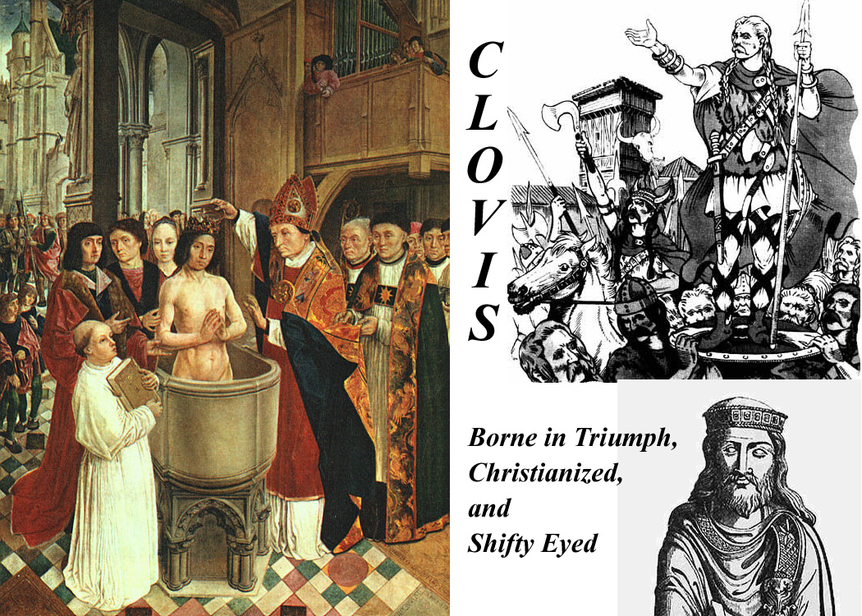

Franks and Holy Romans

The Franks, for centuries, occupied a special position in Roman history -- not "barbarians" like all those other outsiders, but protectors -- saviors from the Byzantines and their machinations. But as often happens, "protection" was sometimes a great burden on those being protected. The Papacy had been aggregating power for centuries and didn't want to share it, neither with the Byzantines nor with the Franks.

The Franks evolved into the Holy Romans, and the relationship between Rome (the Popes) and Holy Rome (the Emperors) became rocky indeed. That wasn't really sorted out until the 19th century.

But it starts with the Franks.

Introduction:
Franks are first noted in the deltas of the Scheldt and Rhine Rivers, along the North Sea coast from modern Antwerp, Belgium, northwest into The Netherlands.

In 350 the became Roman Foederati and were allowed to move into better land inland along the Rhine.

They were Germanic -- just small tribal groups -- and had no overarching organization, but there were two general divisions (recognized first by outsiders and later by themselves), an inland group and those who lived closer to the sea, the later being the Salic or Salian Franks (assumed to be named because they were "salty" or seaward). The Salic Franks eventually dominate -- hence "Salic Law" as the basis of French law.

By 430 they had occupied central "France" (not yet called France) and had control over the imperial arms factory at Soissones -- now the Franks have strategic value. They were a major component of the Roman led army of Aetius that defeated the Huns as Chalons in 451.

After Aetius was murdered by political enemies at Ravenna, they broke away, and when Odovacar disolved the Western Empire and became king of Italy, the Franks were essentially free to do what they pleased.

In 481, 15 year old Chlodoweg (Ludvig, Louis,Clovis) became leader of his small Salian tribe. Leaders of all the tribes claimed to be descended from Wotan and thus they were all ostensibly "related" by (Wotan's) blood. He hit on the idea of killing off other members of his "family" and within five years he had united the Franks under his personal rule. He clearly had a pretty powerful, or at least the most ruthless,"small tribe".

In 486, Clovis defeated the Roman general who had held the area around Paris (and who was waiting, like an unrequited lover, for the Empire to return) and Paris became the capital of the Franks.

Ten years later he defeated the Burgundians after taking an oath that he'd become a "catholic" Christian (i.e., not Arian) if he won the decisive battle (496). His baptism is the subject of many contemporary or later paintings.

In 507, at the request of the Eastern Emperor (and undoubtedly after a big bribe) Clovis started to chase the Visigoths out of Gaul, driving them out of their capital at Toulouse and into Spain. He gained southern France for the Franks by 508, but Theodoric, the Gothic Italian king, kept him from taking the Mediterranean coastal area. (Theodoric had figured out that the whole maneuver by the Franks and Byzantines was an anti-Arian pincer movement.)

In 510 Clovis drove the Allemanni out of the northern Rhine and annexed the territory.

Then he died the next year (511) and Gavelkind, the bane of French and sometimes of English imperialism, took over.

Gavelkind is the equal distribution of wealth and property among male heirs, the opposite of primogeniture. [Gavelkind was still the law in England until 1926. -- tkw]

Clovis had four sons and the Frankish "empire" which Clovis had so carefully unified, was split up at his death

There were then four Merovingian Kingdoms (after Merovech, the semi-legendary granddad of Clovis), centred at Paris, Soissons, Orleans, and Reims, and they fought like cats and dogs. One of the four sons, Claotaire (equivalent to Lothair, Lothar, Luther, or Lothario) , eventually took over all four kingdoms as his brothers or their heirs died off, finishing the re-consolidation in 561, but then he died the same year and Gavelkind again divided the realm again into three parts, Neustria, Burgundy, and Austrasia, ruled by his three sons. We'll continue this stuff in the next topic, the Merovingians.

[And another thing -- tying things together: Until the death of Clovis, Theodoric (who, you remember, was a Ostrogoth) was always on guard against Frankish expansion. When Alaric 2 died in 507 Theodoric inherited Spain, and he united Spain and Italy under his rule (thereby neutralizing, if not reversing that Frankish-Byzantine pincer strategy). As a further way of neutralizing Frankish and other Germanic threats, Theodoric used the "marriage weapon". He married his daughters off to Germanic kings -- he had no sons. The daughters were the result of his own marriage Audefleda, who was the beloved sister of that same Clovis of the Franks . The most important marriage alliance actually turned out to be that of his daughter Amalasuintha to Eutharic, a Visigoth Prince. Theooric had hoped to unite the Visigoths and Ostogoths, but Eutharic died when the resulting son was just a little boy and that little boy inherited the Italian throne from Theodoric. Amalasuintha ruled Italy as Regent and Principa (Princess) when Theodoric died in 526. She lasted until Belasarius came roaring in and took Italy back for Justinian and the Byzantines, meanwhile devastating the city of Rome in the process.]

Merovingians
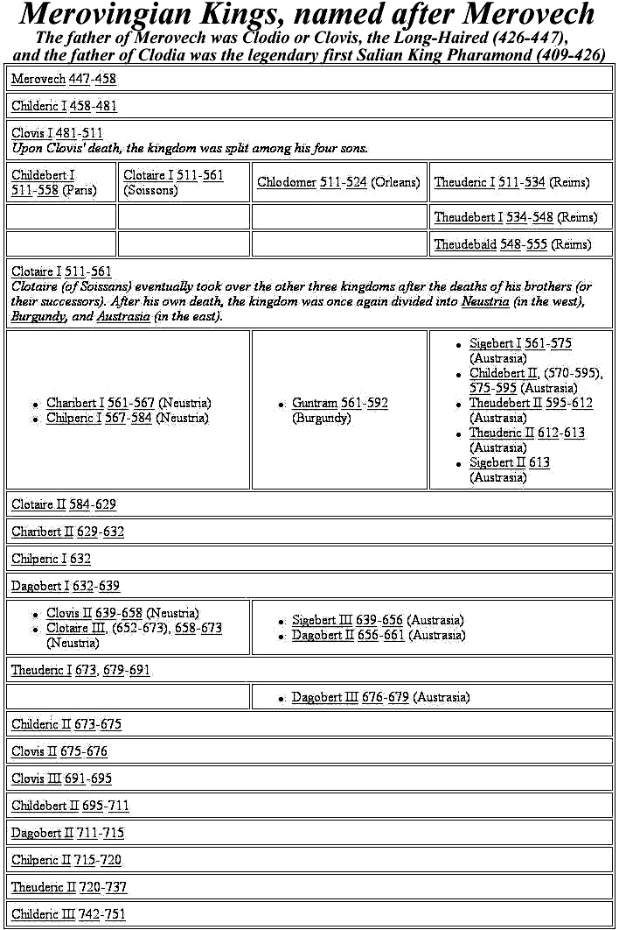

A chart of all the Merovingians and Carolingians is at http://www.wikipedia.org/wiki/List_of_Frankish_Kings

There were 37 Merovingians in all if you count all the way back to the first Clovis/Clodio and his semi-mythical father, Pharamond.

The gavelkind problem sorted itself out and then reasserted itself several times.

But ultimately, it didn't matter. By the end of their line, the Merovingians had become the "Les Rois Faineants" -- "The Do-nothing Kings". In Italian terms, they believed in the "dolce fa niente" -- the "sweet do-nothing". Their interests were dogs, horses, falcons, and women -- some said in that order. Actual rule had passed into the hands of their chief bureaucrats, the Major Domi -- usually translated as "Mayors of the Palace" in English. At some times there were inter-regnums when the Mayors simply ruled.

In the Austrasian Merovingian Kigdom, there was a line of Mayors from the Metz region, and one of them, Pepin 2 of Heristal (680-714) annexed the Neustrian Kingdom to Austrasia, and thereafter there was again only one Frankish realm. Pepin 2 had legitimate sons who succeeded him as Mayors when he died in 714, but his illegitimate son Charles ousted them in 719.

Charles defeated the invading Saracens in 732. The Saracens fled overnight after being hammered by the Franks on the first day of the Battle of Poitiers -- and Charles picked up the sobriquet "Martel", "The Hammer".

[Sobriquet \So`bri`quet"\ (s[-o]`br[-e]`k[asl]"), n.(French sobriquet, OF. soubzbriquet, soubriquet, a chuck under the chin, hence, an affront, a nickname; of uncertain origin; cf. Italian sottobecco a chuck under the chin.) An assumed name; a fanciful epithet or appellation; a nickname; e.g., Martel (from Marteau -- a hammer).]

Charles Martel had two sons who succeeded him as joint Mayors of the Palace (741), but one resigned to become a monk in 747, leaving Pepin 3, The Short, in sole charge.

With the connivance and blessing of Pope Zachary , Pepin siezed the throne from the last Merovingian, Childeric 3, in 751. (and five years later {756}, Pepin reciprocated by giving Pope Stephen 3 the "Donation of Pepin", the "Roman" parts of the Italian lands Pepen had taken from the Lombards and the Exarchs.)

Pepin, The Short, was, of course, the Grandfather of Charlemagne. Although the next dynasty was named "Carolingian" after Charlemagne, the Austrasian Mayors from that Metz line are usually also counted as Carolingians. That's why it sometimes appears that the French Merovingian and Carolingian dynasties overlap by about 150 years.

Carolingians
As noted, the "Carolingian" name was and is still applied retroactively to all those Metzian Mayors, but either Charlemagne, or, with a stretch, Pepin 3, was really the first.

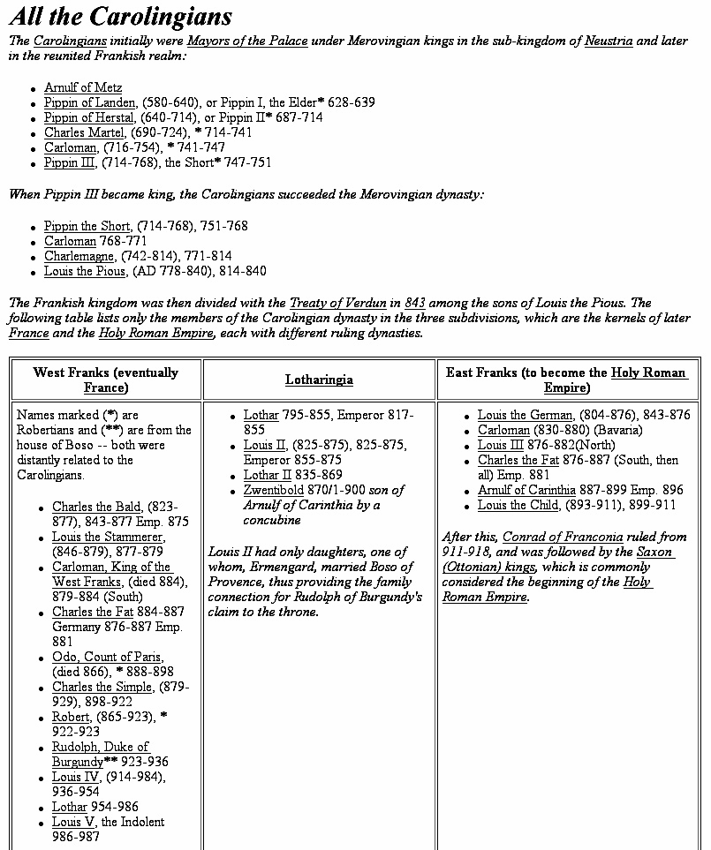

Meanwhile, back in Rome --

In 660, while Pipin of Herstal was still an apprentice Mayor in Austrasia, the Eastern Emperor, Constantine 2, visited Rome for a week with a sizeable army and entourage. Their main employ while in Rome was theft of bronze and lead from roofs of surviving ancient building and from the clamps that held the stonework together.

They loaded three shiploads of metal at Ostia and sent the cargo vessels on their way to Constantinople. En route the ships were intercepted and captured by Saracen pirates. Some of the metal went to Jerusalem, and, according to records still there, the lead sheathing on the roof of the Dome of the Rock and the al Aqsa Mosque, came from Rome.

Without the metal clamps, buildings started to tumble with every earthquake, and unsheathed wooden roofs rotted and fell in. The devastation of Rome's monumental structures far outstripped whatever "Barbarian" marauders had accomplish in the preceding 300 years. Rome's large sewer lines, also clamped with lead, broke open and the largest, the Claoaca Maxima, built in the ancient Roman monarchical period broke flooding the forum. Aqueducts, meanwhile collapsed -- no clamps to hold them together -- reducing the city's water supply, and the remaining sewers blocked up because there wasn't enough flow-through to flush them out. Rome, and especially the low-lying forum area, became a stinking mess, polluted with human and animal wastes. The population was already drastically reduced (and, also, weakened Rome had gotten no new drafts of captured slaves) so there was not enough manpower to make the repairs that could save the situation. The move out of the center of the city and into the Campus Martius accelerated.

[the "good side" of the pollution of the Forum was that it actually saved many of the ancient buildings there. Some of them were simply buried in the accumulated stinking muck. Even the parts of buildings that rose above the level of the ordure were preserved. "Miners" would rather go almost anywhere than into the horrible mess in the Forum to look for marble and limestone either for re-use or to feed lime kilns. A lot was left when archeological excavation finally began in the late renaissance and again in the late 19th century.]

Romans were horrified by the devastation wrought by Constantine 2. In the next century Rome learned other reasons to hate the East.

For one thing, sea routes needed to bring food, commodities, and defensive forces to defend the weakened cities were lost to the Saracens -- the fate of the three ships of lead and bronze was only one example. Eventually the Saracens engaged in internal conflict -- their Umayyad dynasty collapsed in the midst of the first Sunni v. Shiat Ali civil war. He upshot was a new capital in Baghdad and a new Abbasid dynasty. But civil war in the Islamic east just led to anarchy in the Islamic West -- North Africa -- and uncontrolled Saracen piracy around Italy.

The Eastern Empire, which the Romans and Italian had relied on for support against the Saracens, became preoccupied with the arrival of the Slavs on their northern and eastern borders. The Eastern Imperial Navy declined (just when the West needed it most) as Eastern land forces were augmented. Meanwhile the Easterners started to fight amongst themselves over icons.

There was also a period of Frankish consolidation and land expansion, during which the Franks also turned their attention away from the Mediterranean, but that didn't last.

Pepin appeared on the Italian/Roman horizon just when he was needed. The Lombards had been fighting intermittently to throw the Exarchs out of Ravenna, and finally succeeded, but in doing so they had also exhausted themselves. Frankish forces came rolling into the vacuum and Pepin, The Short, paid off his debt with the "Donation of Pepin" in 756. Italy down to a line halfway between Rome and Naples was nominally Carolingian, but it was to be ruled autonomously by the Popes. More importantly, vast tracts of land were transferred to Papal ownership providing much-needed income to the Papacy.

[The Donation and the Frankish -- later French -- "protection" was to be a feature of Papal politics until September 19th, 1870, when the last French garrison was pulled out of Ostia to futilely reinforce French armies in the Franco-Prussian war. The next day the Bersagliari broke through Rome's northern wall, the city fell, the Papal States disappeared, and Italian "Re-unification" was completed.]

Pepin's grandson, Charlemagne, finished unifying the vast Frankish Empire -- from the Atlantic and the Pyrenees to the Oder River and From the Baltic Sea to Central Italy.

By the end of the 8th century, the Byzantine (Eastern) Empire was weakening, and Charlemagne had a plan to marry his Daughter, Rotrud, to the Issaurian Byzantine heir, Constantine 4, whose mother, Irene the Athenian, was ruling as Empress until he came of age. (Some sources say Charlemagne also planned to marry the widow Irene.)

There were several family wars, the last of which was led by Irene against Constantine 4 -- she didn't want to give up the throne. Her forces captured, Constantine and blinded him with red-hot pokers (to make him ineligible -- an old Byzantine rule), but they drove the pokers in too far and he quickly died.

Irene kept the throne, but her brutality cost her the marital alliance with Charlemagne. [For more info on the mid-Isaurian dynastic horrors go to http://www.wikipedia.org/wiki/Constantine_VI and http://www.wikipedia.org/wiki/Byzantine_Emperor_Irene.]

[This was the same Irene who suppressed the Iconoclasts.]

The Sequel was that Charlemagne, and his former tutor, now Chief of Staff, Alcuin, went to "Plan B", and Constantine visited Rome where he was crowned as "Roman Emperor" by Pope Leo 3 on Christmas of 800.

According to legend, the pope put the crown on Charlemagne's head spontaneously, but, even then, nobody believed that long planning and negotiations had not preceded the event.

It's just barely possible, however, that the Pope figured out "which side of the bread the butter was on" and took action without consulting Charlemagne. Whatever was the case, Charlemagne was clearly pleased -- not quite realizing, perhaps, that the act of king-making is more empowering to the maker than to the king.

The coronation ended Byzantine theoretical rule over the West, and successive Western Rulers -- ultimately the Holy Roman Emperors and even modern Western Monarchs could claim continuity with the emperors of ancient Rome. (They already could prove distant consanguinity -- very distant.)

The Carolingian achievement was great, but Charlemagne had not eliminated the basic limitations inherent in the Frankish state. The economic infrastructure of the West had not been repaired, and the reconstruction of anything remotely resembling a Western Roman empire was beyond the means of Charlemagne and his advisors. The Franks had gotten as far as they had simply because their rivals were engaged elsewhere, and they had the good fortune to have enjoyed almost seventy years in which the kingdom had passed to a single heir and so remained united and free from civil wars

This good fortune came to an end in the reign of Charlemagne's son, Louis (AKA, Clovis/Chlodoweg/Ludvig) the Pious, who squandered most of his Father's gains.

Division of Charlemagne's Empire
[Note 1. During his lifetime, Charlemagne and his advisors managed a minor "renaissance" (called, unsurprisingly, the Carolingian Renaissance) in which they attempted to re-create the Roman Empire of the West as best they could. The primary goal of this effort was to concentrate authority permanently in a central government, and, from the beginning, that goal was probably unattainable.

They failed to address the basic problems of the West: the decay of the economic infrastructure (roads, bridges) and the loss of the manufacturing and monetary subsidy that the West had obtained from the East as long as both were under the control of a single imperial authority, and being unable to address these problems, they were not able to command the respect needed for long term central contol.

More importantly, they failed to address the problem caused by the division of the state among the king's heirs according to the traditional inheritance practice of gavelkind. It was only luck that had kept the Frankish realm in the hands of a single ruler from 751 to about 830.]

[Note 2. Something about Louis the Pious:
Louis was born in 778, while Charlemagne was on an expedition to Spain. Charlemagne gave him the newly-acquired land of what is now southern France, stretching from the Atlantic to the Mediterranean, with its capital at Toulouse, and with the name of the Kingdom of Aquitaine. He left the child there under the care of a very able group of secular and clerical counsellors led by Count William of Toulouse (William of Orange in the epics, and St. William of the Desert in the lives of the saints) and Saint Benedict of Aniane, monastic reformer, scholar, and political theorist. Louis had older brothers, so he did not expect ever to get more of his father's lands than the kingdom he had been given. But when Charlemagne died in 814, his brothers were already dead: Louis inherited everything. Gavelkind was avoided.]

Louis, Charlemagne's sole heir, started out smart. By deposing all illegitimately born men from the civil service and the Church hierarchy, he took away the ability of Charlemagne's many bastards to grant political favors (but he also made a bunch of enemies and took out some experienced administrators.)
In Italy there was a short-lived rebellion centered around a child pretender (said to be one of Charlemagne's bastards) named Bernard. Louis put it down, with wide Italian public support, but his torturers botched their job of blinding the child, and the boy's death was a public relations disaster -- Louis should have read what the family chronicles said about Irene.

At that point, the Church exercised the "empowerment" that it had gained when Pope Leo crowned Charlemagne: there would be no coronation for Louis until he did "penance", and he had to do it, literally had humble himself in front of his court. This clearly would have troubled some of Charlemagne's powerful nobles.

Another mistake was made when Louis tried to update his early attempt to ensure an orderly succession. To avoid disputes caused by Gavelkind at his death, he had distributed the various parts of the realm to his three sons while he was still alive: there would be no question of "inheritance". The plan went askew when Louis, a widower, remarried and had another son. Louis announced that he was going to redraw the borders of the lands settled on the first three sons to give his new son an equal share. The first three objected and there was civil war -- which lasted for generations.

A new problem emerged because it was no longer possible to expand the "empire". Infighting essentially prevented "outfighting" and that meant that benefices and, more importantly, tax-farming rights were no longer available to pacify the nobles. That meant they had to look more to their internal fiefs for income -- and, in turn, it meant a decentralization of power.

[One of the eventual results of decentralization was the inability to agree on maintaining a navy to defend against piratical Saracens. And at about the same time, there were new "barbarians", fierce Magyar horsemen on the borders. If all this sounds familiar, it's because it was the same scenario that played out at the end of the ancient Roman Empire, but things moved faster in modern times -- it only took a few generations.]

Louis died in 840 and his first three sons divided the realm amongst themselves. By 843 theTreaty of Verdun was hammered out (but there was still violent jostling and civil war along the borders of the three divisions). The jostling created new realities, and by 870 a new Treaty of Mersen was signed. Three divisions, West Franks, East Franks and Middle Franks resulted. The west Franks eventually became France. The East Franks became the Holy Roman Empire, which absorbed and for a long time kept "Lotharingia", the lands of the Middle Franks. Lotharingia, as we can see from the maps, included the northern half of Italy and, more specifically, all that territory around Rome that was included in the Donation of Pepin.
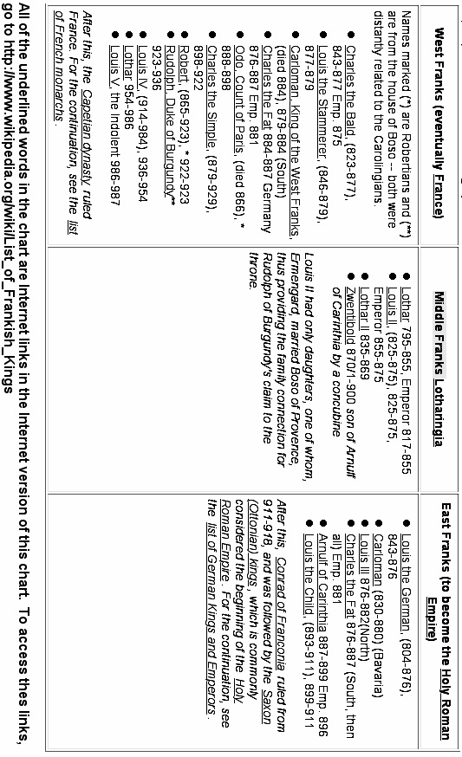
After the Donation of Pepin and subsequent Carolingian events the church became much more wealthy as a result of the increase in the size of Papal estates. There was once again surplus income building and aggrandizing churches. The city of Rome was one of the places where this occurred. We are still in the Romanesque period before the rise of European Gothic architecture (which never really caught on in Rome anyway -- in Rome, only the 12th century church of S. Maria Sopra Minerva is Gothic, and its nave is nowhere near as high as in Gothic churches elsewhere, and its interior was repainted/redecorated in the 19th century in a thoroughly "un-Gothic" style.)

Two notable examples of Carolingian era churches in Rome are Santa Cecilia in Trastevere and Santa Prassede. There were pre-existing churches on both sites, but what we see today are the Carolingian rebuilds. Each has a formidable collection of important and well-preserved mosaics from the Carolingian period (better preserved, in fact, than the later Late Medieval and Renaissance frescos which are considered equally important in art history.)

Transition from Carolingian to Holy Roman
The tripartite division among the Grandsons of Charlemagne and their heirs was largely linguistic -- "French" speakers were in the west, and "German" speakers in the East. All of the Franks, of course, were "Germanic", but the West Franks were in old Gaul, where centuries of Roman domination had "Latinized" both the street and the Palace.

Middle Frankish Lotharingia had a mixed "French" and "German" area in the north and an "Italian" speaking area in the south -- all those quotation marks, by the way, indicate developing rather than fully grown languages.

Between the Treaty of Verdun (843) and the Treaty of Mersen (870) the Eastern and Western Franks divided the northern part of Lotharingia between themselves. Neither side was happy with the division, and both sides coveted the southern, "Italian", part of Lotharingia. Disputes and wars involving the northern part would be the cause of bitter territorial disputes between France and Germany until the first half of the 20th century.

In the ninth and tenth centuries, Europe was disrupted by a series of invasions by Vikings, Hungarians, and Muslims.

When the invasions finally subsided, Germany's initial recovery was characterized by the emergence of semi-independent duchies based on earlier Germanic tribal divisions, and by the early tenth century, five duchies dominated Germany: Bavaria, Franconia, Lorraine, Saxony, and Swabia.

After the death of the last Carolingian emperor in 911, the monarchy fell into the hands of the dukes of Franconia and Saxony until the Saxon line was able to assimilate the crown into their dynastic line. The dukes of Saxony soon extended their control over Franconia and Lorraine and retained the German monarchy for the next century.

The second king in the Saxon line was Otto I, the Great, who consolidated his authority in Germany and then added the title of 'King of Italy' in 951. His successful defense of Germany against the Hungarians in 955 validated his claim as monarch over the German princes and, in 962, Otto I was crowned 'Roman Emperor' by Pope John 12.

Although the term 'Holy Roman Empire' would not be regularly used until the twelfth century, for later historians the coronation Otto 1 marked the beginning of the medieval Holy Roman Empire which was to remain a fundamentally German phenomenon until its demise in the nineteenth century (and successor regimes continue until today).

We won't follow the complex line of Holy Roman history, but will now shift southward to Italy.

[A basic outline/timeline of Holy Roman Empire history is available at
http://www.scaruffi.com/politics/holy.html and there are libraries full of books for those who really want to dig in.]

It should be noted, before we shift into Italy, that, at various times, and in some circumstances, the "Holy Romans" have claimed that the Holy Roman Empire started with Charlemagne or even with his ancestors.

Guelphs and Ghibellines

[First, another German digression:
How the Names Originated: Welf vs. Waiblingen

They originated in the 12th century from the names of rival German houses in their struggle for the title of Holy Roman Emperor. The election, favored by the Pope, of Lothair II (c. 1070–1137), Holy Roman emperor from 1133 and German king from 1125, was opposed by the Hohenstaufen family of princes.

This was the start of the feud between the house of Welf (Guelph), the followers of the dukes of Saxony and Bavaria (Henry the Proud, 1108–1139; later of his son Henry the Lion, 1129–1195), and that of the lords of Hohenstaufen whose castle at Waiblingen (near present-day Stuttgart) gave the Ghibellines their name.

Eventually the Guelph-Ghibelline conflict gave way to a civil war in Germany, which was finally settled in 1152 by the election of Frederick I (Barbarossa), the son of a Hohenstaufen father and a Welf mother.

When Henry the Lion (Welf) incurred the disfavor of the Holy Roman emperor Frederick Barbarossa in 1180, Waiblingen and his lands were forfeited to a duke of the Wittelsbach family – a dynasty that was to dominate Bavarian history until the end of World War I.

The Guelph-Ghibelline feud continued for another two centuries, but it became a specifically Italian conflict between forces opposed to the papacy and those supporting it.]

Italian Guelphs and Ghibelline
In Italy, the terms Guelfi and Ghibellini were introduced about 1242 in Florence. The names seem to have been grafted on to pre-existing papal and imperial factions within the city-republics. Eventually the original "party platforms" became obfuscated by mere struggles for power by local factions so that if a rival city became Guelph, the other automatically became Ghibelline to maintain its independence.

Aribert (died 1045), Archbishop of Milan 1018–45, should have been a Guelph on the side of the Pope; instead he was one of the early leaders of the Ghibelline party. In fact 1026 he crowned the emperor Conrad II as king of Milan.

The Colonna family in Rome, an old and illustrious Italian family that produced popes, and cardinals, belonged to the Ghibelline party.

The Italian Guelphs early became associated with the papacy because of their mutual Hohenstaufen enemy. They were represented by the more democratic 'middle classes' and 'merchant class' who desired a constitutional government. They represented an indigenous Italian stock and looked to the Pope for help against the Ghibellines. However this distinction became more and more blurred as we shall see in Dante's case.
The Lombard League, an association of northern Italian towns and cities (not all of which were in Lombardy, nor were they all Lombards), was established 1164 to maintain their independence against the Holy Roman emperors' claims of sovereignty. Venice, Padua, Brescia, Milan, and Mantua were among the founders. Supported by Milan and Pope Alexander III (1105–1181), the league defeated Frederick Barbarossa at Legnano in northern Italy 1179 and effectively resisted Otto IV (1175–1218) and Frederick II. The League became the most powerful champion of the Guelph cause. Internal rivalries led to its dissolution 1250.

Brunetto Latini (c. 1220–1294) was Italian man of letters and public affairs. He was attached to the Guelph party and held some of the most important offices in the republic. His most noted work is an encyclopaedia, Li Livres dou trésor, written in French. He was also the author of a didactic and allegorical poem, Il tesoretto; a moral epistle, Il favolello; and a treatise on rhetoric.

Dante was a Florentine Guelph politician in addition to being the great author ot the Divine Comedy, and eventually, when the Florentine region Guelphs split into "Black" and "White" factions, Dante was a White Guelph and was persecuted when the Blacks won control.

Italian Ghibellines were aristocratic, contemptuous of the church, and supported the emperor.
Ezzelino da Romano (died 1259), was a leader of the Ghibelline movement. His reputation for cruelty led to him being called 'the tyrant' and he was depicted as a tyrant in Dante's Inferno.

Guido Cavalcanti (c. 1255–1300) was arguably the greatest Italian poet before Dante. He was a friend of Dante and a leading exponent of the dolce stil nuovo ["sweet new style", how Dante used the language -- tkw]. Cavalcanti married Beatrice, daughter of Farinata degli Uberti, head of the Ghibelline faction in Florence (Inferno VI, v. 79 and X, v. 22). When the leaders of both Guelphs and Ghibellines were driven out by the rulers of Florence, he was banished to Sarzana and returned to Florence only to die.

Guido Guinizelli (c. 1230–1276) was another Ghibelline of the Lambertazzi party from Bologna. He was exiled in 1274 and died never to return to his native Bologna.

In Florence, the Ghibellines, with the help of Frederick II (grandson of Frederick Barbarossa) won the first round and banished the Guelphs from the city (1249). When Frederick II died in 1250, the Guelphs came to power again for 10 years. During this period Florence flourished both economically and politically. However, the fateful battle of Montaperti (1260), in which the Florentines lost to the Sienese, was to obliterate all that the merchant middle class (Guelphs) had accomplished politically. With the Guelphs responsible for the loss, the Ghibellines resumed power, restored the old institutions, and decreed the destruction of the palaces and towers and houses which the principal exponents of the Guelph party owned in the city and in the surroundings. All of Tuscany was in the hands of the Ghibellines except Lucca. For six years Florence was forced to submit to these outrages. At the Ghibelline League convention of Empoli, it was resolved that Florence itself be razed to the ground. It would have been destroyed had it not been for the fearless defense of Farinata degli Uberti who spoke vehemently in opposition saying that he would defend his native city with his own sword.

Petrarch was a Roman Ghibelline.

Roman Guelphs and Ghibellines
Medieval Roman noble families chose Guelph and Ghibeline banners, but mostly as a way of advancing family fame and fortune and Papal aspirations.

As noted above, the Colonna were Ghibelline and their great rivals, the Orsini, were Guelph. As their sometimes violent rivalry progressed each family had its peaks and valleys and each produced great statesmen and scoundrels -- the only difference being who was in power.

Eventually, other families, often from outside the city, later also joined the Papal/Imperial fray -- the Spanish Borgias and the Florentine Medici are the first to spring to mind. Family names eventually became more important than "Guelph" or "Ghibelline" as factional identifiers as control of the Papacy shifted among families-- and here we're moving out of Medieval and into Renaissance.

There's more on this available at http://www.boisestate.edu/courses/hy309/docs/burckhardt/1-10.html, which is but one chapter of Jacob Burkhardt's famous book, The Civilization of the Renaissance in Italy. The whole book is available on the Internet at http://www.boisestate.edu/courses/hy309/docs/burckhardt/burckhardt.html.

Shakespearian Guelphs and Ghibellines
Elizabethan England was fascinated with Italy. There were several famous Italian exiles in the English court -- they had fled to Protestant England to escape church persecution (or in some cases, apparently, to capitalize on "exile" notoriety).

Elizabethan drama was full of "Italian" stories derived from prose and poetry in mass printed circulation. The most popular were those that featured "uncivilized" Italian violence -- supposedly in contrast to (Protestant) England's law and order. (It actually got even worse after Shakespeare -- the last "Elizabethan" dramatist, John Webster, was disgustingly violent. Full text of his Duchess of Malfi is on the Internet at http://larryavisbrown.homestead.com/files/Malfi/malfi_home.htm .)

There has always been speculation about whether Shakespeare traveled in Italy. Many modern Shakespeare scholars maintain that his "Italian" works could only have attained their coherence if the Bard had experienced Italy first hand, but others say, with some justification, that he merely lifted entire stories from works by Italian authors -- stories that already had been translated and published in England.

Two of Shakespeare's plays have direct "Guelph and Ghibelline" story lines. The Montagues and Capulets of Romeo and Juliet were based on two influential families in Venetian society -- the Montecchis (Ghibellines) and the Capuleti (Guelphs). The willingness of the bravos in each family to provoke each other into street fights is understandable in the context of Guelph-Ghibelline feuding. At the time Romeo and Juliet was written, the prevalence of street swordplay in Italy -- usually associated with Guelph-Ghibelline conflict -- was a topic of scandalized conversation in England.

And in Twelfth Night, Orsino, Duke of Illyria, is easy to identify as one of the Orsini, and the pre-play situation that led Viola to disguise herself was family enmity -- she and her brother Sebastian can be Colonnas, or at least, Colonna allies. Sebastian's friend, Antonio, is in hiding because he, as a sea captain, has fought against the Orsini.

Elizabethan plays were written to be enjoyed by the unlettered mass of groundlings (the cheap standing-room crowd whose place was on the ground in front of the stage) as well as by the literate and history-aware upper classes in the upper tiers of the Rose and Curtain theaters, and, later, the Globe. Although the groundlings would not be expected to catch Shakespeare's references to the Italian feud, the upper classes probably would have understood the context and may even have read one of the earlier versions of the story.

More info
http://www.newadvent.org/cathen/07056c.htm
http://www.dantealighieri.net/cambridge/guelphs.html

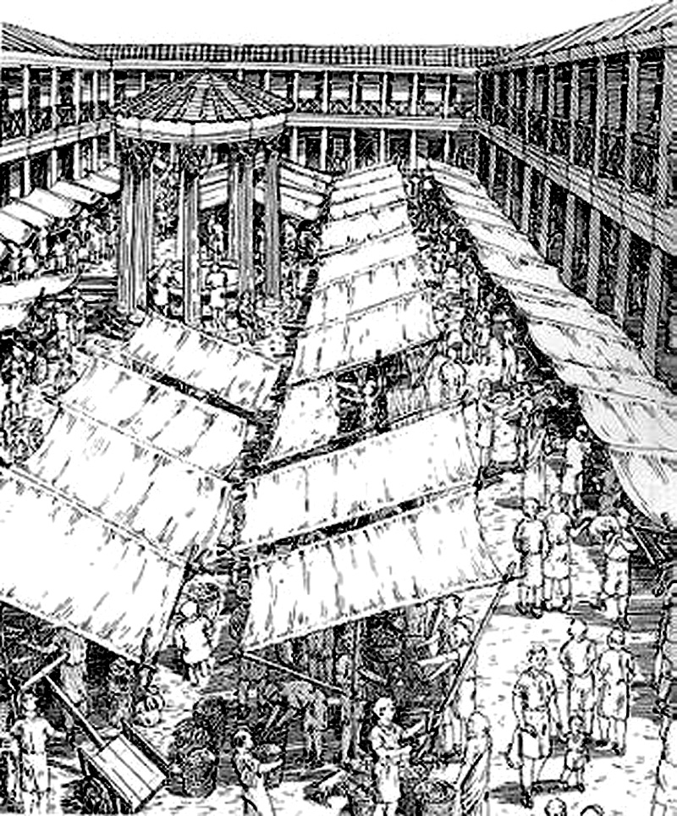
Unit 7--Medieval Roman/Italian Economy
Medieval Roman/Italian Economy

Think in the right direction -- economists fill the air with jargon. Let's not do that.

Questions for non-economists:

What effect does our own background have on how we view other economies?

What is "property" and who, if anyone has a right to own it? to control it? to dispose of it?
Does economic liberalism require abolition of property? Will equitable distribution do?

What is the function of "power" in acquisition and holding of property?

How is property inherited? "Gavelkind" and primogeniture?

Can groups, or "peoples", or "nations", or "tribes", etc., inherit?

What are "takings", eminent domain, adverse possession, and is there ever really a "greater good for the greater number"?

Are we the first to think about such things?

Ancient Romans?

What survived into medieval times?

Did medieval times produce anything new?

What is manorialism? Feudalism? Latifundia?

Any further questions that need answering?
--------------------------------------------------------
Italian Economy in the Middle ages

[Note that "Italy" is used here as an ex post facto geographic definition.]

1. Rural Economy
Early medieval Italy was an overwhelmingly agrarian society.
Tenants rather than slaves worked farms.

A few skilled specialist slaves still remained.

Rent was paid in cash or kind to the curtes (estate center "court") of the landlords.

The "fall of the Roman Empire" put many people back on the land. As distribution systems collapsed, folks just had to be closer to food sources.

Initially there was only agricultural "subsistence" [a strange word directly from Latin: subsistere, meaning, "to come to a stand" the sub- prefix (meaning "under") possibly meaning "under pressure". It's clear from usages that "subsistere" meant "to hold one's own under pressure" or "to survive -- but just barely".]

Rents in kind reflected what the peasants could grow for their own use: grains (rye, north; wheat center and south), grapes after the 8th century, olive oil in the center and south (Spanish imports having greatly declined due to loss of control of sea routes), hunting and gathering in the forests (much more extensive than now).

Meat was fairly common on farmers' tables in the earlier period (mutton, beef, pork raised individually) but less common as specialist herders took over raising meat for the market -- but as meat consumption went down among farmers, more was sold to increasing urban populations. Animal "byproducts" -- leather, wool, tallow, glues became more available and industries using them rose in towns. Fruits and vegetables were first grown for individual use and later for markets.

Early land ownership: many tenants, some peasant owners. Acreages were small -- even big landowners owned hundreds or even thousands of small plots rather than one big farm. Big landowners often had their seats in cities and had local overseers -- often individual tenants or hired peasants.

Northern estates gradually became more organized -- there, unpaid labor on the demesne (land farmed by the owner rather than by the tenants) might also be required.

Estates could be huge and could produce salable surpluses.

Over time, estates were consolidated and larger landholdings became more common.

The papacy eventually was the main "Roman" landholder -- in quotes because papal estates, the result of donations (including the donation of Pepin) were far-flung, not just around Rome: papal estates in the far south were huge.

By the 12th century the papal estates were among the largest in Italy.

[This did not imply that the popes were among the richest -- many of the great families had other sources of income, especially trade, which the popes never had. Eventually, when the Popes were drawn from the great families -- starting in the late Medieval, when there were, for example, Orsini and Colonna popes -- papal and family fortunes became indistinguishable. Contrary to popular opinion, popes or papal families didn't increase their wealth by attaining the papacy -- it was usually the other way around. Having a pope in the family was costly.]

Money rents became more common as time went on, because there was a fair amount of cash floating around in trade and because new lands brought into cultivation "around the edges" (due at least partly to warming) gave tenants produce to sell for cash.

As time went on, the "aristocracy" consolidated their power, but note that you had to have some power (= wealth of some kind, gotten by whatever means) to become an aristocrat. The aristocracy was actually just a loose assemblage of the rich and powerful. Kings developed the same way. The very existence of a "Feudal System" is questionable -- not because it wasn't "Feudal" but because there was no "System" except as seen ex post facto.

In Italy, more than in the rest of Europe, there developed a "landed plutocracy" -- rich landowners who gradually consolidated large estates which were often run from urban offices by bureaucrats employed by the rich. Such "agribusiness" wasn't new, nor did it end with the medieval period. When other investment opportunities were available they put some money into that also, but the Italian economy was predominantly agricultural at least until the end of the 19th century.

As the aristocracy developed, peasants lost out -- land and sometimes even their freedom was lost. Kings (there were usually several regional "monarchs" often with "king" in their title) tried to protect the peasants. They did this, because they feared that incentives for services to the "kingdoms" -- road and bridge maintenance, court and military service, etc. -- would disappear and that "royal" power would be lost to the nobility. That's just what happened.

Agrarian monarchies collapsed in the 10th century and individual fortified manors -- really castles in Italy -- became the rural power centers. Rural military families rose and military power was concentrated in their militias. The higher nobility -- counts, dukes, some of the old kings -- could maintain power only by making deals with the lower nobility and that only to the extent that they had militias of the their own.

[In northern Europe this same pattern lead to powerful castles with alliances that could put large military forces in the field and concentrate power. This was less true in Italy because concurrently the cities were developing as balancing power foci.]

2. Urban socio-economy

Most of the ancient Roman cities survived -- although populations declined dramatically. Rome went from 1.5 million in the 2nd and 3rd centuries down to perhaps 15 thousand at the middle of the 14th century. The transfer to Constantinople, barbarian depredations, supply problems, and plagues all contributed.

But in the early Middle Ages and until the 10th or 11th century, Rome was still a major European population center of 50 thousand (?) people. There was still nothing bigger in Europe, and even when the plagues of the 14th century dropped Rome's population to its lowest point, the same thing was happening elsewhere in Europe. Most of the time, Rome was Europe's biggest city.

Rome also had historical and religious prestige going for it. Charlemagne, the Ottonians, the Holy Romans, everybody came to Rome to claim the "Roman" imperial crown. Papal opinions -- and especially condemnations -- counted.

But some former “Roman” cities in Italy failed, mostly up in the mountains and down by the sea. Some mountain cities existed only as resorts and needed central Roman military support to survive. Crossroads cities did survive, even up in the mountains. Similarly, there were coastal port towns, which lost their reasons for existence when imports declined whether due to lack of demand or due to loss of control of sea lanes.

Urban populations no longer filled the walls of the cities. In Rome, most of the population moved off the hills and down into the Campus Martius. People huddled together in what was the lowest and still the most pestilential section of town.

Most cities maintained an urban economic identity -- town records were kept and indicated that trades and crafts persisted. As the "landed aristocracy" had their headquarters in the cities, there was a market for luxury goods. Trades, especially building trades, also did well as the nobles vied with each other in building urban churches. Some goods that were imported during the Roman Empire were made locally in the cities. The evidence for pottery is best, but possibly only because pottery outlasts most other manufactures -- potsherds are almost indestructible.

[Our own "indestructibles" may include plastics and aluminum and glass beer containers, but vitreous pottery will still be right in there with the rest. Can you guess what our most durable manufacture is, according to archeologists? David McCauley's Motel of the Mysteries provides the answer: bathroom fixtures and especially toilets.]

Italy's classical cities were not based on commerce (although they were somewhat dependent on commerce) so the breakdown of classical commerce didn't threaten their existence (just their feasible size). The slow revival of trade after about 750 did help cities to start to grow back to their former size. They always were and would remain later as nodes at intersections of river and road networks that, by the High Middle Ages, were again commercial trade routs.

Coastal cities became trade centers and, before the beginning of the Renaissance, they became international trade and naval powers. Venice and Genoa and to a lesser extent Pisa, were among the strongest and ultimately became masters of the reviving Mediterranean trade. Naval alliances, with major "Italian" participation ultimately swept away the Saracen pirates -- in fact replacing them and becoming looters of other peoples shorelines. Remember, the Venetians carried off most of the wealth f sacked Constantinople and still proudly display it in and around St. Mark's cathedral.

3. Late Middle Ages:

In the late Middle Ages, the 12th and 13th centuries, Genoa, Pisa, and Venice were all international powers. Rome maintained its prestigious position but could never project military power. [Nonetheless, some Roman families, particularly the Colonna, bought their way into the naval coalition that defeated the Saracens.]

Population rose rapidly in Italian cities and the countryside as wealth and food production increased. Some population experts also attribute the population rise to the general immunity to locally circulating diseases [-- a situation that changed when the plague arrived from the east in the 14th century. But even before the arrival of the plague, population plunged due to famine in the early 14th century, caused by drought and exhaustion of crop land.]

In the 13th century prosperity increased dramatically both in the maritime cities and in cloth industry centers, especially woolen textiles in Tuscany. Venice dominated eastward trade, especially after the 4th crusade (1204) and Genoa, eclipsing Pisa, dominated the Western Mediterranean and trade into Provence. In the second half of the 13th century, Florence gained influence in the Kingdom of Sicily due to its close ties with the Angevins and the Papacy. By the end of the 13th century, the first urban residential "Palazzos" -- small, but still Palazzos -- started to pop up in Italian cities.

There was also enough excess wealth to build new municipal buildings, like the Palazzo Senatorio, built over the top of the ancient Tabularium, in Rome. Big new churches were built in the cities, especially for the Franciscans and Dominicans, and Assisi became Italy's biggest religious tourist attraction.

The Tabularium/Palazzo Senatorio building played a part in many Roman developments. The Tabularium had been built as the national archives of ancient Rome over an archaic temple of Veiovis (later identified with, but not identical with Jove). In the Middle ages it was first fortified as a residential compound by the Corsi family. When the Roman Free Commune was established in 1143 the Corsi "Palace" became the seat of the Senators and local magistracy. By 1299 it had been aggrandized by the addition of a loggia by Pope Boniface 8. Petrarch was crowned as Rome's first Poet Laureate since the end of the Empire in the council chamber in 1341. In 1354, on the steps leading up to the loggia, Petrarch's protégé, Cola di Rienzo, was torn to pieces by the mob that had formerly supported him. (More on them in later units -- for now, suffice it to say that some historians list those two events as ending the Roman middle ages and starting the Renaissance. .)

As mentioned above, there were agricultural and health crises in the 14th century, but even then, despite these setbacks, northern and central Italian trade, manufacture and venture capitalism recovered rapidly -- in fact, population declined (after the rapid gains of the two previous centuries) leaving resources to be shared out among fewer people. Individual artisans, tradesmen, even urban laborers and rural peasants got richer after the plague because they more easily could sell their products and labor in a shortage economy.

Economic developments in southern Italy were much slower [and many modern Italians will tell you that the south is still today in the Middle Ages: "They have cars, but look how they drive!"]

In Rome, the disabitato shrunk slowly moving first to the east of Via del Corso in the Campo Marzio (no longer the "Campus Matrius" as "Italian" replaced Latin) and then into other areas around the tower-fortresses of the rich families. [But there were still farms inside the Aurelian Walls until the Post Resorgimento building boom of the 1880's.]

In the central and northern countryside, sharecropping gradually replaced tenancy, but there were also more freeholders in the later years. New rural technologies and methods were also developed in response to population growth, and an upward spiral began -- population that had been limited by agricultural production and lack of food imports now was the engine behind more production and renewed imports. A new "heavy" plow pulled by teams of oxen allowed deeper plowing, which brought nutrients to the surface. "Intensive farming" meant more crops growing on fewer fields, which should have allowed crop-rotation and more fallow fields. But population outstripped production and the fallow fields more and more marginal lands were all forced into production. (This was, in fact, the pattern in most of temperate Europe at this time.) This was all OK until agricultural conditions changed.

The Medieval Warm Period and the Little Ice Age: Yes, Mother Nature took a hand. The increases in agricultural production in the 12th and 13th centuries were partially caused by what is now known as the "long term pattern" of the North Atlantic Oscillation -- we are more familiar with its Pacific analog which is associated with El Nino fluctuations. What it boils down to is that it was warmer than usual in the 12th and 13th centuries and that also meant much more moisture for Europe as warm air flowed inland from the Atlantic. But some trip point was reached in the second quarter of the 14th century and the pattern reversed: cooler drier air covered Europe and what is now known as the Little Ice Age ensued. Meteorologists say that it lasted until about 1900. What we are experiencing now -- what the ecologists call Global Warming -- is an upward swing toward "normalcy." This all appears to be driven by long term Solar cycles. Note that the direst predictions of the ecology industry are probably true -- it's only when they put too much emphasis on the effects of human activity that they go off track. [Coastal flooding is a good example of the real effects of "Global Warming" effects. The Netherlands were under water through most of the Medieval Warm Period as were large areas around the Chesapeake Basin -- the latter, by the way, formed by the arrival of a mile-wide rock from space called the Chesapeake Bolide about 35 million years ago]. We could do another whole course on the long term Solar cycles, the Atlantic and Pacific oscillations, the Japan Current and the Gulf Stream, sea and land tides, etc. -- maybe some day.

At the same time, reduced population meant less food was needed so field could lie fallow more often. After the population reductions caused by recurring plague outbreaks, the rural peasantry cold no longer be held in their "home" estates -- they had bargaining power because they could simply decamp and sell their labor to another estate or move into town where labor was also scarce. Smaller rural populations also meant that some landowners, including the papacy were forced to lease their land to farmers at low rates and for long terms if they wanted any income at all for their lands.

In a later unit, we'll talk more about the opportunities that arose as a consequence of the agricultural collapse caused by climate change, overstressing the land during the Medieval Warm Period, and plague induced population reductions.

Unit 8 -- Rome Architecture--Late Medieval
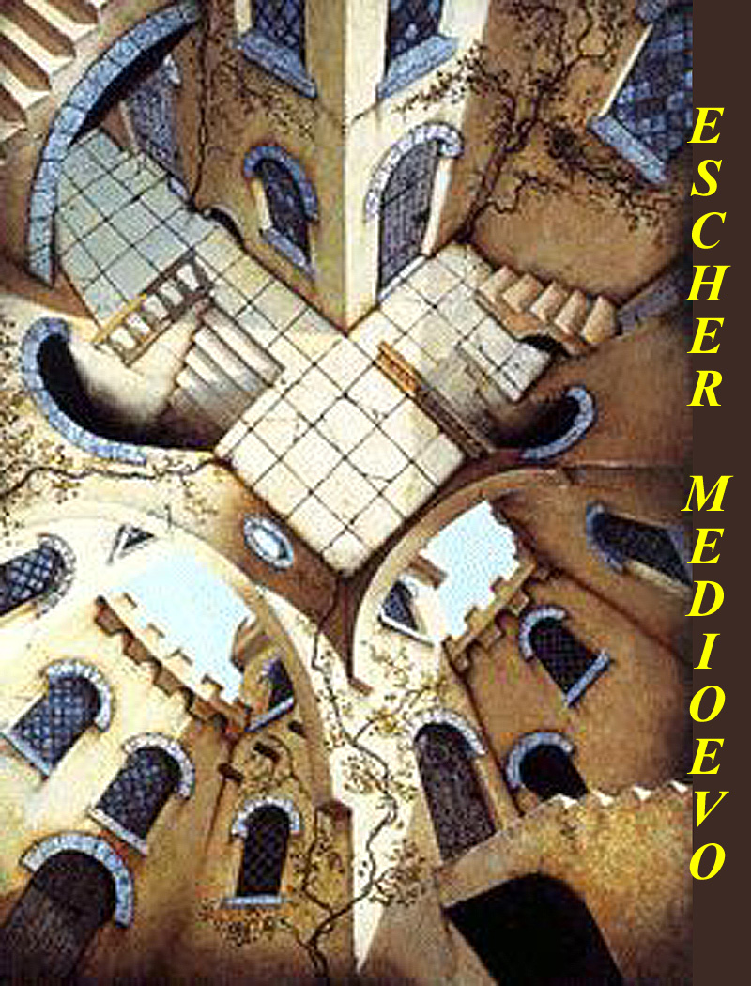
Rome Architecture--Late Medieval

How do we know what we know?

Most Early Medieval architecture is a mystery. Almost all of it was destroyed to make place for later structures. A few churches survive, and we have seen Santa Prassede and Santa Cecilia. They survived either because they were out of the way (Prassede) or in much modified form, especially the exteriors (Cecilia).

For the later Medieval, we have remains of several different kinds of structures: towers both as fortresses and bell towers; monasteries (the biggest and best are not in Rome); and housing, although the houses that remain in Rome are invariably of the upper classes.

We also have late Medieval structures preserved in works of art and in tourist maps and brochures. Many of the tourist items were produced just at the end of the Medieval or at the beginning of the Renaissance and were usually designed to guide Jubilee pilgrims. Renaissance artists were fascinated by ancient Rome's ruins, often fancifully reconstructed and filled with biblical rather than Roman scenes -- they were not much interested in painting the remains of "lesser", i.e., Medieval, structures.

Some pre-Raphaelite painters, in reaction to the Mannerists (who painted "in the manner of" Raphael and Michelangelo, painted simpler scenes using Medieval looking backgrounds.

"Modern" Roman artists -- in Roman parlance, that's anything after about 1750 -- when they were still doing representational and impressionistic art made images of Rome's Medieval past.

History always intervenes, and a watershed date for Roman architectural history was September 20, 1870, when Rome as the last vestige of the Papal States fell to the Bersaglieri forces of the Risorgimento. From the beginning, there was never any doubt that Rome would be the capital of reunified Italy. That meant massive redevelopment in the 1870s and '80s. The last empty spaces of the disabitato were rapidly filled. A huge flood control project drastically altered the Tiber shoreline, and many medieval structures were replaced or buried behind modern facades.

Of course there had already been several waves of urban renewal in the Renaissance and Baroque periods, the most drastic of which was the imposition of wide straight avenues connecting the Pilgrimage Churches by Pope Sixtus V (Felice Peretti -- pope from 1585 - 1590). Much of Medieval Rome disappeared then and during the construction of the great Palazzos from the Renaissance until the 1880s.

A lot of what was left disappeared in the post-Risorgimento building boom, but luckily, artist Ettore Roesler Franz decided to document what was being replaced in a series of watercolors called Roma Sparita -- Disappearing Rome. The paintings are now preserved in the Rome City Museum in Trastevere (one of the Museum's several venues), and there are several "art books" available that show them very well. Some of his works are on the Internet and you can see them by linking through http://images.google.com/images?hl=en&lr=&ie=ISO-8859-1&newwindow=1&q=roesler+franz

Ettore Roesler Franz has always been though of as a workmanlike journeyman -- never a "Master" -- and someone whose works would be studied by a "Rome Historian" rather than by an "Art Historian".

What's left in Rome (and elsewhere, as analogs)?

Churches as mentioned above, for example:

S. Cecilia:
Looks almost like an ancient Roman temple at the back of a portico -- except, of course, that the courtyard has no side porticos. The roof has acrotiria in the same positions as those of ancient temples and the central roof fixture, a crucifix, is in the position usually saved for Apollo or the dedicatory god/goddess.

The narthex (porch) in front of the church is 12th century with re-used ancient columns. [The "curls" at the joint of the façade and the narthex roof are baroque, as are the papal plaque, and some other façade decorations were added about 1725.]

The urn in the center f the courtyard is an ancient lustral basin, and it's just where it would be for lustration ceremonies in ancient times. Baptisms might be performed in and around it. [But the lustral area is also very reminiscent of what you find in Mosque courtyards -- cleaning up before entering a place of worship was a pan-Mediterranean phenomenon.]

The fabric of the church and its entrance narthex is 9th century and it's built over the ruins of an earlier church and of even earlier ancient Roman residences. The urns on the rail above the narthex are probably Renaissance.

The campanile, bell tower, is 12th century -- you can this tell by the triple windows. Later campanili typically had double windows and sometimes pairs of double windows.

For architectural and artistic information on many of Rome's churches, see
http://www.sacred-destinations.com/italy/rome-churches.htm or
http://penelope.uchicago.edu/Thayer/E/Gazetteer/Places/Europe/Italy/Lazio/Roma/Rome/churches/home.html

Abbeys

There had been a flurry of church aggrandizement during Rome's brief "Carolingian Renaissance", but the real building boom, when many churches were rebuilt or enlarged, coincided with the period of Roman prosperity in the 12th and 13th centuries .

Many of Rome's churches were turned over to the Benedictines and to Benedictine offshoots in the early monastic phase, and more were given to the mendicant orders (Franciscans, Dominicans and offshoots) in the late Medieval period.

During the late Medieval turnovers, cloisters, quarters, refectories, and bell towers (campanili), were added and many of Rome's churches became urban abbeys. There were many later changes, but the cloisters and campanili remain. ["Cloister" is derived from Latin claustrum = an enclosed space; "campanile" would mean "bell place" from Late Latin (i.e., Early Medieval Latin) campana = bell (perhaps from a kind of metal bell made in Campagna, the area between Rome and Naples), or perhaps from cembalus, which we have elided into cymbal.]

It's hard to visualize Roman abbeys as separate architectural complexes, because they mostly surrounded by other strictures, and in many cases their fabric has been buried in later additions.

Two of Italy's most famous abbeys -- outside of Rome and looking much as they did during late medieval times -- can give us a better idea of "Roman abbey architecture."

Both of our examples, the Franciscan abbey in Assisi and the Benedictine Monte Cassino Abbey, have had major recent reconstructions, but both were rebuilt to the "original" plans, i.e., to the way they were in the Late Medieval.

Assisi:

The September 26, 1997, earthquake heavily damaged the Church and complex in Assisi. Reconstruction money flowed in rapidly -- $50 million from the Government of Italy and another $50 million from the Vatican. Collections worldwide more than equaled the Government and Vatican donations. Initially towns around Assisi complained that all the money was going into the pilgrimage/tourist town, but Franciscan administrators of the funds found ways to spread the excess funds around, and just about everything in all the towns has been rebuilt in the last five years.

[There was extensive damage to some frescoes inside the church of St. Francis, but by coincidence a photographic archive of all of the frescoes in the upper and lower churches was completed just minutes before the first quake. It was the middle of the night -- before one A.M. on the morning of Sept 26. The photographer took his last shot, brought his cameras down from the scaffold, and left them standing in the sanctuary while he went outside for a cigarette. Halfway through the cigarette, the first earthquake struck. At first light, a group of monks and town officials entered the church to survey the damages, and the photographer went in with them to retrieve his cameras. He was taking pictures of the surveying party when the second quake struck. He photographed the roof caving in on them and killing two of themPictures of the Basilica and of all the frescoes are on the Internet at http://www.christusrex.org/www1/francis/upper.html and following pages.]

Around the church and abbey, collapsed buildings that had been built onto the original structures -- haphazard accretions -- were simply hauled away and the complex was restored to its Late Medieval condition. The Google Search engine will find you thousands of Internet sites with information and more pictures of Assisi and the Abbey/Basilica Complex. [The Franciscan Order has an Internet site at http://www.ofm.org but it sometimes seems to be on Medieval Standard Time -- loading slower than almost anything else on the web.]

Montecassino:

German forces emplaced artillery and observation posts within the Abbey as allied troops moved north toward Rome. A long battle for the plateau on which the abbey stood ensued. There were heavy artillery barrages and bombing attacks on the monastery. Eventually, on May 18. 1944, after five months of fighting, the position was taken by American and allied forces (mostly Poles), but by that time there was nothing left but rubble.

The artistic loss was great -- Italy's best medieval and Renaissance artists had decorated the place -- but, contrary to what has sometimes been reported, much of the library was saved. Some Medieval and Renaissance books had been stashed in caves in the mountain and others had been evacuated. It is also worth noting that both the Vatican and the Benedictine Order agreed to the allied bombing and artillery attacks in advance.

The Monastery was completely rebuilt using detailed architectural drawings and photographs taken before the destruction. The Monastery has its own Internet site at http://www.officine.it/montecassino/main_e.htm, and there is more info and pictures at the Benedictine Order's web site at http://www.osb.org/osbsitemap.html.

Medieval Roman Housing

Little if anything remains of Roman housing of the early or middle Medieval periods. The same is true in other Italian towns and cities.

Houses from the earlier periods simply weren't as substantial as those built later, and the vast majority of them were replaced during the boom years of the late 12th, the 13th, and the early 14th centuries. Any that remained after that period were the most likely to be removed in later centuries.

At any rate, there is not even much evidence that new permanent housing was built in Rome during the long population decline from the time that Constantine decamped first to Milan and then to his new capital, Nova Roma, later Constantinople, until the short-lived population rise that started in the 12th century boom. While the population was shrinking, most folks apparently just moved into increasingly ruinous ancient Roman structures, keeping them in the best repair that the long depression economy could provide.

There were exceptions, of course, particularly in the growth of the two Roman "borgos" -- like fortified villages -- one around St. Peters on the Vatican hill and the other south of the city on the Tiber River near the church and monastery of St. Paul's Outside the Walls. Both of these "borgos" were built as defenses against sea-born barbarian raids up the Tiber River in earlier Medieval periods. But these places were popular in later times and so they were also ripe for later redevelopment.

Examples of late Medieval housing still exists in fairly large numbers in Rome, but we'll start with what isn't there and why.

Housing for the lower orders didn't survive. It was still, essentially, "in the ruins" and remnants of their habitation there were later removed .

You sometimes see rows of holes along the outsides of ancient Roman monuments where Medieval joists and roof beams were inserted, and, if the rows are low and not very long, they indicate lower class structures -- lean-tos and sheds.

[Not all "rows of holes" indicate Medieval structures. For example, the holes along the front of the Curia Julia in the Republican Forum are where a front porch was attached during the Roman Empire period. And some of the holes on the outside of the Colosseum were attachments for external Medieval structures, but most of the holes there were drilled in to get at metal -- mostly lead -- that was holding the main fabric together. We know that the removal of the metal soon had disastrous results.]

Any new lower-class housing that was built in the late Medieval would probably be built for them by patrons, employers, or landlords, who would have no interest in maintaining such structures beyond their useful lifetime. After that they would be demolished and replaced if replacements were needed.

There are numerous upper-class remains.

A lot of what's visible are towers (torri), some of which still jut up dramatically in the Roman skyline. These were the fortress homes of Rome's noble families and their retainers. Generally speaking, the bigger ones are later than the smaller ones.

And the towers were offensive as well as defensive. Families tried to overtop nearby towers. The object would be to have a high enough tower that you could shoot or catapult downward at your neighbors.

In Rome today, it's hard to see this "one-upmanship" worked, because there are so many later tall buildings blocking our views of the towers. But we can easily see what was "up" by looking at other towns, where later development did not cut off our lines of sight.

Rome's huge Torre dei Milizie, which, although now truncated, still dominates central Rome, is now a museum attached to the site of the Trajan's Market Museum just to the northwest of the Imperial Forums. If it looks a little tilted when you see it, it's not your imagination. It's not like the more famous leaning towers in Pisa and in Venice, but it has a bit of a tilt.

It was once one of two huge towers that belonged to the Conti family. Its size was determined by the size of the Colonna Tower built about two hundred meters away on slightly lower ground on the slope of the Quirinale Hill.

The Conti eventually reduced the Colonna tower to rubble, but their victory was short lived. The Colonna brought in clients from their rural holdings and eventually killed off the Conti -- the Conti family disappeared and their tower passed into other hands.

The Colonna family prospered and took over the whole of the slope of the Quirinale and built a new tower. They built their huge Renaissance Palace and gardens a bit to the north of the tower. The Colonna princes and princesses still live there and are the leaders of the highest rank of modern Roman "society." (More about the Colonna Renaissance Palazzo and Gardens is at http://www.romeartlover.it/Vasi193.htm and at http://www.romeartlover.it/Vasi63.htm.)

[The main reception hall of the Palazzo Colonna, the largest ever built in Rome after ancient times, is now a private art gallery -- actually open to the public for three hours most Saturday mornings -- and the room and kitchens can be booked for very large receptions.

[One of the main conversation pieces of the hall is a Napoleonic cannon-ball still lodged in a low set of steps that crosses the room near its eastern end. It's one of Rome's three famous cannon-balls: the one in Palazzo Colonna; Queen Christina's canon-ball at the Palazzo Medici; and the 1870 Bersagliari cannon-ball lodged in the outside of the Aurelian walls between Porta Pia and Porta Pinciana -- all three were stray shots. There are numerous un-famous cannon-balls jumbled or piled in nice pyramids in courtyards, palazzos, and fortresses around Rome.]

Nobody is quite sure of what to make of the Conti tower's current "Milizie" name -- the most common conjecture is that it may have been held for a while by somebody's militia, perhaps the Colonna militia after it defeated the Conti.

The other Conti tower -- still called Torre dei Conti is fifty meters north of Via dei Fori Imperiali where it intersects with Via Cavour. It's also an impressive structure, it's "footprint" and foundation is the pavilion that stood on the Northwest corner of the Forum Pacis built by Augustus. It now houses an office of the Antiquities Ministry and some Rome city government offices.

The Frangipane family occupied the Colosseum for a while and had a small tower at one end of the Circus Maximus -- now called Torre dei Frangipane. It's unlikely, however that this was the Torre dei Frangipane where Francis of Assisi lived during his last visit to Rome in 1223. More likely he stayed at the Frangipane fortress, the ruins of which are on the edge of the Palatine near the other end of the Circus Max.

Another Frangipani tower, now known as the Torre di Scimmia (= Monkey Tower, after an odd legend) marks another corner of the Frangipani huge temporary Roman hegemony. It's on the other side of the Capitoline Hill about 300 meters north of the Tetra Marcello, which was also in Frangipani hands for a while.

Some upper-class Medieval tower housing remnants are now "invisible", having been incorporated and sometimes redecorated into later Palazzos and housing blocks. In many cases, the "belvedere" (= good viewing) at the corner or core of Roman Renaissance palazzos are towers that the same or predecessor families inhabited.

The incorporations were in some cases documented at the time when they occurred, but in other cases they are discovered when modern preservation of improvements are attempted. Depending on the personality and wealth of the current owners this can be a good or a bad thing. It's much more difficult and expensive to preserve or upgrade a Medieval core structure than to work on later, i.e., Renaissance or later, fabric.

Much of the remaining late Medieval housing in Rome was for what we would call the upper-middle class.

A lot of that started as just plain middle-class, but it was upgraded and greatly modified in several waves of consolidation and "gentrification". The first such wave occurred during the late Medieval not long after many of the structures were built. The prosperous period we're talking about lasted almost 200 years, and as folks got richer they wanted to spread out.

Many Late Medieval middle class houses in Rome's Trastevere and Campo Marzio neighborhoods were originally built with kitchen garden plots behind them. But buildings first grew into and over those plots and then into each other. A householder might buy out his or her neighbor and connect adjacent houses into one bigger house. It was an old Roman tradition, after all -- it was how Augustus put together his palace on the Palatine.

[Also keep in mind of what has happened here in Arlington over the past 50 years and what is continuing today with expansions, inbuilding, and joining together adjacent "townhouses" in neighborhoods like Fairlington. During prosperity, changes and gentrification changes can occur very rapidly.]

There are numerous examples in Rome of this early aggrandizement. You can see where building were melded together -- uneven doorways, a few steps between unmatched floor levels, an occasional stairway to nowhere.

This process continued through the centuries and many Medieval houses weren't very Medieval in the end. In recent times there have been some efforts at "restoration" but it's mostly "Disneyfication" -- a Medieval "look", but with central heat, air conditioning, modern plumbing, full electric kitchens, elevators, big screen TV. Some of Rome's highest priced condos are advertised as "Medieval". Examples are the often photographed "Medieval casa" across the street from Santa Cecilia church in Trastevere and the mega-buck condos in the Teatro Marcello below the Capitoline Hill.

More Information
http://www.pitt.edu/~medart/menuglossary/INDEX.HTM
http://www.pitt.edu/~medart/
http://www.romeartlover.it/Mages.htm

Unit 9--Late Medieval Arts and letters
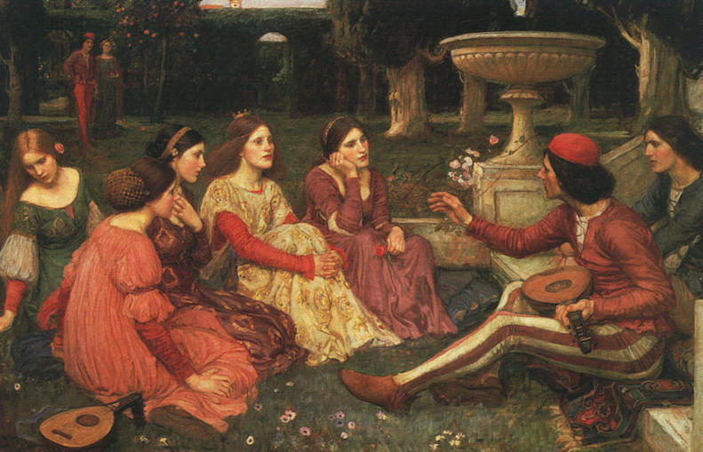
John William Waterhouse - THE DECAMERON 1915 - 1916
THE NATIONAL MUSEUMS AND GALLERIES ON MERSEYSIDE,
LADY LEVER ART GALLERY, PORT SUNLIGHT

Boccaccio's tales of 14th century are the basis of this dramatic composition of 1916. In 1348 a party of wealthy young patricians take refuge from the plague that is raging in the city in a villa outside Florence. To pass the time, they tell each other stories. Ranging from the earthily comic to the profoundly tragic, they encompass marital misunderstanding and thwarted passion, the simple joys of physical love as well as exuberant tales of deception and hypocrisy shamed. The perceived bawdiness of the novellas is somewhat challenged by Waterhouse's exploration of the suppressed sexual tension and emotion in the contrasted faces and demeanors of the women. The idyllic garden setting and the inclusion of the symbolic lutes of love give the picture a dramatic intensity.
Late Medieval arts:

Late Renaissance Mosaics:

Mosaics, or at least "mosaic like structures" go back at least to the Sumerians in the 3rd millennium BC.

Mosaics have always been for rich folks, and frescoes were used if you couldn't afford mosaics.

The great artistic fresco "re-inventions" of Cavallini, Cimabue, and Giotto -- three dimensional "living" figures and perspective scenes, especially architecture -- were anticipated in mosaics made at least a generation earlier.

Mosaics in S. Maria Maggiore

We've already seen some of Rome's early medieval mosaics in S. Prassede and Santa Cecilia. There is also a cycle of early medieval mosaics high on the walls of the interior of Santa Maria Maggiore, but it’s the late medieval mosaics in apse of S.M.Maggiore and outside under the roof of the Renaissance loggia that interest us now

Apse Mosaic by Jacopo Toriti

Torriti, Jacopo [Iacobus]

(c. 1270–1300). Italian painter and mosaicist. Two mosaics in Rome are signed by him: one, on the apse of S Giovanni in Laterano, that once bore the date 1291 (or, according to some sources, 1290 or 1292); and another on the apse and triumphal arch of S Maria Maggiore, now replaced by a 19th-century restoration but at one time dated 1295 or 1296. Torriti is also known to have executed a mosaic for Arnolfo di Cambio’s tomb of Pope Boniface VIII (1296; destr.; see ARNOLFO DI CAMBIO) in Old St Peter’s, Rome. Torriti was active during the same period as Cimabue and Giotto, Pietro Cavallini and Arnolfo di Cambio, but his fame has been obscured by theirs, no doubt because of his closer links with Byzantine art. He was nevertheless one of the most important artists working in Rome during the papacy of Nicholas IV (1288–92) and was entrusted with some of the most prestigious commissions of the day.

Circular "orbus" -- actually a large blue universe with gold stars -- inside of which, on a double throne, are seated Jesus and, to his right, his mother. Jesus is crowning her with his right hand and holding the "word" in his left. Below them the River Jordan flows in both directions, and to the sides are scenes of from the life of Mary. As usual, Saints are standing by as are the donors, Pope Nicolas4 (Girolomo Masci, reigned 1288-92) and Jacopo Colonna (elected Cardinal 1278.) Christ is shown not, as usual, as Pantokrator (=all ruler) but as coronator.

The figures are in no way Byzantine: poses are naturalistic, there is interplay among the figures, they reach back into and out from the plane of the picture and they are naturalistic in color -- all the things said to have been "invented" later by the fresco artists.

Loggia Mosaics by Filippo Rusuti

Rusuti [Bizuti], Filippo

(c. 1297–1317). Italian painter and mosaicist. His only certain work is the mosaic on the façade of S Maria Maggiore, Rome, which is signed on the mandorla of Christ. He served as ‘King’s painter’ in France during the reigns of Philip IV and Louis IX, receiving payments in 1304/5, 1308 (for repairs in the Grande Salle of the royal palace at Poitiers), 1309, 1316 and 1317, but none of this work survives.

Originally the mosaics were under a projecting curved super-structure and open to the piazza, like those on the front of S, Maria in Trastevere, but on a grander scale over and surrounding a rose window. They were covered with a Baroque Loggia, but in such a way as to incorporate them as decorations of the loggia.

Here the central figure is Christ Pantokrator holding a book with the text exposed: "Ego sum lux mundi qui" -- "I am the light of the world who (takes away sin)", with appropriate saints, donors and angels in attendance.

As with the apse mosaic, figures are three dimensional and "alive". Three dimensional structures are featured -- the other great "invention" of the later great fresco artists.

More Mosaics information:
http://www.dimosaico.com/pages/mosaic.htm
http://www.pitt.edu/~medart/menuglossary/INDEX.HTM

Late Renaissance Frescoes

There were two great schools of Late Medieval fresco artists, usually designated Florentine and Roman, but actually northern and southern with their centers in Florence and Rome, where there was enough money actually to attract artists who would set up studios.

This is not to say that the other cities in the north didn't produce fresco artist -- but they were usually co-opted into the "Florentine" or "Roman" schools. Also, then as now, a lot of inferior work was produced

The great northern masters were Cimabue (Cenni di Peppi, 1240-1302) and Giotto (Ambrogio Bondone, 1267-1337.

Pietro Cavallini (ca. 1243-1308) headlined the southern or Roman school.

[Georgio Vasari (b. 1511, d. 1574) was a mid-level artist but had a major influence on art history because of his series of artists' biographies. He was a northerner and his biographies were certainly biased in favor of the north -- and often said to be wittingly biased. His list of biographies starts with Cimabue and Giotto. Vasari wrote a bio of Cavallini, but did not credit him with all of his works nor with his clear influence on Giotto. [Vasari also does not explicitly credit the mosaicists, who came first, with some of the artistic "inventions" of the time.]

In the north, Cimabue flourished first, and Giotto was his student. Vasari inserts in their joint biography a legend that tells how Cimabue found a juvenile Giotto scratching pictures on a slate. There is no outside evidence that it's true, but it might have been current in Vasari's time -- nothing is really verifiable for the first 30 years of Giotto's life. He simply appears as a 30-year-old already being mentored by Cimabue.

Cimabue's work is usually still "Byzantine" -- i.e., traditional, flat, etherial, "not alive" -- but he did experiment.

Giotto's work is non-traditional, alive, three dimensional (both people and scenes), and of all the frescoists of his time, best at all of these things. His Padua frescoes clearly demonstrate this.

Of the three, north and south, Cavallini was the best known in his own time. He got the biggest and best commissions, especially in Rome. But his popularity meant that he decorated all the biggest and best churches in Rome -- where, in this period, the biggest money was.

Among his commissions were the major works in Old St. Peters, St. Paul Outside the Walls, S. Cecilia, S. Maria in Trastevere, and S. Maria in Aracoeli.

Because they were the biggest and most important Roman churches, they were most likely to be rebuilt or redecorated. Old St. Peter's was completely replaced, St. Paul's burned down in the 19th century, The Santa Cecilia Frescoes were buried behind and inbuilt loft (but eventually rediscovered around the beginning of the 20th century), the S. Maria in Aracoeli frescoes were painted over (only rediscovered in the last ten years). Only his mosaics in S. Maria in Trastevere were visible from the time of their making.

Assisi Frescoes

Giotto and Cimabue traditionally have received the lions’ shares of the credit for the frescos in the church of St. Francis in Assisi. Cimabue and Cavallini were credited with frescoes in the lower church. In the upper church, Cimabue was credited with the biblical cycle and Giotto with the "Life of Francis" cycle.

Recent research has pretty much established that the "Francis" cycle was actually the work of Cavallini's Roman school.

More Fresco info:

Cimabue:
http://www.abcgallery.com/C/cimabue/cimabue.html
http://www.mega.it/eng/egui/pers/cimab.htm
http://easyweb.easynet.co.uk/giorgio.vasari/cimabue/cimabue.htm
http://www.kfki.hu/~arthp/html/c/cimabue/
http://www.christusrex.org/www1/francis/lower.html
http://images.google.com/images?q=cimabue&ie=ISO-8859-1&hl=en
http://www.nga.gov/cgi-bin/psearch?Request=S&imageset=1&Person=232230
http://www.fordham.edu/halsall/basis/vasari/vasari1.htm

Giotto
http://www.google.com/search?num=100&hl=en&lr=&ie=ISO-8859-1&newwindow=1&client=googlet&q=giotto+bondone
http://www.christusrex.org/www1/francis/
http://www.newadvent.org/cathen/06565a.htm

Cavallini
http://news.bbc.co.uk/2/hi/europe/946648.stm
http://www.truefresco.com/dcforum/DCForumID29/1.html
http://www.google.com/search?num=100&hl=en&lr=&ie=ISO-8859-1&newwindow=1&client=googlet&q=cavallini+pietro&btnG=Google+Search
http://www.kfki.hu/~arthp/html/c/cavallin/lastjudg/index.html
http://www.kfki.hu/~arthp/html/c/cavallin/mosaic/index.html
http://www.mmdtkw.org/VCavallini.html
http://wwar.com/masters/c/cavallini-pietro.html
http://www.artcyclopedia.com/artists/cavallini_pietro.html

Fresco info
http://www.truefresco.com/technique.html
http://www.italianfrescoes.com/history.asp
http://www.italianfrescoes.com/frescotechnique.asp
http://www.sinopia.com/
http://www.muralist.org/fresco/intro.html

Late Renaissance Letters
http://www.newadvent.org/cathen/08245a.htm

Before we can understand the flourishing of "Italian" literature in the late Medieval period, we have to acknowledge a few things:

First, what we're talking about here is, finally and for the first time, really "Italian". The big three -- Dante, Petrarch, and Boccaccio -- all consciously decided to use and promote the "Italian vernacular".

Second, they and others before them were responding to stimuli from outside. Nobody, including themselves, ever claimed otherwise, but it's just not commonly known.

Third, they were the culmination of an already existing movement -- not its inventors -- and again, they never claimed otherwise.

Fourth, Dante did not invent the "dolce stil novo" (the "Sweet new Style"). In fact, what he did was invent the term to describe and praise the style that he and others before him were already using -- and he emphasized the work of others. Acknowledged precursors and then colleagues included Brunetto Latini and Guido Cavalcanti.

Fifth, Dante, was the undoubted leader of letters of his generation, and Brunetto Latini and Guido Cavalcanti were his contemporaries. Petrarch was in his mid teens when Dante died, and Boccaccio was five years old -- they were therefore contemporaries in the next generation.

Sixth, they all were well known in their own time and were memorialized by the great artists of their time. This means there are hundreds of pix of the big three to choose from in print and electronic sources.

Seventh, modern Italians are intensely proud of their literary tradition and the Italian language that grew from it. We, on the other hand, know that high class Italian, as it is defined today, was chosen to emulate the three masters -- it wasn't that they necessarily used the best, but rather that their popularity ensured that it would what was decided to be the best.

Brunetto Latini (c. 1210—C. 1294)

LATINI, BRUNETTO, Italian philosopher and scholar, was born in Florence, and belonged to the Guelph party. After the disaster of Montaperti he took refuge for some years (1261—1268) in France, but in 1269 returned to Tuscany and for some twenty years held successive high offices. Giovanni Villani says that “he was a great philosopher and a consummate master of rhetoric, not only in knowing how to speak well, but how to write well. . . . He both began and directed the growth of the Florentines, both in making them ready in speaking well and in knowing how to guide and direct our republic according to the rules of politics.” He was the author of various works in prose and verse. While in France he wrote in French his prose Trésor, a summary of the encyclopaedic knowledge of the day (translated into Italian as Tesoro by Bono Giamboni in the 13th century), and in Italian his poem Tesoretto, rhymed couplets in heptasyllabic metre, a sort of abridgment put in allegorical form, the earliest Italian didactic verse. He is famous as the friend and counselor of Dante (see Inferno, XV. 82-87).

More info
http://www.newadvent.org/cathen/09034a.htm
http://www.google.com/search?client=googlet&q=Brunetto%20Latini
http://www.italianstudies.org/comedy/Inferno15.htm
http://www.fh-augsburg.de/~harsch/italica/Cronologia/secolo13/Latini/lat_intr.html

Guido Cavalcanti (c. 1250—1300)

CAVALCANTI, GUIDO, Italian poet and philosopher, was the son of a philosopher whom Dante, in the Inferno, condemns to torment among the Epicureans and Atheists; but he himself was a friend of the great poet. By marriage with Beatrice, daughter of Farinata Uberti, he became head of the Ghibellines; and when the people, weary of continual brawls, aroused themselves, and sought peace by banishing the leaders of the rival parties, he was sent to Sarzana, where he caught a fever, of which he died. Cavalcanti has left a number of love sonnets and canzoni, which were honoured by the praise of Dante. Some are simple and graceful, but many are spoiled by a mixture of metaphysics borrowed from Plato, Aristotle and the Christian Fathers. They are mostly in honour of a French lady, whom he calls Mandetta. His Canzone d’Amore was extremely popular, and was frequently published; and his complete poetical works are contained in Giunti’s collection (Florence, 1527; Venice, 1531—1532). He also wrote in prose on philosophy and oratory.

More info
http://www.sonnets.org/pound.htm
http://en.wikipedia.org/wiki/Guido_Cavalcanti
http://www.enotes.com/classical-medieval-criticism/guido-cavalcanti

Dante

born c. May 21–June 20, 1265 , Florence, Italy; died September 13/14, 1321 , Ravenna

Italian poet. Dante was of noble ancestry, and his life was shaped by the conflict between papal and imperial partisans (the Guelphs and Ghibellines). When an opposing political faction within the Guelphs (Dante's party) gained ascendancy, he was exiled (1302) from Florence, to which he never returned. His life was given direction by his spiritual love for Beatrice Portinari (d. 1290), to whom he dedicated most of his poetry. His great friendship with Guido Cavalcanti shaped his later career as well. La Vita Nuova (1293?) celebrates Beatrice in verse. In his difficult years of exile, he wrote the verse collection The Banquet (c. 1304–07); De vulgari eloquentia (1304–07; “Concerning Vernacular Eloquence”), the first theoretical discussion of the Italian literary language; and On Monarchy (1313?), a major Latin treatise on medieval political philosophy. He is best known for the monumental epic poem The Divine Comedy (written c. 1310–14; originally titled simply Commedia), a profoundly Christian vision of human temporal and eternal destiny. It is an allegory of universal human destiny in the form of a pilgrim's journey through hell and purgatory, guided by the Roman poet Virgil, then to Paradise, guided by Beatrice. By writing it in Italian rather than Latin, Dante almost single-handedly made Italian a literary language, and he stands as one of the towering figures of European literature.

More info
http://www.newadvent.org/cathen/04628a.htm
http://www.danteonline.it/english/home_ita.asp and linked pages
http://www.trincoll.edu/~pbittenb/00-Intro.htm
http://images.google.com/images?hl=en&lr=&ie=ISO-8859-1&newwindow=1&q=dante+dore
http://dante.ilt.columbia.edu/comedy/
http://www.sacred-texts.com/chr/dante/

Petrarch

born July 20, 1304 , Arezzo, Tuscany [Italy], died July 18/19, 1374 , Arquà, near Padua, Carrara

Francesco Petrarca -- Italian scholar, poet, and humanist.

After 1326 he abandoned the study of law for his true interests, literature and the religious life. He took minor ecclesiastical orders and moved to Avignon, where in 1327 he first saw Laura, the idealized subject of his chaste love and of his celebrated Italian love lyrics; mainly sonnets and odes written over some 20 years, most were included in his Canzoniere or Rime (1360). The greatest scholar of his age, especially of Classical Latin, he traveled widely, visiting learned men, searching out manuscripts, and undertaking diplomatic missions. He strongly advocated the continuity between Classical culture and the Christian message; in combining the two ideals he is considered the founder and a great representative of humanism. His Latin works, reflecting his religious and philosophical interests, include On Illustrious Men (begun c. 1337), the epic poem Africa (begun c. 1338), the autobiographical treatise Petrarch's Secret (written 1342–58), De vita solitaria (1345–47; “The Life of Solitude”), and Epistolae metricae (begun c. 1345; “Metrical Letters”). After 1367 he lived in and near Padua. His influence on European literature was enormous and lasting, and his deep consciousness of the Classical past as a source of literary and philosophical meaning for the present was of great importance in paving the way for the Renaissance.

More info
http://www.newadvent.org/cathen/11778a.htm
http://petrarch.petersadlon.com/pictures_laura.html
http://petrarch.petersadlon.com/
http://petrarch.petersadlon.com/his_writings.html
http://www.google.com/search?client=googlet&q=Petrarch
http://www.worldwideschool.org/library/books/hst/roman/TheDeclineandFallofTheRomanEmpire-6/chap37.html
http://www.humanistictexts.org/petrarch.htm

Boccaccio

born 1313Paris, France, died Dec. 21, 1375Certaldo, Tuscany

Italian poet and scholar.

His life was full of difficulties and occasional bouts of poverty. His early works include The Love Afflicted (c. 1336), a prose work in five books, and The Book of Theseus (c. 1340), an ambitious epic of 12 cantos. He is best known for his Decameron, a masterpiece of classical Italian prose that had an enormous influence on literature throughout Europe. A group of 100 earthy tales united by a frame story, it was probably composed 1348–53. After this period he turned to humanist scholarship in Latin. With Petrarch, he laid the foundations for Renaissance humanism, and through his writings in Italian he helped raise vernacular literature to the level of the classics of antiquity.

More info
http://italian.about.com/cs/boccaccio/
http://www.newadvent.org/cathen/02607a.htm
http://en.wikipedia.org/wiki/The_Decameron
http://www.brown.edu/Departments/Italian_Studies/dweb/index.php

Additional RelevanLinks

Dolce Stil Novo

http://en.wikipedia.org/wiki/Dolce_Stil_Novo
http://italian.about.com/library/weekly/aa060699a.htm
http://www.crs4.it/HTML/Literature.html
http://digilander.libero.it/maironidaponte/didattica_online/vita_nuova/pagine/stilnovo.html (in Italian)

Courtly love
http://cla.calpoly.edu/~dschwart/engl513/courtly/courtly.htm
http://condor.depaul.edu/~dsimpson/tlove/courtlylove.html
http://www.astro.umd.edu/~marshall/chivalry.html

Unit 10 -- Cola, Plague, Other Opportunities

When did the Medieval period end?

Just as it didn’t “begin”, it didn’t really end. History simply doesn’t stop and then restart as something else.

History courses do begin and end, however, so historians invent and embrace “periods”.

Most historians say that the European Medieval period ended with The Plague and its aftermath or that the Roman/Italian Medieval period ended with Cola di Rienzi and his aftermath.

[and remember that Italy was invented, formed, discovered during the Medieval period.]

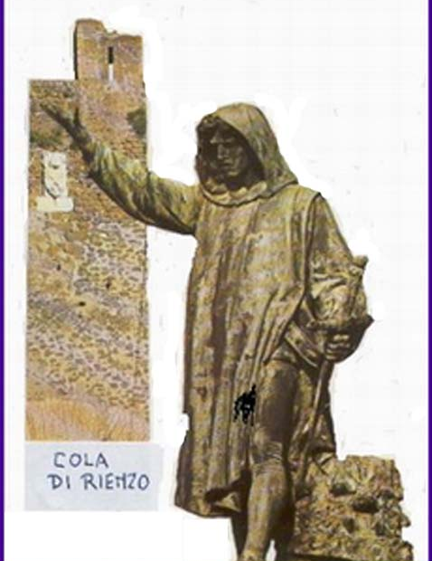

A. Cola di Rienzi

Much of what we know about Cola di Rienzi is semi-legendary.

Petrarch, who transmitted and controlled some of the initial information was an interested party – some say that Petrarch may have manipulated Rienzi as part of the Guelph/Ghibelline conflict and/or as part of the Colonna/Orsini rivalry in Rome and/or as an agent for the Avignon Pope (a Frenchman) who really wanted to stay in Avignon.

If Petrarch really was the puppet-master, he then was the first Renaissance man

The Rienzi Story:

Rienzi’s younger brother was killed in a dust-up between the Orsini and the Colonna.

Rienzi, who had been a client of the Colonna, asked for and was promised revenge by the Count, but the count reneged when he discovered that Rienzi’s younger brother was killed by Colonna’s own lieutenant.

Rienzi rallied the people to oppose/expel all of the nobility – i.e. both the Orsini and Colonna factions and their various allies.

The nobility fled – perhaps because they had previously had to send most of their urban retainers to the countryside to fill in behind a starving peasant population.

Rienzi antagonized the population and the church, and he fled when the noble return.

After wandering and imprisonment, Rienzi was returned to Rome under the sponsorship of Petrarch and the Avignon Papacy.

Rienzi soon antagonized the population again by taxes and his own excesses.

The nobility moved against him, and the antagonized “popolo” didn’t rally to his aid.

Rienzi was murdered by the nobility on the steps of the Palazzo Senatorio – he was then hacked by other nobles and thrown to the dogs.

End of Revolution.

A cynic might find a different story:

After Rienzi was shocked by the death of his brother he was manipulated through the above chain of events by Petrarch and other Avignon Papal partizans(/agents?) who wanted to bring the nobility down a notch or two.

After that was accomplished, the church withdrew its support and Rienzi was discarded.

Petrarch, as poet laureate and papal house philosopher made a pretty speech.

Post-Rienzi exploitation of the legend

Later dictators (universally ignoring how Rienzi ended) made him an heroic icon.

Napoleon, Hitler, and Mussolini all glorified Rienzi as their own heroic predecessor – they would finish his mission and restore the ancient Roman Empire.

Napoleon had a copy of de Cerceau’s Rienzi book with him at Waterloo.

Hitler told friends and the heirs of Wagner that Wagner’s Rienzi had been the motivational force of his life. (Wagner’s opera was based on Bulwer-Lytton’s novelization of the Rienzi story.

Mussolini had Gabriele d’Annunzio, the author of the most famous Italian glorification of Rienzi, as his own philosopher/poet laureate – the relationship paralleled that of Rienzi with Petrarch.

Rienzi was one example of what was going on

Arnald of Breschia’s activities and the Sicilian Vespers had similar “radical” characteristics, and after the plague there were similar outbreaks all over Europe.

More info
http://www.worldwideschool.org/library/books/lit/historical/RienzithelastoftheRomanTribunes/toc.html, Full Text of Bulwer-Lytton’s novelization of the life of Rienzi
http://www.mmdtkw.org/VRienzi.html
http://www.newadvent.org/cathen/13052c.htm
http://www.worldwideschool.org/library/books/hst/roman/TheDeclineandFallofTheRomanEmpire-6/chap37.html Gibbon's account from "Decline and Fall"
http://www.durbeckarchive.com/rienzi.htm

B. Plague and the Late Medieval Crisis

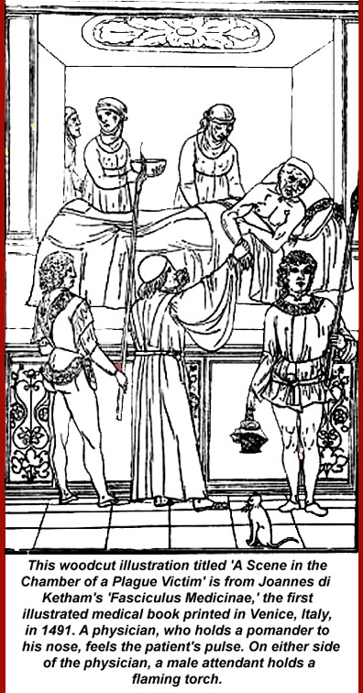
Pre-plague Population growth and decline

Population had grown dramatically in the 150 years before 1315, but then it started to drop.

The evidence is clear that population had hit a peak in Italian towns well before the plague struck in 1347.

Expansion of city walls stopped. In Rome, where there had already been large open spaces inside the Aurelian walls, the abitato had been growing, but then it shrunk again.

According to Malthus, population grows geometrically while food and other supplies grow arithmetically, but, in fact, that's not true in subsistence economies where supplies regulate population pretty quickly and very effectively -- folks simply starve to death as you move from subsistence to famine.

(Malthus was also wrong, of course, in the longer run -- he didn't know about or factor in the coming industrialization and green revolutions, birth control, or education-driven declines in birth rates. Some countries, notably Russia and Italy, already have negative population trends, and others appear to be moving toward negative population growth. Modern experts -- De Blij, et al., now ascribe local food shortages to distribution rather than over-fecundity.)

A three-year famine started in 1315. Then there were a few good years, a few bad, etc., but soon there were more bad than good. Land had been overused -- couldn’t even raise an increase on initial seed weight. And the weather also changed. As we've seen, the "Medieval Warm Period" ended and the "Little Ice Age" started at the end of the first quarter of the 1300s. A population die-off caused by famine was already in progress even before the plague arrived, and those who didn't die were in a weakened state.

Psychologizing the plague
Although "psychology" is always a dicey thing to bring into the study of history, it probably played a part here: not only were folks stressed by the increasing difficulty of putting food on the table, but, particularly in Rome, politics and the economy also were on a seriously chaotic course. Cola di Rienzi was busy agitating the lower class (the Roman mob redux), and the existing power structure -- the nobility -- was leaving town, both because of Rienzi and because the reduced rural population (those famines) required their presence on rural estates. Actually it was their retainers who were needed in the countryside, but if the retainers went to the fields, the nobles didn't have much of an urban gang to surround and protect them, so the nobles also left town.

When plague entered Rome, the population was therefore neither physically nor mentally able to resist.

Premonitions
In 1345, Saturn, Jupiter, and Mars aligned in Aquarius and astronomer/astrologists made dire predictions.

Early in 1348, a major earthquake rattled Italy from Naples to Venice: it was clearly volcanic as indicated by the release of vast clouds of sulfurous gasses – smelling of fire and brimstone -- in the Campi Flegrei. Within hours of feeling the quake, Romans and Neapolitans smelled the results, and when plague reached the cities a few weeks later, everyone knew that the volcanic “mal aria” was the real cause.

Plague
Some general statements on disease:

Diseases that are endemic to areas produce general immunity unless they are so virulent that everyone dies. There are long-term low levels of infection and, most importantly, equilibrium is established.

Diseases can and do change, sometimes by mutation and sometimes by “evolution”.

Diseases evolve toward weaker strains. The most virulent strains produce the greatest death rates in their hosts and therefore have less probability of long term survival: if, after a short time, there are few remaining hosts, then there is less probability of continued contagion.

Diseases can have multiple hosts. In the case of “plague” caused by yersina pestis, there are three: rodents, fleas, and humans.

Rodent populations (rats in the case of the 14th century plague) develop immunity by constant exposure – surviving individuals have antibodies.

Fleas die, but before they do, they infect humans. The mechanism appears to be that a common mutation in yersina pestis that makes it indigestible in the flea gut. The gut blocks and the flea stomach fills with rapidly proliferating yersina, but nothing gets to its intestine where digestion takes place. The flea gets (literally) insatiably hungry. When it tries to feed, the pressure from its engorged stomach forces some yersina into the bite wound. Fleas would keep biting and trying to feed until they died of malnutrition.

People die either from massive infections at the bite site(s) – large swellings called buboes marked the sites. If the infection had time to reach the victims’ lungs before they died, they could further spread the plague by aerosol expulsions. Plague could also reach the blood stream and blood would then also be infectious.

Only the rats were an effective reservoir for the disease.

Epidemics are simply mass infections. Equilibrium collapses, and many die.

Pandemics are multiple epidemics, either across wide area or over long periods, and usually both.

How it spread
Yersina Pestis is common in wild rodent populations and seldom spreads beyond wild populations – its endemic, for example, among prairie dogs in the American West and in wild rodent populations in Asia and Africa. Some rodents die, but the population in general becomes a reservoir which can be breached either by humans encroaching on their habitat or because the food supply in the habitat is disrupted. The 14th century outbreak was contemporaneous with the end of the Medieval Warm Period and the start of the Litle Ice Age, which is thought to have put the Central Asian wild rat population in motion toward areas of human population to the southeast – toward the Crimean.

Another theory links spread of the plague to the Mongol unification of Asia which facilitated trade in Asia and along the Silk Road to Europe and inadvertent transportation of infected rats by traders and or by persons who had survived the bubonic type of plague but were still contagious with the pneumonic type – if they went toward the Crimea, that may have been how the plague got there and then onward to Europe.

Course of the pandemic of “1347-50”
[That terminology is clearly Eurocentric – the epidemic actually started in western China in 1333 and appears to have move eastward first before it moved into the Crimea and the into Europe. China and Japan were clearly devastated – maybe worse that Europe. In 1346 plague was epidemic in Syria and Mesopotamia, those two geographic designations then including all of the Asian “Middle East” –tkw]

In 1347 the plague spread into Europe (from the Crimean Area) and Egypt (from Syria/Mesopotamia). By 1350 plague had crossed North Africa and all of Europe to the Atlantic Ocean and looped back into north eastern Europe (Russia and other north Slavic areas) – the farthest extent appears to have been Greenland where the population was totally wiped out.

Spread of the disease is thought to have been a result of trade, because it demonstrably followed land and sea trade routes

-1347 Sept - Sicily – Messina, thence to Pies/Florence and Ostia/Rome

-1348 Jan - France Marseilles

-1348 - England, Spain

-1349 - Eastern Europe, Iceland,

-1350 - Wipes out Greenland?

Later iterations

-Repetitions up until 1720s

-Spread by same trade routes

-1361-62 (Pest second - the children's plague), 1369, 74-75, 79,90, 1407

Effects of Black Death

Not every effect is due to the plague. Some trends happening earlier. Real danger of "post hoc ergo propter hoc" fallacy.

Population Effects

Overall “guestimate” one third of the European population died in the first wave of plague 1347-50. Population went down from 70-75 million to about 50 million.

Up to 50% in some towns - less with bubonic form of the plague, and more with the pneumonic and enteric forms

-Bohemia 10% -- got off lightly, and this was the area of minimum loss

-Paris -– 35-50% and the university, much worse
-- Avignon – 30-45%

-England -- 40-50% (e.g. clerical mortality - 40-50%.)

-Rome –- 35-50% (many fled, so it’s hard to tell)

-Siena -- 40-50%

-Orvieto -- 50%

-Florence -- 45-70%

“Childrens plague”, 1361-- 25% of population died.

Population declines for 150 years as a result of local recurrences.

Economic Effects

-Good for the surviving lower classes and bad for the surviving middle and upper classes

-No shortage of supply of goods and food (if anything, oversupply)

-Shortage of Labor

Price of Labor rises - peasant revolts when control attempted.

Golden age of the laborer?

-Increased prominence of cities over the countryside.

-Commerce revived after 1460.

Cultural Effects

-Denial, Acceptance, Lack of restraint

Art

Images of Death

Realism

Flamboyant architecture

Dance of Death

[Flagellants – actually a pre-plague phenomenon]

More info
http://www.courses.fas.harvard.edu/~chaucer/special/authors/boccaccio/boc-1-1.html
http://www.niaid.nih.gov/publications/dateline/0996/page9.htm
http://www.fordham.edu/halsall/lect/med25.html
http://history.boisestate.edu/westciv/plague/
http://www.historyguide.org/ancient/lecture29b.html
http://www.historyguide.org/ancient/lecture30b.html
http://historymedren.about.com/library/weekly/aapmaps1.htm and 7 additional pages
http://jefferson.village.virginia.edu/osheim/intro.html
http://www.fidnet.com/~weid/plague.htm
http://www.pbs.org/wnet/secrets/case_plague/index.html
http://historymedren.about.com/library/weekly/aapmaps3.htm
http://www.snopes.com/language/literary/rosie.htm "Ring Around the Rosie"

