Unit 2 – Barbarians
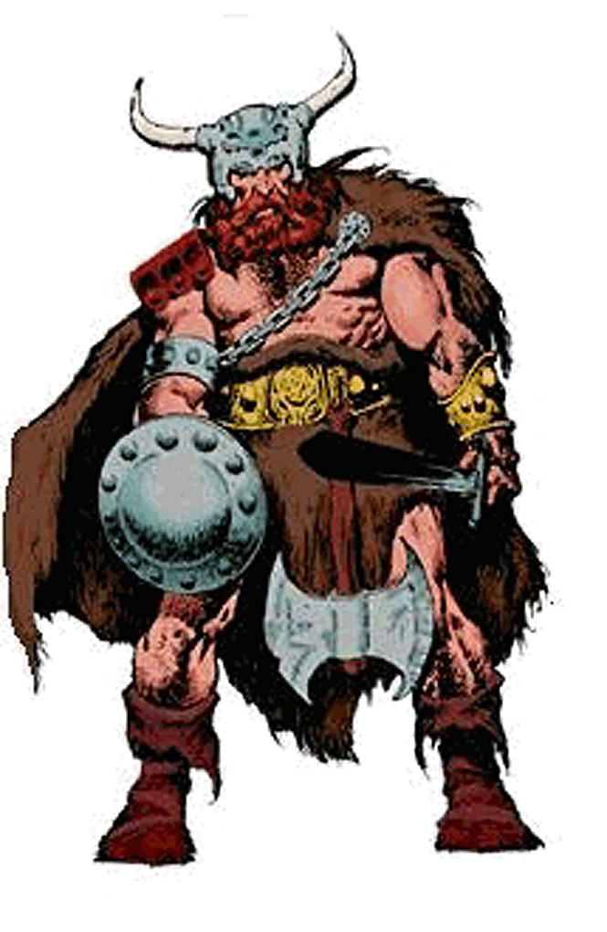
Introduction to Barbarians
Who were these guys and what did they look like?
They were neither the comic book characters nor the Hollywood barbarians.
Initially they were Northern Europeans, Middle Easterners, and North Africans that the ancient Romans were familiar with.
By "early barbarian" we mean those folks that the Romans fought against on
the fringes of the Roman Empire.
When barbarians were coopted into fighting on the side of the Romans the
were deemed to be "foederati", i.e., independent groups "federated" with Rome
If they were conquered or "provincialized" they were deemed to be inside of
and part of "Greater Rome", the empire.
Status of groups was somewhat fluid --
they could slip from one category to another

Ancient Romans called everyone who wasn't them "barbarians"

Etymology of "barbarian":
theory 1 -- Onomatopoeia: foreign languages sounded like "bar-bar-bar"
theory 2 -- facial hair: Latin word for beard was "barba"
theory 3 -- nobody really knows and 1 and 2 are ex post facto guesses
Romans exported Latin and were jingoistic about other languages --
except Greek
Romans were almost always clean-shaven --
except philosophers who were expected to have a beard (that's why
Marcus Aurelius is often shown with a beard that he probably didn’t have.)
Later Romans -- even emperors -- might be barbarian enough for beards
Romans themselves didn't know and debated the origin of the word
"barbarian"
We needn't worry about our Ignorance
So most early barbarians were long-headed caucasoid types or round-headed
Mediterraneans -- By caucasoid here we mean either "caucasian" or "from
the Caucasus region", i.e., slavs.

Later barbarians might be more oriental --
the Huns are sometimes thought of as Chinese
the Goths were pushed into Europe from the TransCaucasus by the Huns
the Lombards were Central Asians

Or they might be from the far north --
The Normans, as their name implies, were "North-" or "Norse-men":
They actually were peripatetic "Vikings" who conquered northern France and then sold their services as freebooters -- later versions were called "Condottieri".
As might be expected, they overthrew their employers.
And that was a well-established pattern.

Before talking about the sequential barbarian "invasions", we need to remind ourselves of several things:

The special case of the Franks -- It's hard to distinguish Franks from "barbarians"
but they usually are looked at differently and separately, maybe as heirs -- perhaps
because of Charlemagne and the founding of the Holy Roman Empire (not holy,
nor Roman, nor even imperial).
We will adhere to the "different/separate" convention.

Barbarian groups (often really just ad hoc confederations)
changed their names due to:
Population movements -- acquiring new place names
Expansion or contraction
Conquering or being conquered
Different names at different times
Different names in different languages
Different versions of "history"
Intentional ideological mislabeling -- as in "enemies" always equal ""
barbarians (of some stripe), and in modern times equal "terrorists"

"Historical" names for the large groups might be names that were applied by
enemies or by later writers/historians. They might not be what the folks
involved called themselves: we may not even know what they called
themselves.

This was already a long standing pattern and it still goes on today: American/English names of peoples, nations, communities, and states may bear little resemblance to what folks call themselves.
Italy/Italia;
Germany/Deutchland;
Switzerland/Helvetzia;
Greece/Hellas;
"Macedonian" claimed by two enemy groups;
Who are the "hilf tahrir falastinii"?;
etc.)

We can swallow all the historical naming variations, keeping in mind that
what is really important is coming to some conclusion about how the
peoples and events affected Medieval Rome (for the sake of this course) and
the end product us. (We'll keep asking that!)

Note also that there is a temporal organization here, but it is based on when the groups had their major interactions with Rome, not when the groups were formed, or had their most exciting events from an "in-group" viewpoint, or when they dissolved.

There will necessarily be loose ends -- there are just too many folks coming from too many directions to talk about everything and everyone. Our topics in this unit will therefore be somewhat illustrative rather than exhaustive. As usual, some of the more bizarre events will be included so that everyone doesn't just go to sleep.

Internal affairs, the predisposition of the Romans at various times and what was going on in Roman politics, often had more influence on their encounters with barbarian invasions than did the actions and strengths of the Barbarians.

Who's on first?????

A timeline/scorecard, even the bits that have little or nothing to do with Rome, using as many names of the teams and players as we can find (to confuse the innocent and conflate the guilty) is on the Internet at: http://www.mmdtkw.org/ALRItkwRom303_2BarbTimelin.html

Barbarian Groups and their Roman Interactions:

Visigoths -- Alaric trashes Rome -- 410 AD
http://www.mmdtkw.org/VAlaric.html
Galla Placida -- a woman with connections
http://www.mmdtkw.org/VGallaPlacida.html

Vandals -- Gaiseric nips off Spain, then N. Africa --
409-429 AD, Plunders Rome -- 455 AD
http://www.newadvent.org/cathen/15268b.htm
http://www.wikipedia.org/wiki/Geiseric
http://www.wikipedia.org/wiki/Vandal

Huns -- Attila dissuaded from attacking Rome by Leo 1 --
450's AD
http://www.mmdtkw.org/VAttila.html
Leo 1:
http://www.newadvent.org/cathen/09154b.htm

Visigoths (Sciri) again -- Odoacer, a mercenary, rules Rome --
476 AD
Romulus Augustulus and Orestes
http://www.mmdtkw.org/VRomulusAug.html
http://www.roman-emperors.org/auggiero.htm

Ostrogoths -- Theodoric boots out Odoacer -- 493 AD
http://www.fordham.edu/halsall/source/jordanes-theodoric1.html
http://historymedren.about.com/library/who/blwwtheogrt.htm
http://www.wikipedia.org/wiki/Ostrogoths
http://www.wikipedia.org/wiki/Theodoric_the_Great
Amalasuntha, Daughter of Theodoric, Regent for Athalric -- 526 AD
http://www.wikipedia.org/wiki/Amalasuntha
http://womenshistory.about.com/cs/medrenqueens/p/amalasuntha.htm

Lombards -- Alboin takes most of Italy -- 568-570
Lombards hold it for two centuries
http://www.boglewood.com/timeline/alboin.html
http://www.wikipedia.org/wiki/Alboin
The Movie:
http://www.cinemedioevo.net/Film/cine_rosmunda_alboino.htm
http://www.cinema-shop.com/Filme/Adventure/X_Plakate/alboin_11.jpg
http://www.imdb.com/title/tt0056427/

Franks -- Merovingians and Carolingians -- "protectors" not
barbarians -- 8th, early 9th century
See Unit 6

Saracens -- Pirates become occupiers -- 9th Century
http://www.ccel.org/g/gibbon/decline/volume2/chap52.htm Gibbon, east, chapter 52
http://www.ccel.org/g/gibbon/decline/volume2/chap56.htm Gibbon, east, chapter 56
http://www.bbc.co.uk/dna/h2g2/alabaster/A275492 Gibralter
http://www.angelfire.com/md/8/moors.html Many images
http://the-tech.mit.edu/Shakespeare/othello/index.html Othello
http://the-tech.mit.edu/Shakespeare/ All Shakepeare's plays

Normans -- Robert Guiscard -- expels Saracens, saves
then sacks Rome -- mid-11th century
http://www.roangelo.net/valente/conquest.html

Summing up:
Waves of "barbarians", all seeking the better life of southern Europe, brought new ideas into this "desirable" area. For the most part the barbarians wanted to preserve (for themselves) rather than to destroy the system in place.

The greener pastures and better organization that they sought in western and southern Europe were real, and by the end of the period of "invasions" everyone was much better off than ever before -- except, perhaps for the very thin veneer that had constituted the Ancient Roman ruling class. Remember that most of Ancient Rome's population was slave or downtrodden workers and that the "high culture" of the ancient civilization belonged only to a few.

And Medieval "culture" was more civilized than the Ancient Rome, which, by end, was chaotic, riven by civil wars and disputes, engorged and fascinated with human blood-sports, wrong (even evil) in so many ways. (Think about how few of us would have any chance of being what we are today in an "Imperial Roman" civilization.)

There were several reasons for this -- Christianity, removal of several layers of the ruling class to Constantinople, better land use, immunities to known diseases, etc. -- but not least among them were the new blood and ideas and more egalitarian social and legal organizations that arrived with the barbarians.

But then in the 13th/14th centuries, things came crashing down, first due to economic setbacks -- too many people and overcropped land led to food crises -- and then came the plagues with the opportunities that followed. More about that in unit 10.

